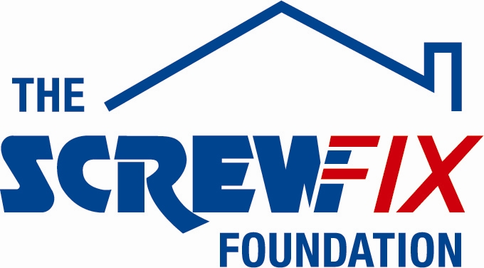

August 2017

ABOUT WITH FRIENDS GETS A HELPING HAND FROM THE SCREWFIX FOUNDATION

About with Friends, based in Cromer, is celebrating after being awarded £5,000 worth of funding from The Screwfix Foundation - a charity which supports projects to fix, repair, maintain and improve properties and facilities for those in need.

Jamie Moses Head of workskills for About with Friends comments: “We are very grateful to The Screwfix Foundation for donating these much needed funds to support our charity. About with Friends supports adults and young people with learning difficulties and is a fun, active and energetic charity based in Cromer. We offer children, young people and adults with learning disabilities the chance to lead the lives they choose they have opportunities to develop lasting friendships; engage in fun and active social activities; get involved in the community; have the chance to try new experiences; learn new skills both for life and work; but above all feel a valued part of society while enjoying life to the full. The funding will be used towards the cost of dividing the premises into smaller spaces including an activity room, a sensory room, quiet rooms, meeting rooms, safe storage as well as the fittings. We’d like to thank everyone who was involved in the fundraising – it’s been a great help to us.”

Andrew Knight Store Manager of the Screwfix store in Cromer, comments: “We’re really pleased that one of our local charities has been awarded funding by The Screwfix Foundation. Staff from across the business have held a variety of fundraising events to raise vital funds for The Screwfix Foundation, so it’s fantastic to see the money we have raised being invested back into such a worthwhile community project.”

The Screwfix Foundation, which launched in April 2013 donates much needed funding to help a variety of local projects throughout the UK, from repairing buildings and improving community facilities, to improving the homes of people living with sickness or disability.

It also works closely with two national charity partners, Barnardo’s children’s charity and Macmillan Cancer Support, as well as supporting smaller, local registered charities like About with Friends.

Relevant projects from across Cromer are invited to apply online for a share of the funding at screwfixfoundation.com.

For more information about The Screwfix Foundation, visit screwfixfoundation.com.

-ENDS-
Note to editors
About The Screwfix Foundation:
The Screwfix Foundation is a charity set up by Screwfix in April 2013. We have a clear purpose of raising funds to support projects that will fix, repair, maintain and improve properties and community facilities specifically for those in need in the UK.
The Screwfix Foundation raises funds throughout the year to support causes that will change people’s lives. Working with both national and local charities, The Screwfix Foundation donates much needed funding to help all sorts of projects, from repairing buildings and improving community facilities, to improving the homes of people living with sickness or disability.

PRESS information:
For more information, please contact:
The Screwfix Foundation,
E: Foundation@screwfix.com

