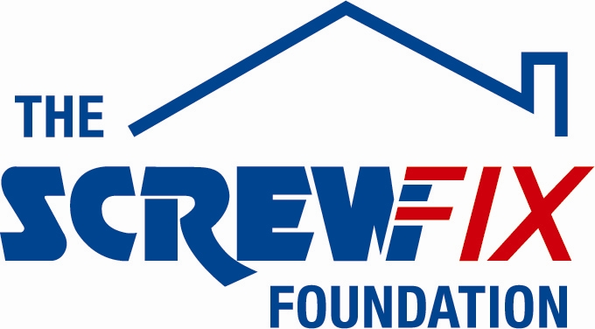

APRIL 2017
ARCH RECEIVES GENEROUS DONATION FROM THE SCREWFIX FOUNDATION
Arch , based in Stoke-on-Trent, is celebrating after being awarded £1,730 worth of funding from The Screwfix Foundation, a charity which supports projects to fix, repair, maintain and improve properties and facilities for those in need.

Toni Starkey from comments: “We are very grateful to The Screwfix Foundation for donating these much needed funds to support our charity. Arch is a registered charity which connects with people at difficult times in their lives, providing a range of accommodation and support services across Staffordshire. The funding has been used to convert an unused store cupboard into a dedicated counselling room for our Pointon House service. We’d like to thank everyone who was involved in the fundraising – it’s been a great help to us.”

Scott Pritchard, Assistant Manager of the Screwfix store in Stoke-on-Trent, comments: “We’re really pleased that one of our local charities has been awarded funding by The Screwfix Foundation. Staff from across the business have held a variety of fundraising events to raise vital funds for The Screwfix Foundation, so it’s fantastic to see the money we have raised being invested back into such a worthwhile community project.”

The Screwfix Foundation, which launched in April 2013 donates much needed funding to help a variety of local projects throughout the UK, from repairing buildings and improving community facilities, to improving the homes of people living with sickness or disability.

It also works closely with two national charity partners, Barnardo’s children’s charity and Macmillan Cancer Support, as well as supporting smaller, local registered charities like Arch.

Relevant projects from across Stoke-on-Trent are invited to apply online for a share of the funding at screwfixfoundation.com.

For more information about The Screwfix Foundation, visit screwfixfoundation.com.

-ENDS-
Note to editors
About The Screwfix Foundation:
The Screwfix Foundation is a charity set up by Screwfix in April 2013. We have a clear purpose of raising funds to support projects that will fix, repair, maintain and improve properties and community facilities specifically for those in need in the UK.
The Screwfix Foundation raises funds throughout the year to support causes that will change people’s lives. Working with both national and local charities, The Screwfix Foundation donates much needed funding to help all sorts of projects, from repairing buildings and improving community facilities, to improving the homes of people living with sickness or disability.
About Arch

Arch is a registered charity working with people in housing need, families needing support, victims and perpetrators of domestic violence and people wanting to return to work, education and training.

Arch is part of the Staffordshire Housing Group, which provides a diverse range of housing for rent and sale, along with development, regeneration, support and wellbeing services through Staffordshire Housing Association, Arch, Blue Mountain and Revival Home Improvement Agency.
PRESS information:
For more information, please contact:
The Screwfix Foundation,
E: Foundation@screwfix.com
For Arch please contact:
Sarah Pye – Communications and PR Officer
01782 743883 sarah.pye@staffshousing.org.uk

