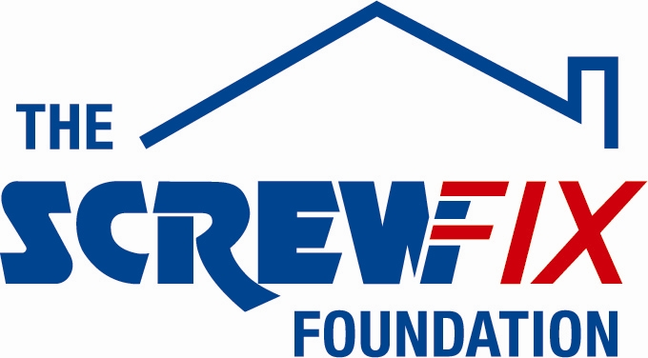

Aug 2017

NEWRY BASED CHARITY GETS A HELPING HAND FROM THE SCREWFIX FOUNDATION

The Brain Injury Foundation, based in Newry, is celebrating after being awarded £5,000 worth of funding from The Screwfix Foundation, a charity which supports projects to fix, repair, maintain and improve properties and facilities for those in need.

Frank Dolaghan from The Brain Injury Foundation, comments: “We are very grateful to The Screwfix Foundation for donating these much needed funds to support our charity. We support people with all forms of brain injuries and their families and carers. The charity was launched by a group of survivors, carers and volunteers in August 2012 and we now have over 100 members, from all over Newry and Mourne, Armagh, Banbridge and Dungannon. The funding will be used towards the cost of converting a social club into a pub catered for those with brain injuries. We’d like to thank everyone who was involved in the fundraising – it’s been a great help to us.”

Paddy Lock, Store Manager of the Screwfix store in Newry, comments: “We’re really pleased that one of our local charities has been awarded funding by The Screwfix Foundation. Staff from across the business have held a variety of fundraising events to raise vital funds for The Screwfix Foundation, so it’s fantastic to see the money we have raised being invested back into such a worthwhile community project.”

The Screwfix Foundation, which launched in April 2013 donates much needed funding to help a variety of local projects throughout the UK, from repairing buildings and improving community facilities, to improving the homes of people living with sickness or disability.

It also works closely with two national charity partners, Barnardo’s children’s charity and Macmillan Cancer Support, as well as supporting smaller, local registered charities like The Brain Injury Foundation

Relevant projects from across Newry are invited to apply online for a share of the funding at screwfixfoundation.com.

For more information about The Screwfix Foundation, visit screwfixfoundation.com.

-ENDS-
Note to editors
Picture Caption:
Paddy Lock, from Screwfix, presents cheque for £5,000 to The Brain Injury Foundation
Left to right – Aileen and Frank Dolaghan - founder members of the charity - their son is a brain injury survivor | Paddy Lock – Screwfix Store Manager | Aine McKevitt – founder member of the charity and brain injury survivor

About The Screwfix Foundation:
The Screwfix Foundation is a charity set up by Screwfix in April 2013. We have a clear purpose of raising funds to support projects that will fix, repair, maintain and improve properties and community facilities specifically for those in need in the UK.
The Screwfix Foundation raises funds throughout the year to support causes that will change people’s lives. Working with both national and local charities, The Screwfix Foundation donates much needed funding to help all sorts of projects, from repairing buildings and improving community facilities, to improving the homes of people living with sickness or disability.

PRESS information:
For more information, please contact:
The Screwfix Foundation,
E: Foundation@screwfix.com

