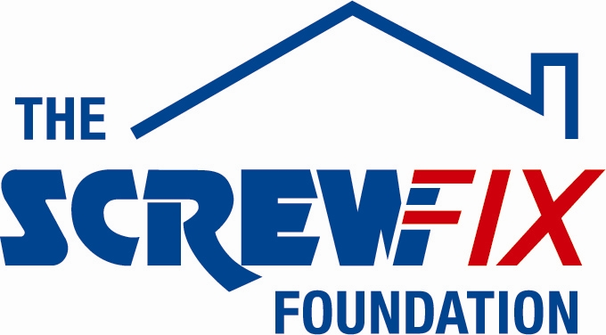

July 2017

LEEDS BASED CHARITY GETS A HELPING HAND FROM THE SCREWFIX FOUNDATION

Breast Cancer Haven, Yorkshire is celebrating after being awarded £890 from The Screwfix Foundation, a charity which supports projects to fix, repair, maintain and improve properties and facilities for those in need.

Breast Cancer Haven is a national charity, offering free emotional support, help with symptom control and practical advice to anyone affected by breast cancer from its network of centres. Everyone is welcomed; whether recently diagnosed, in treatment, or seeking help to lead a healthy life after that treatment has finished.

Hannah Beezer, Trust Fundraiser for Breast Cancer Haven, Yorkshire comments: “We are very grateful to The Screwfix Foundation for donating these much needed funds to support our charity. Being diagnosed with cancer can be frightening, and the treatment gruelling. Breast Cancer Haven provide everything from practical support to a friendly face you can always talk to. We have centres across the UK, providing free, tailor-made support and advice to anyone diagnosed with breast cancer. This much needed funding will be used towards the cost of repairing our air-conditioning and heating system. We’d like to thank everyone who was involved in the fundraising – it’s been a great help to us.”

Victoria Burch, Store Manager of Screwfix Stourton – Leeds, adds: “We are really pleased that one of our local charities has been awarded funding by The Screwfix Foundation. Staff from across the business have held a variety of fundraising events to raise vital funds for The Screwfix Foundation, so it’s fantastic to see the money we have raised being invested back into such a worthwhile community project.”

The Screwfix Foundation, which launched in April 2013, donates much needed funding to help a variety of local projects throughout the UK, from repairing buildings and improving community facilities, to improving the homes of people living with sickness or disability.

It also works closely with two national charity partners, Barnardo’s children’s charity and Macmillan Cancer Support, as well as supporting smaller registered charities like Breast Cancer Haven.

Relevant projects from across Yorkshire are invited to apply online for a share of the funding at screwfixfoundation.com.

For more information about The Screwfix Foundation, visit screwfixfoundation.com.

-ENDS-
Note to editors
Image Caption: Screwfix Foundation at Breast Cancer Haven, Leeds. In picture is Debra Horsman from Breast Cancer Haven and Vicky Burch, Manager at Screwfix Stourton Store.
About The Screwfix Foundation:
The Screwfix Foundation is a charity set up by Screwfix in April 2013. We have a clear purpose of raising funds to support projects that will fix, repair, maintain and improve properties and community facilities specifically for those in need in the UK.
The Screwfix Foundation raises funds throughout the year to support causes that will change people’s lives. Working with both national and local charities, The Screwfix Foundation donates much needed funding to help all sorts of projects, from repairing buildings and improving community facilities, to improving the homes of people living with sickness or disability.

PRESS information:
For more information, please contact:
The Screwfix Foundation,
E: Foundation@screwfix.com

