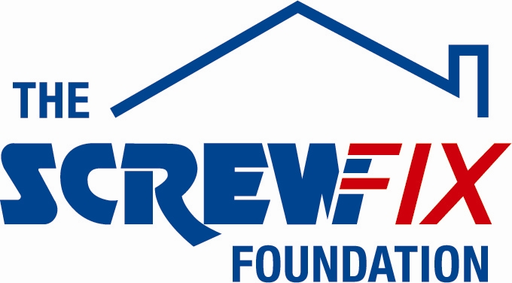
15th November 2018

CAMPHILL COMMUNITY, COUNTY TYRONE, GETS A HELPING HAND FROM THE SCREWFIX FOUNDATION

The Camphill Community, based in Clanabogen, County Tyrone in Northern Ireland, is celebrating after being awarded £5,000 worth of funding from The Screwfix Foundation, a charity which supports projects to fix, repair, maintain and improve properties and facilities for those in need.

Martin Sturm (Director) comments: “We are very grateful to The Screwfix Foundation for donating these much-needed funds to support our charity.
Camphill Community Clanabogan provides an inclusive community ethos which seeks to ensure that each individual’s intrinsic worth is valued and respected For adults at risk of harm we provide support, care and day opportunities in order to meet their needs and maximise their dignity and independence, we promote life opportunities so they can achieve personal fulfilment, an improved quality of life and inclusion in society. Adult residents and co-workers and their families share life and work together to maintain and develop the Community as an active part of society.

The funding was used towards improving our Social Care Farm. To build a new purpose-designed barn to house all hay and straw adequately, fitted out with drying and handling equipment enabling the production of high quality barn dried hay using largely renewable energy sources and technology.

We’d like to thank everyone who was involved in the fundraising – it’s been a great help to us.”

Karl Watson, Store Manager of the Omagh Screwfix store, comments: “We’re really pleased that one of our local charities has been awarded funding by The Screwfix Foundation. Staff from across the business have held a variety of fundraising events to raise vital funds for The Screwfix Foundation, so it’s fantastic to see the money we have raised being invested back into such a worthwhile community project.”

The Screwfix Foundation, which launched in April 2013 donates much needed funding to help a variety of local projects throughout the UK, from repairing buildings and improving community facilities, to improving the homes of people living with sickness or disability.

It also works closely with two national charity partners, Barnardo’s children’s charity and Macmillan Cancer Support, as well as supporting smaller, local registered charities like United Response

Relevant projects from across Northern Ireland are invited to apply online for a share of the funding at screwfixfoundation.com.

For more information about The Screwfix Foundation, visit screwfixfoundation.com.
Picture Caption;- l-r - MS Society staff Anne Moore, Senior Care Assistant; Helen Wall, Health Care Assistan; Tom Mallon, Fund Raising Manager, with Jacqueline McBride, Screwfix Store Manager at the Ravenhill Branch, and Lesley Clews-Stevenson, Day Care Assistant.

-ENDS-
Note to editors
About The Screwfix Foundation:
The Screwfix Foundation is a charity set up by Screwfix in April 2013. We have a clear purpose of raising funds to support projects that will fix, repair, maintain and improve properties and community facilities specifically for those in need in the UK.
The Screwfix Foundation raises funds throughout the year to support causes that will change people’s lives. Working with both national and local charities, The Screwfix Foundation donates much needed funding to help all sorts of projects, from repairing buildings and improving community facilities, to improving the homes of people living with sickness or disability.

PRESS information:
For more information, please contact:
The Screwfix Foundation,
E: Foundation@screwfix.com

