
August 2016

LATEST SCREWFIX CATALOGUE OUT NOW - WITH 1,000 PRICE CUTS

Multi-channel retailer, Screwfix, has released the latest edition of its renowned catalogue, packed full with clever innovations and essential tools for tradespeople and serious DIYers.

What’s more, all products ordered via the catalogue, are available for next day delivery seven days a week, or via its five minute Click & Collect service, so customers can get the best quality products even quicker.

Available to collect free from over 470 Screwfix stores nationwide, the new catalogue includes 27,000 items, price cuts on over 1,000 products and features a comprehensive range of products from leading brands such as DeWalt and Titan.


DeWalt 18V Cordless Combi Drill – Robust, powerful and versatile
No tool kit is complete without a drill. Unsure of which one to buy? Built for power and performance, the DeWalt Cordless Combi Drill comes with 15 torque, drill and hammer settings. It also features a fan-cooled, 2-speed variable motor which provides long lasting performance as well as an integrated LED light to improve visibility in dimly lit areas. Complete with two 1.5Ah Li-lon batteries, a 30 minute charger and a kit box, this drill provides great value at only £99.99.

Committed to enhancing its range, the latest catalogue also features a wide variety of other new drills, available from leading brands including a Makita 18v Combi Drill with two 3.0Ah Li-lon batteries for £169.99 and a 18V Bosch Combi drill for only £99.99.

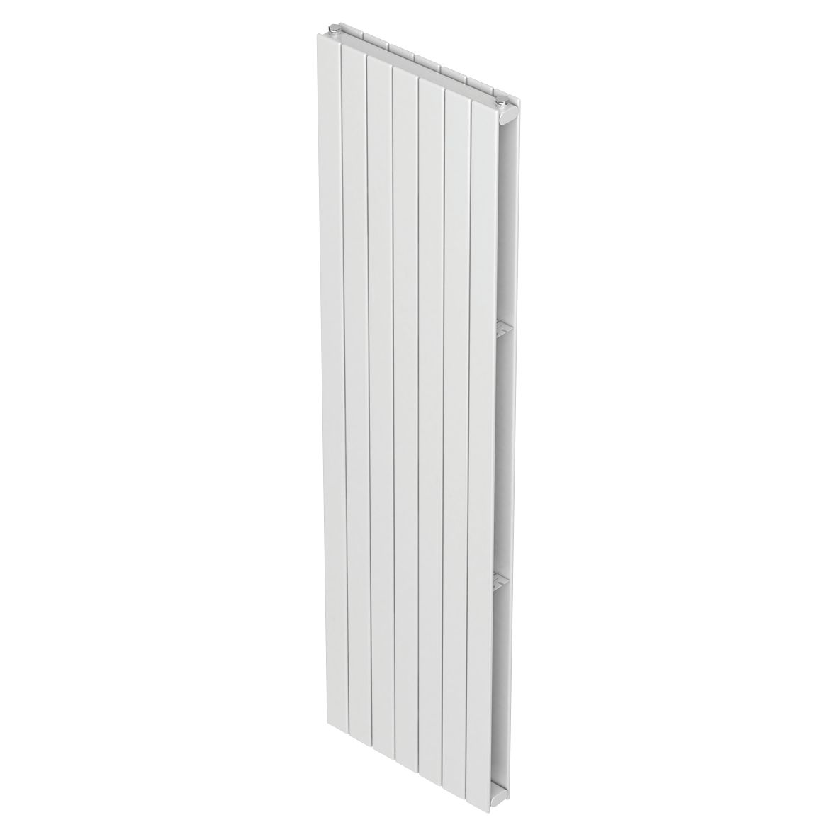
Radiators with modern designs
The Moretti Modena Double Panel Designer Radiator is perfect for Screwfix customers looking to create a striking design statement as well as ensuring high heat output. The Moretti range, all have a high quality British steel construction and are easy to handle and install.
The sleek Moretti designer range of styles and colours reflects current homeowner trends with the benefit of a five-year manufacturer’s guarantee. Customers can get their hands on the Moretti Modena Vertical Designer Radiator for £269.99 or save further with the Sorrento Horizontal Designer Radiator for just £139.99. Delivered complete with wall brackets, plug and vent.

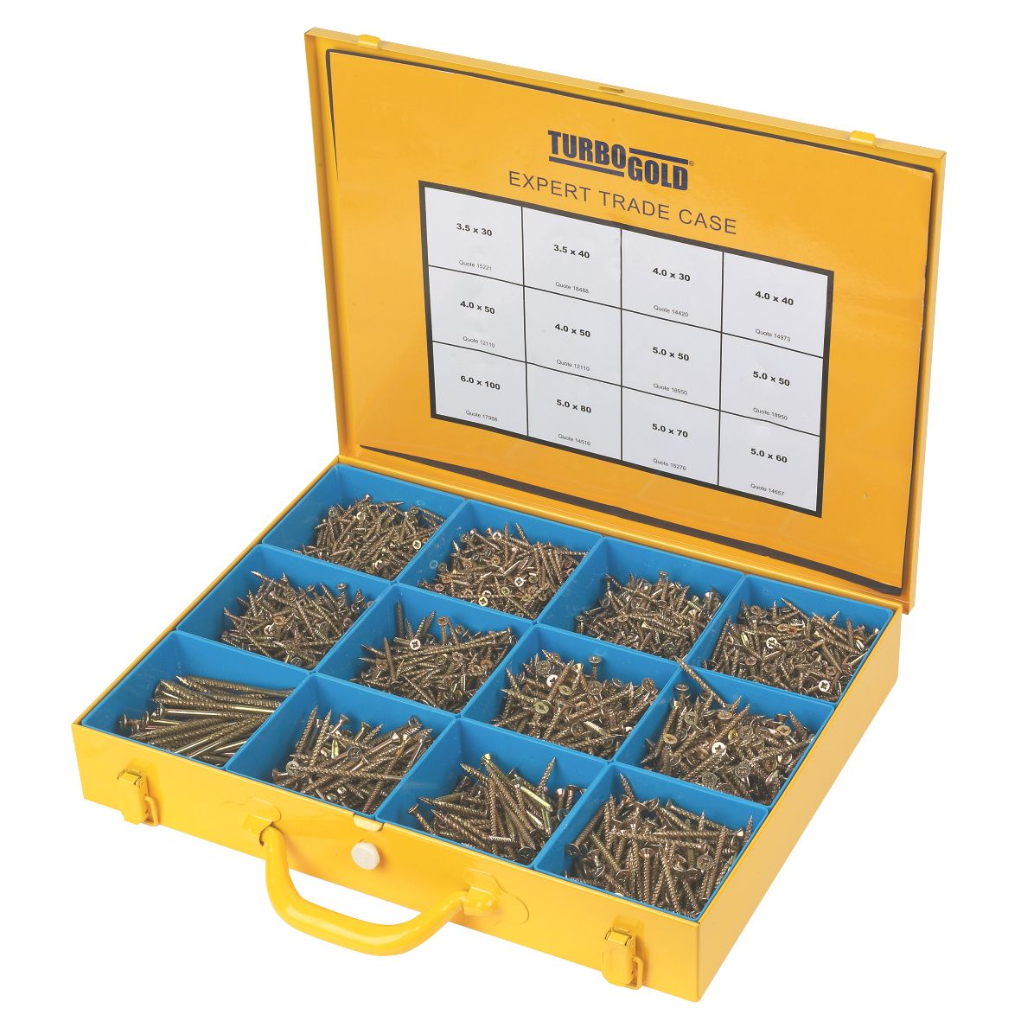
Super savings on TurboGold Expert Trade Cases
TurboGold Expert Trade Cases are the professionals’ choice. The screws are strong and durable so there is no need for a pilot hole and with a unique rifled shank they can be used close to the edge of materials without splitting. Suitable for use with all types of wood, plastic, sheet metal and even masonry with a pre drilled hole, the Turbo range features TurboGold (first fix), TurboSilver (second fix) and TurboUltra (outdoor) and are available from Screwfix for only £39.99.

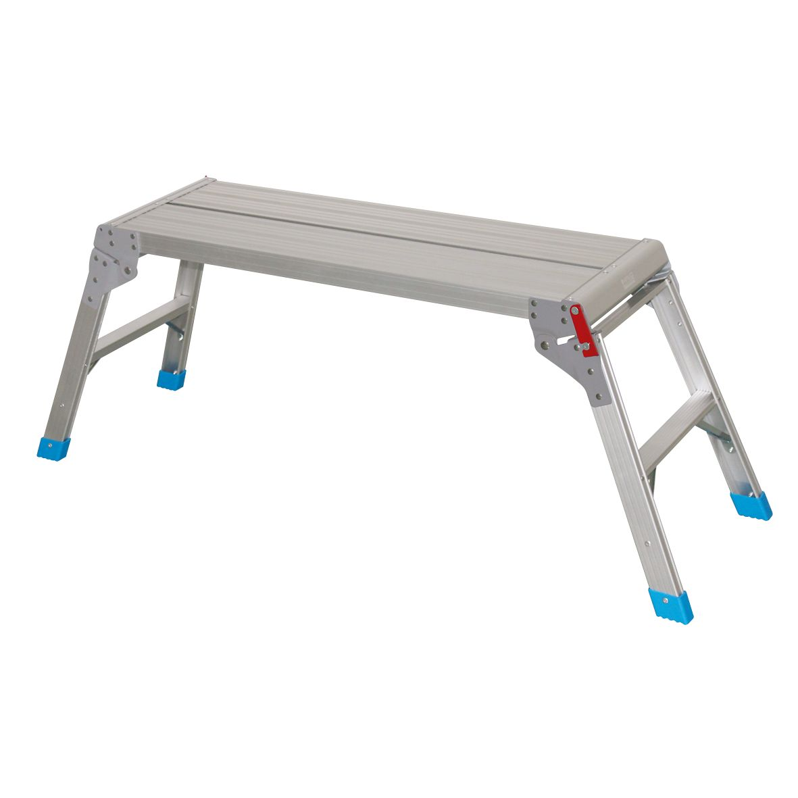
Great value on robust platforms
The Aluminium Work Platform is ideal for most trades who need a sturdy platform to work just off the ground. The platform is constructed of high quality aluminium, with a total product weight of 4.9kg or 5.6kg depending on size, for easy handling. Complete with steel quick-lock hinges as well as an anti-slip surface, Screwfix customers can get their hands on two sizes - 600mm for the low price of £19.99 or 900mm for just £29.99.

Save on LED bulbs
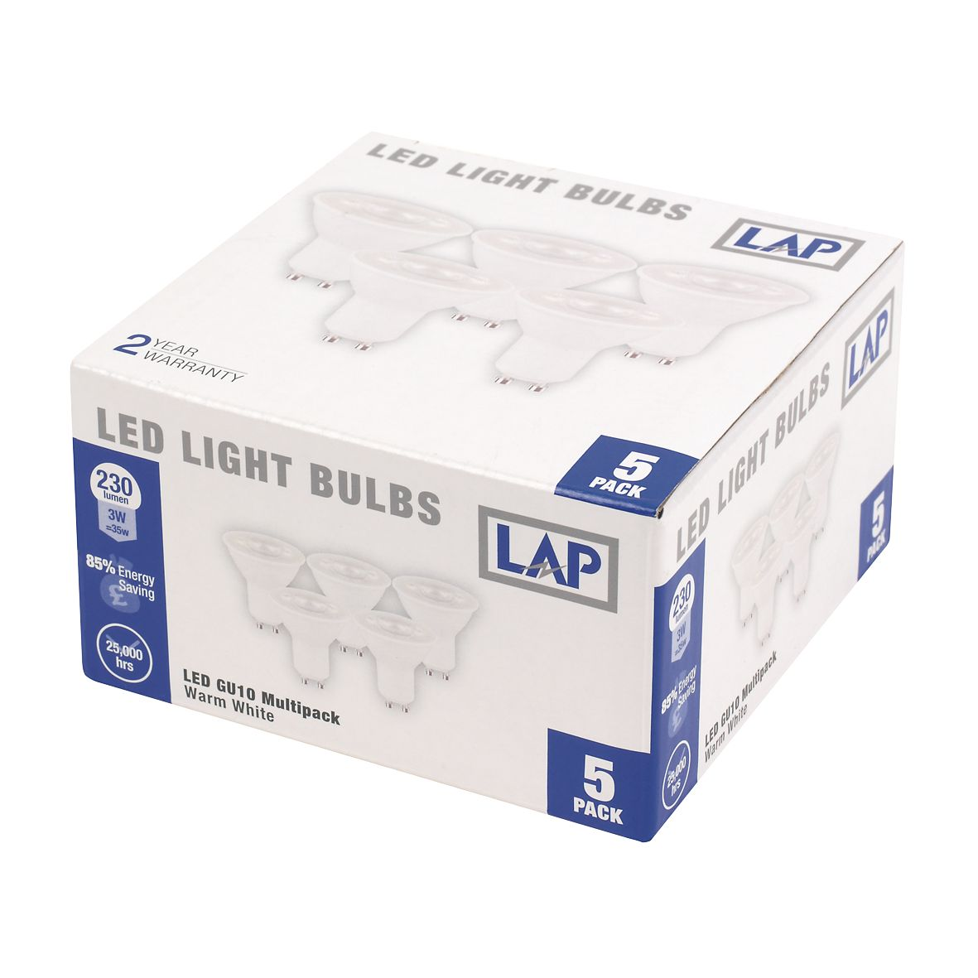
When it comes to lighting a home, LED has become increasingly popular due to its exceptional energy efficiency and long-lasting lifespan. Screwfix continues to develop its already extensive range of LED bulbs and work lights. For just £8.99, the LED GU10 Multipack includes five Warm White bulbs that feature full, instant light. These LED bulbs can be retrofitted into existing household light fittings. The discounted LED range also includes a rechargeable LED work light, designed with high and low power modes and 15,000 hours’ life length - offering the highest quality without the price tag at £29.99.

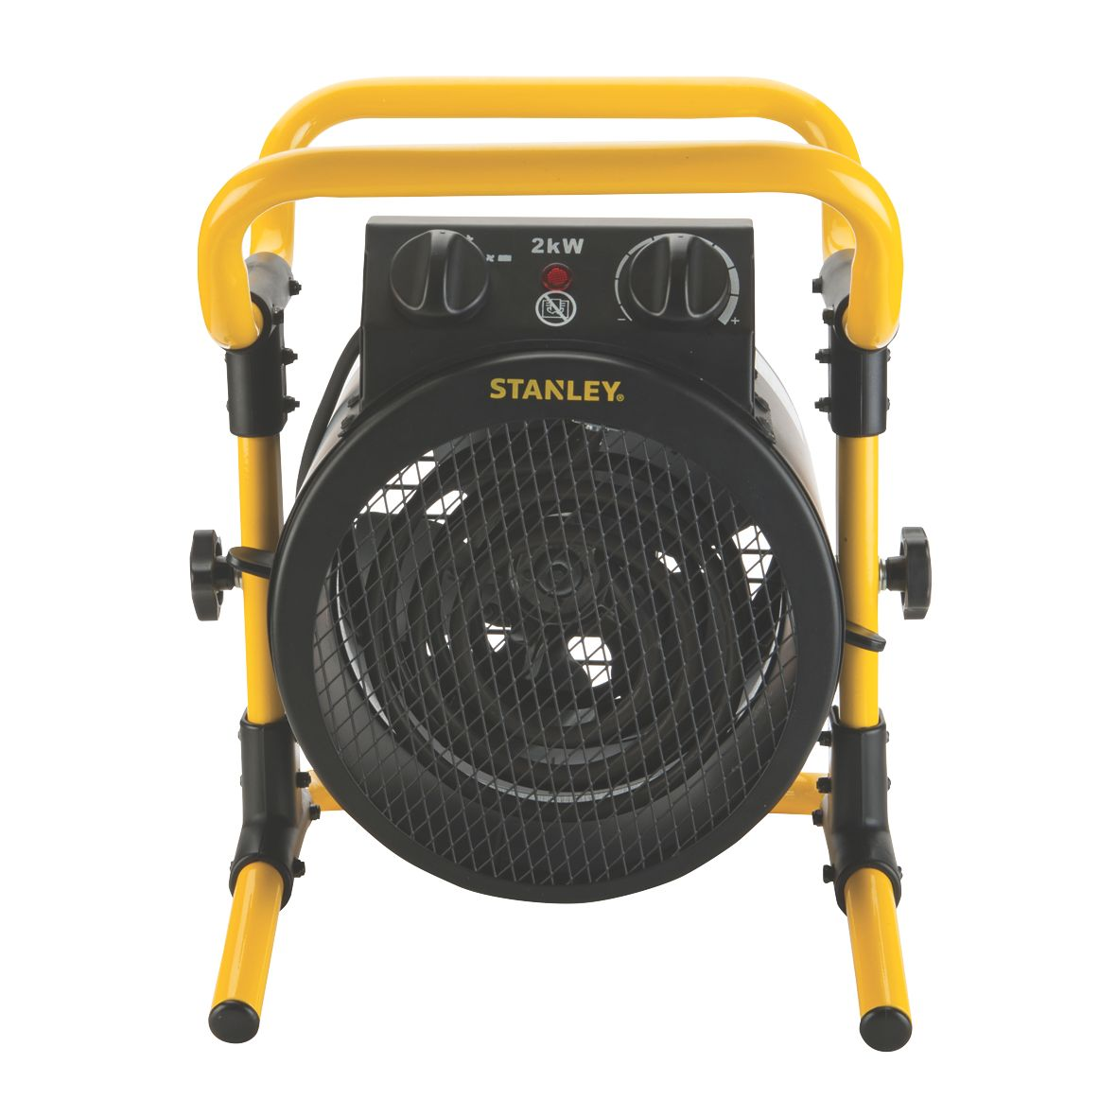
Turning up the heat
With autumn fast approaching, Screwfix is offering savings of up to 40% on its high performance heaters. Starting from only £11.99, Screwfix customers can get their hands on a variety of heaters including the 2000W Stanley Electric Turbo Fan Heater. With an adjustable thermostat as well as a 1.7m cable, the Electric Turbo Fan Heater is designed to keep any space warm.

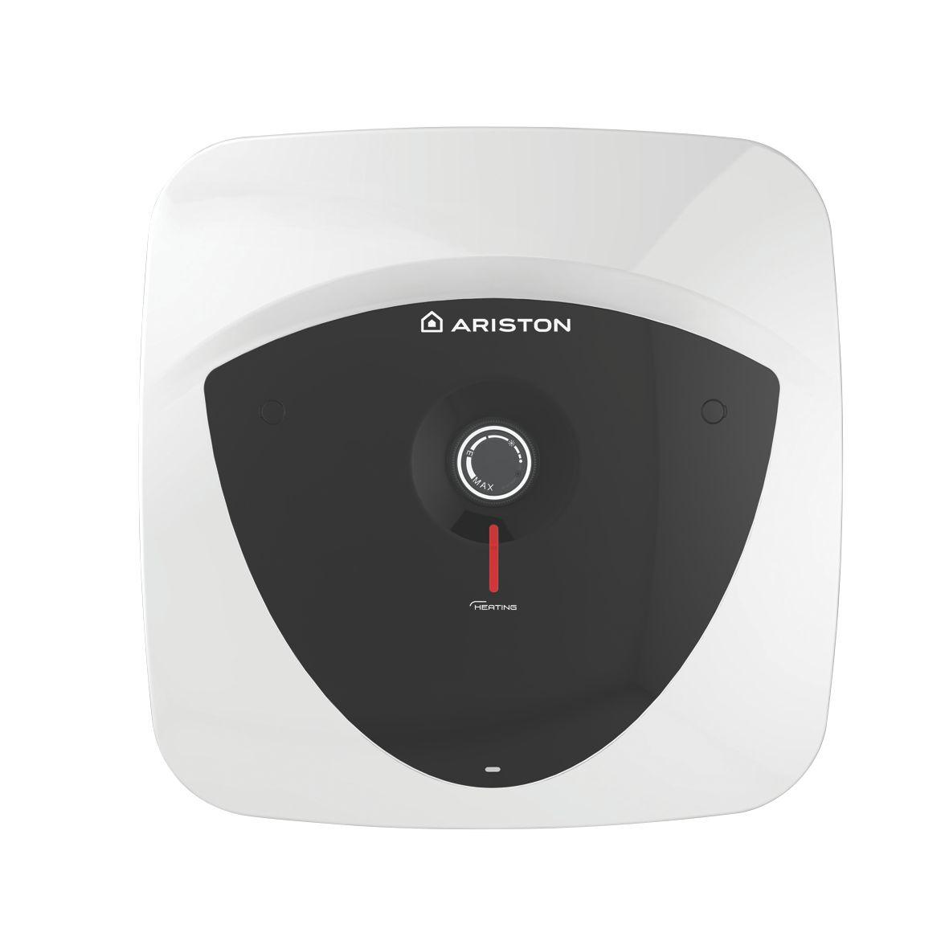

Ariston Water Heater now available for less
Highly efficient and easy to install, the Ariston Water Heater has a robust internal 4-bolt flange for increased durability and a frontal knob for easy temperature regulation for just £94.99. With a three year tank guarantee and a one year electrical guarantee, this steel constructed heater has a high quality, vitreous enamel coating finish and is available in white or black. With a range of capacities from 10 to 30 litre units, the Ariston Water Heater is cutting-edge in water heating.

Exclusive kitchen taps with Screwfx
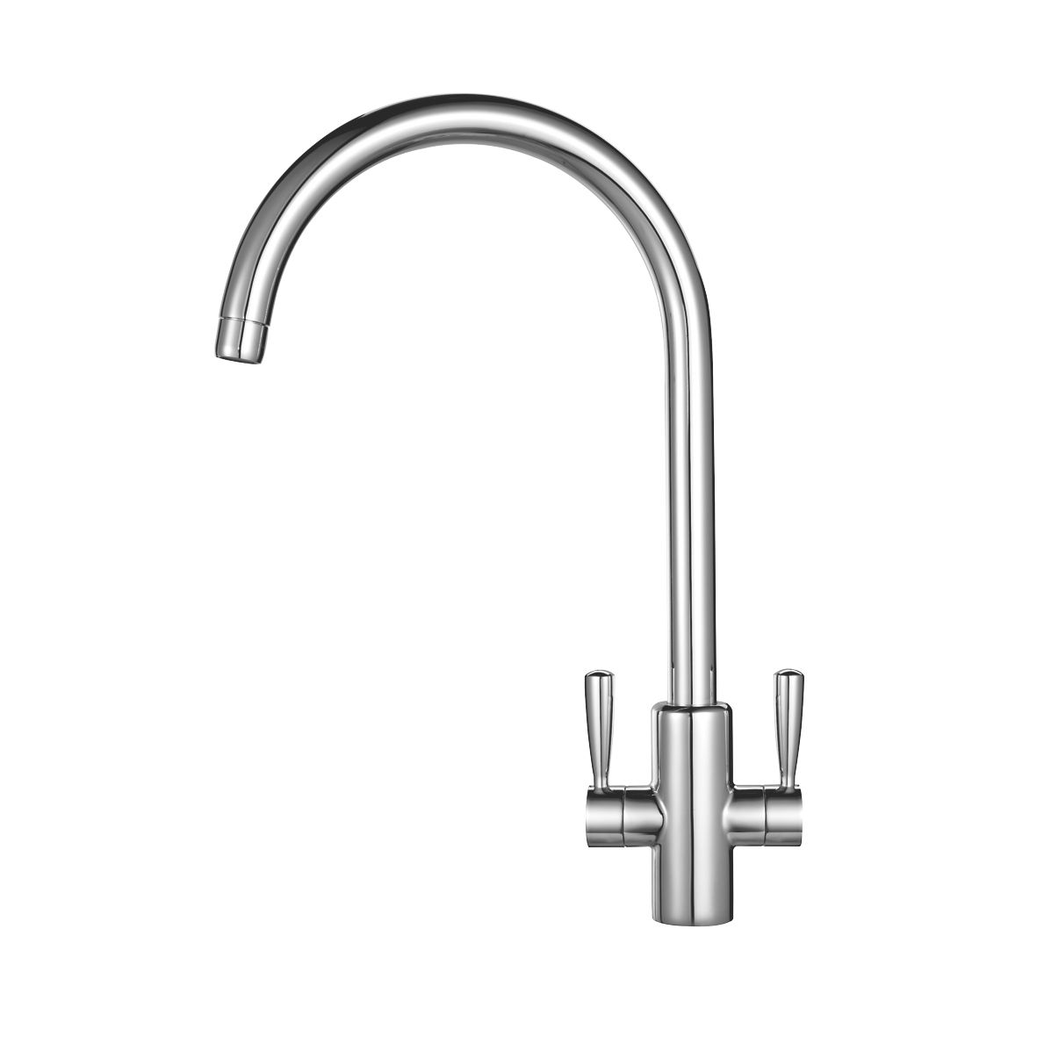
Boasting style and chic design, the latest catalogue includes a brand new range of kitchen taps exclusive to Screwfix which have a value for money price tag with no compromise on quality. Our New range of Watersmith taps comes with a 10 year guarantee. To make life easier the majority of our taps are suitable for both high and low pressure systems. Customers can also enjoy savings on existing items such as the popular Franke Ascona Chrome Mixer Tap , at just £99. The range also includes a great selection of Bristan taps which have a 5 year manufacturer's guarantee, they all include EasyFit technology for quick and simple installation

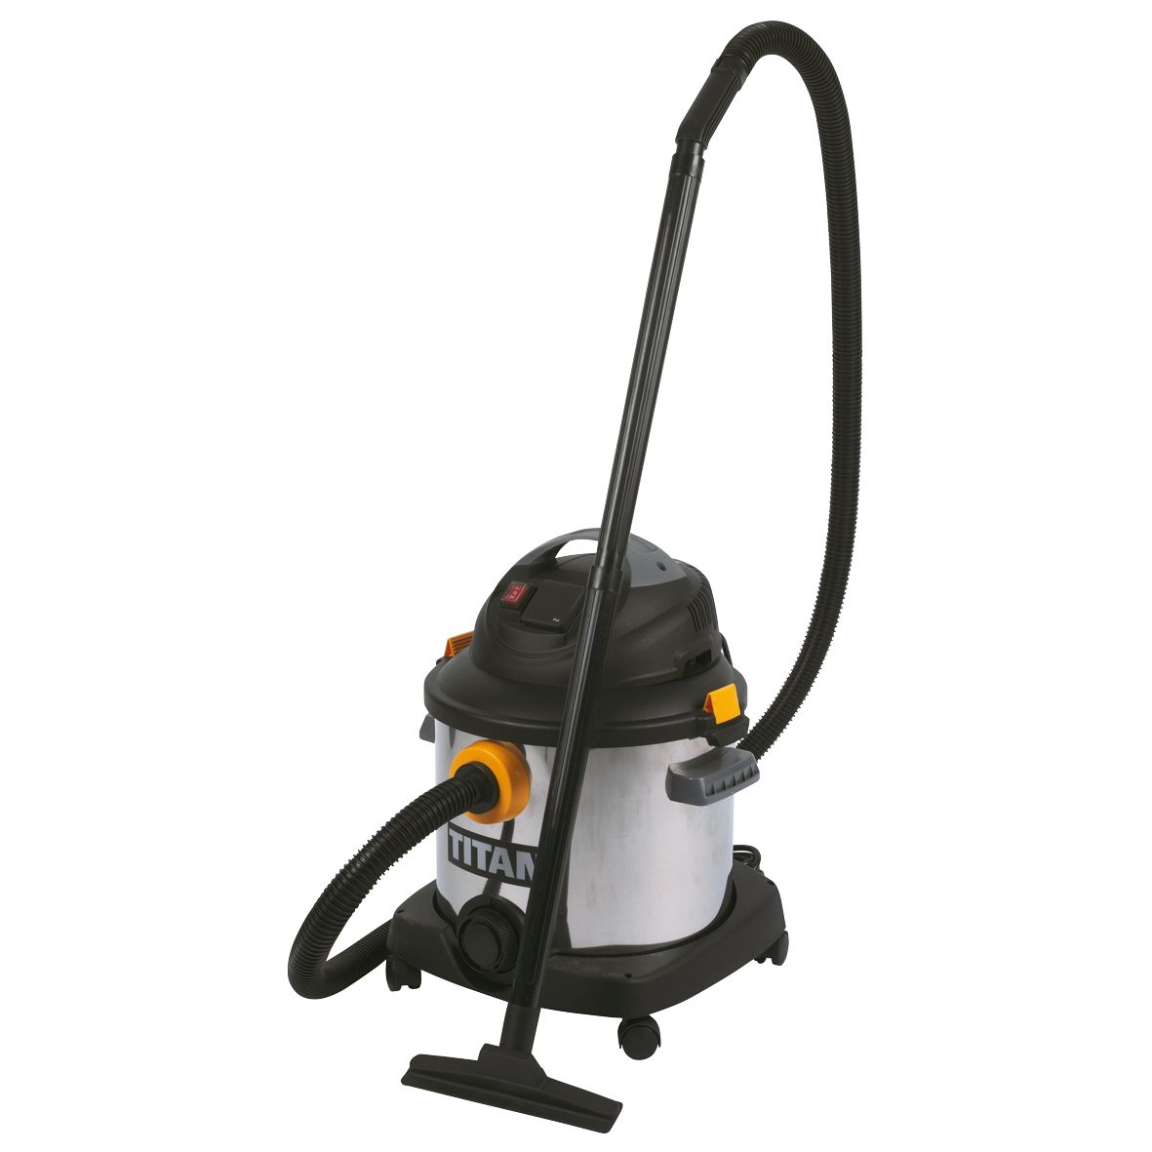
Titan Wet & Dry Vacuum only £54.99
For only £54.99, the Titan Wet & Dry Vacuum Cleaner provides superior cleaning power and has a 30 litre capacity. This high performance 1400w motor is constructed with a heavy duty stainless steel tank and features a 1600w power take off socket and on board tool storage.

Customers can collect their free copy of the all new Screwfix catalogue from over 470 Screwfix stores or download the Screwfix catalogue app to their Apple, Windows or Android smartphone, or tablet.

All of the new ranges are available from Screwfix.com for next day home delivery or collection from any branches. The Click & Collect service enables customers to order their selected products online or by phone and pick up their items just five minutes later at their chosen store. Screwfix stores are open from 7am on weekdays and Saturday and between 10am and 4pm on Sundays, and with a UK based Contact Centre open 24 hours a day, it’s never been easier to get hold of all the trade essentials before the start of the working day. For added convenience, it offers next day delivery, seven days a week.

Fancy a quicker way of ordering in store? Screwfix has launched the brand new Screwfix Card. With this, customers can link their account to their card and can easily keep track of their order history in one place. Simply visit a store to sign-up for the Screwfix card or key fob or download the Screwfix QuickShop app for the same experience.
For more information on Screwfix’s new range of products, visit www.screwfix.com, call 03330 112 112, or pick up a copy of the new catalogue at a local Screwfix store.

-ENDS-

Note to editors
About Screwfix:
Screwfix is part of Kingfisher plc, a home improvement company with over 1,100 stores in 10 countries in Europe, Russia and Turkey. For further information go to www.kingfisher.com.
Screwfix is recognised as being “where the trade buys”, offering a straightforward and transparently-priced retail experience that enables busy trade customers to shop 26,000 products over the phone, online, via their mobile or from their local store.
- From power tools and work wear to cables and pipe fittings, more than 11,000 products are available to pick up from the national network of over 470 stores. A further range of over 16,000 products can be ordered over the phone, online or from a local store, with orders taken up until 7pm for next day delivery to home or site.
- Screwfix.com attracts 2.2 million unique visitors per week and the Screwfix Click & Collect service means customers can conveniently purchase supplies online (or over the phone) and then collect from store just five minutes later.
- Customers can call the UK-based Screwfix Contact Centre 24 hours a day, 7 days a week (including bank holidays) on 03330 112 112.
- UK stores are open 7 days a week, from 7am – 8pm Weekdays, 7am – 6pm Saturdays and 10am – 4pm Sundays.
- 9 out of 10 customers would recommend Screwfix to a friend.
- Screwfix was voted the 5th highest rated UK company for work-life balance by Glassdoor Employees' Choice Awards 2016.

PRESS information:
For more information, please contact:
Hannah Montgomery, McCann Public Relations, Tel: 0121 713 3745 hannah.montgomery@mccann.com

