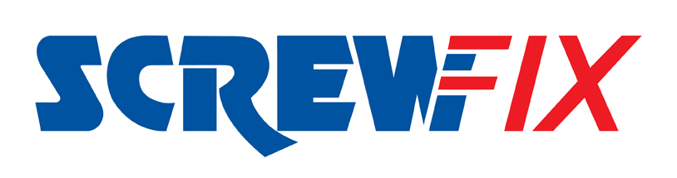

5th November 2018

Clitheroe New Screwfix store is declared a runaway success

Screwfix is celebrating the successful launch of its new store opening in Barrow Brook Trade Park, North Road, BB7 9QZ. The store officially opened its doors on Thursday 1st November 2018 with hundreds of eager customers ready to stock-up on the latest tools and trade essentials.

The Clitheroe Screwfix store is part of the company’s growing network of over 600 stores nationwide, meaning 97% of the UK population is within a 30-minute drive of a store. Open seven days a week and from 7am Monday to Friday, the store also provides a convenient, Click & Collect service available at all Screwfix locations. Using this service, customers can order their goods online or over the phone and pick them up from a store in as little as one minute.

Clitheroe Screwfix Store Manager, Paul Holden, said: “We chose to open a new store in Barrow, just outside of Clitheroe to better meet the needs of the local tradespeople. Many of our new customers previously shopped with Screwfix at our stores in Accrington or Burnley, so we’re delighted to bring Screwfix even closer to them for greater convenience.

“Our celebration period, which ran from Thursday 1st November and throughout the weekend until Sunday 4th November, attracted hundreds of customers. We have received fantastic support from the local homes or community facilities and are looking forward to welcoming and helping more tradespeople and serious DIYers over the coming months.”

Visit Screwfix’s new Clitheroe branch in Barrow Brook Trade Park, North Road, BB7 9QZ
Monday to Friday 7am-8pm, Saturday 7am-6pm and Sunday 9am-4pm.
The brand’s huge range of products and exceptional deals are also available online at www.screwfix.com, on Screwfix’s mobile site or over the phone on 03330 112 112.

-ENDS-
Note to editors
About Screwfix:
Screwfix is part of Kingfisher plc, the international home improvement company, with 1,300 stores in 10 countries in Europe, Russia and Turkey. For further information go to www.kingfisher.com.
Screwfix is convenient, straightforward and affordably-priced, helping its trade customers get the job done quickly, affordably and right first time.
• From power tools and work wear to cables and pipe fittings, Screwfix offers over 11,000 products available to pick up from over 600 stores nationwide.
• Over 32,000 products can be ordered over the phone, online or from a local store, with orders taken up until 8pm (weekdays) for next day delivery to home or site.
• Screwfix.com attracts 5 million visits per week.
• Store network is visited by 7.8m customers a year
• The Screwfix Click & Collect service which enables customers to pick-up their goods in as little as one minute after ordering online or over the phone, has already received more than 27 million orders.
• UK-based Screwfix Contact Centre open 24 hours a day, 7 days a week (including bank holidays) on 03330 112 112.
• See www.screwfix.com/stores for store opening information.
• World leading customer satisfaction levels.
• Screwfix was awarded Glassdoor’s Best Places to Work in 2017 and 2018.
• Screwfix was awarded Retail Week’s ‘Best Retailer over £250m’ and ‘Digital Pioneer’ awards in 2018
• For more information about Screwfix please visit our media centre: www.screwfixmedia.co.uk
PRESS information:
For more information, please contact:
Screwfix Press Office
Tel: 01935 441706
E: Claire.hart@screwfix.com

