

**England May Not Have Won the Cup but…**

**When it comes to social media Screwfix really scored!**

Figures just released by Foresee Insight, a company that measures digital reach, shows that of the Top 10 World Cup commercials on social media: Screwfix topped their league

Not only were Screwfix proud sponsors of ITV World Cup Match coverage, but Screwfix’s ad on ITV received the highest positive sentiment of 79%.* The Omnichannel retailers’ “Legends of the Game” hailed unsung heroes in the construction business, featuring genuine trades people with sound alike names, such as Kevin Keegan, Stuart Pearce, Ashleigh Cole and Peter Crouch. The tongue in cheek campaign achieved over 20 million reach and over 8 thousand engagements. The campaign was skilfully managed by the Screwfix in-house team, supported by their forward-thinking agency, demonstrating their ability to play at the highest level as home grown talent at its best. Tackling some strong competition, together they achieved fantastic results from organic rather than any ‘paid-for’ posts. Clever tactics and solid teamwork meant that no sky-high transfer fees were involved, as the campaign certainly proved it had what it takes to go all the way on its own merit.

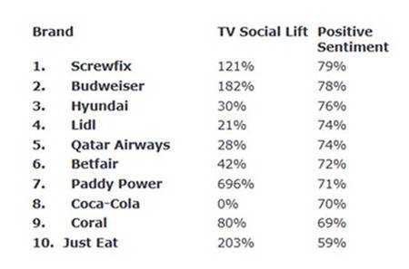

Furthermore, these “Legends of the Game” were totally ‘on-side’, helping to gain great coverage in the sports sections of national press and being featured on Digital Screens in pubs across the nation. There was also a clear ‘advantage’ having players interviewed on radio as well. This great bunch of players certainly helped Screwfix to achieve their goal.

Brand and Marketing Director, Caroline Welsh pointed out that; ‘We couldn’t have done this without our loyal fans, customers and legends. This was a big investment and luckily the England team ably assisted, by going even further in the tournament than we dreamed. Our internal volunteers who monitored and responded to every social interaction are the true hero’s, but watching football is their passion, so it was a win-win situation’

Proof that when it comes to team tactics, Screwfix are in a league of their own!

*Figures provided by [www.netimperative.com](http://www.netimperative.com)

**Note to editors**

**About Screwfix:**

Screwfix is part of Kingfisher plc, the international home improvement company, with nearly 1,200 stores in 10 countries in Europe, Russia and Turkey. For further information go to [www.kingfisher.com](http://www.kingfisher.com).

Screwfix is convenient, straightforward and affordably-priced, helping its trade customers get the job done quickly, affordably and right first time. Tradespeople can shop 31,000 products over the phone, online, via their mobile or in-person from their local store.

* From power tools and work wear to cables and pipe fittings, Screwfix offers over 11,000 products available to pick up from over 580 stores nationwide. Our full range of over 31,000 products can be ordered over the phone, online or from a local store, with orders taken up until 8pm (weekdays) for next day delivery to home or site.
* Screwfix.com attracts 5 million visits per week.
* The Screwfix Click & Collect service means customers can conveniently purchase supplies online or over the phone and then collect from the store in as little as one minute.
* Customers can call the UK-based Screwfix Contact Centre 24 hours a day, 7 days a week (including bank holidays) on 03330 112 112.
* UK stores are open 7 days a week, from 7am – 8pm Weekdays, 7am – 6pm Saturdays and 9am – 4pm Sundays. Excludes selected stores. See [www.screwfix.com/stores](http://www.screwfix.com/stores) for details.
* London stores are open from 6am – 10pm on weekdays
* In 2016, Screwfix sales surpassed £1bn for the first time
* World leading customer satisfaction levels.
* Screwfix was awarded Retail Week’s Customer Experience Initiative in 2017.
* Screwfix was awarded 2nd place in Retail Week’s Best Employer Rankings in 2017.
* Screwfix was awarded South West Contact Centre Forum’s Large Contact Centre of the Year Award in 2017. Screwfix was awarded Glassdoor’s Best Places to Work in 2017 and 2018.
* Screwfix was awarded Retail Week’s ‘Best Retailer over £250m’ and ‘Digital Pioneer’ awards in 2018
* For more information about Screwfix please visit our media centre: [www.screwfixmedia.co.uk](http://www.screwfixmedia.co.uk)

**PRESS** information:

For more information, please contact:

Matthew Allen, McCann Public Relations, Tel: 0121 713 3579 / [Matthew.thomas-allen@Mccann.com](mailto:Matthew.thomas-allen@Mccann.com)