January 2019
EXCLUSIVE PRODUCTS UNVEILED IN LATEST SCREWFIX CATALOGUE

The latest Screwfix catalogue is out now and is packed full of ‘Trade Rated’ products and exclusives, including 450 NEW products, all offering great value and peace of mind.

The new catalogue’s range of trade essentials and exciting new products includes everything from power tools and workwear to sealants that reduce waste. The ‘Trade Rated’ endorsement provides an additional level of confidence and reassurance, having been independently tried and tested by Screwfix customers.

One of the stand out products featuring for the first time is the DeWalt 18V Brushless Combi Drill. Available at the special introductory price of £119.99, it comes complete with 2 x 2.0Ah Li-Ion batteries so users should never be without charge. This powerful and versatile drill offers 15 different torque settings, alongside all-metal gearing, making it a robust, efficient and powerful combi drill. Its bright white LED light with a delay feature gives improved visibility.

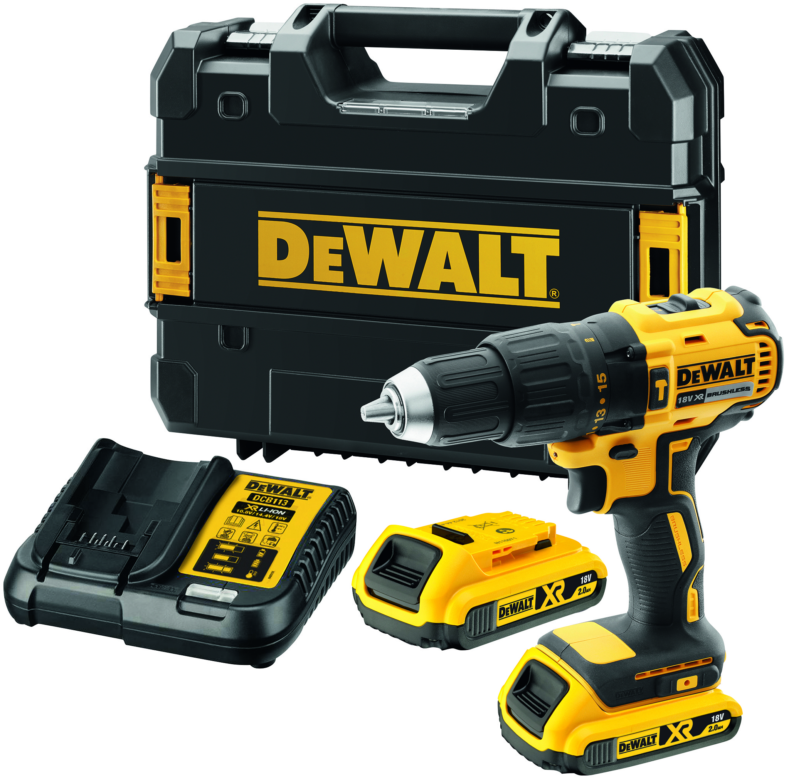

Rhian Bartlett, Trading Director at Screwfix, says: “Our latest catalogue is jam packed with over 16,000 products and enhanced ranges, with over 450 new products having been added to give our customers the products they need and can trust. It’s loaded with a host of ‘Trade Rated’ products to ensure our customers can be confident they’re getting the best each and every time.

“The products in our new catalogue are all available via our 24/7 contact centre, online and from one of our 620 stores. Our Click & Collect service allows customers to order via the phone or online and pick up their goods in store in as little as one minute.”

Other highlights in the new catalogue include Smart Home ranges, sealants, an enhanced selection of power tools and safety & workwear.

KEY HIGHLIGHTS

No Nonsense 8 in 1 Hybrid Sealant
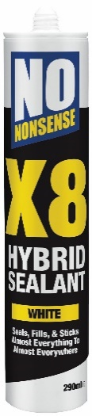

The all-new No Nonsense 8 in 1 Hybrid Sealant is perfect for a wide variety of applications including sanitary, GP, glazing, gap filler, builders, grab, lead & gutter seal. This new hybrid formulation gives its highest performing, most versatile product ever. X8 replaces eight tubes with one single 290ml tube. Available in three colours – white, black and grey. It costs £6.99 or any two for £10.

Kudox Premium Radiators
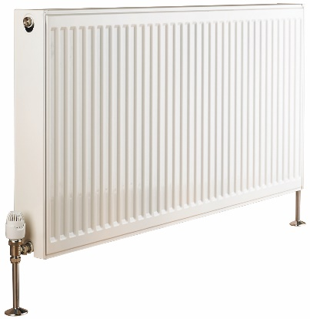

The Kudox Premium Radiators come complete with a 15 year manufacturer’s guarantee (T & Cs apply) plus, brackets, wall fixings and plug & vent are included. The radiators feature factory fitted side panels and top grilles. There is a free Drayton RT212 TRV and Lockshield (worth £21.99) with any Kudox steel panel radiator. Type 11 Single panel 600 x 1000mm costs just £37.79 and type 21 Double-Panel Plus 600 x 1000mm costs only £48.89 and Type 22 Double-Panel 600 x 1200mm costs just £61.99.

Erbauer Twin Pack
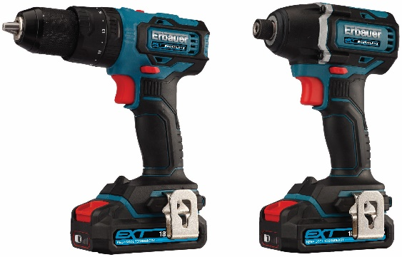

The Erbauer Brushless Twin Pack is supported by the innovative 18V Keep Cool Erbauer EXT battery technology. The 18V EXT battery platform gives tradespeople the freedom to share batteries and chargers across 14 different power tools and also boosts run time by 25% compared to non EXT batteries. The Erbauer power tools range also benefits from brushless motor technology, which delivers longer motor life, more power and up to 200% higher torque.

The twin pack features both an 18V Combi Drill and Impact Driver, along with two 18V 2Ah Li-Ion batteries and a one hour charger, making this a great value package for only £149.99.

Timberland Sawhorse Safety Boot
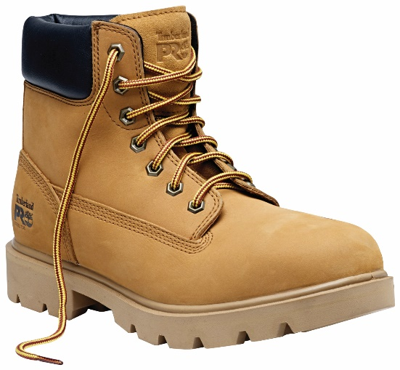

The ‘Trade Rated’ Timberland Sawhorse Safety Boot is known for its durability and comfort. A 200J steel toe cap, penetration resistant insert for underfoot protection and an oiled leather upper combine to create a strong safety boot suited to all situations. Now available with a 20% saving, the Sawhorse Safety boot comes in a variety of sizes, costing £54.99.

ENDS
Note to editors
About Screwfix:
Screwfix is part of Kingfisher plc, the international home improvement company, with 1,302 stores in 10 countries in Europe, Russia and Turkey. For further information go to www.kingfisher.com.
Screwfix is convenient, straightforward and affordably-priced, helping its trade customers get the job done quickly, affordably and right first time. Tradespeople can shop 33,000 products over the phone, online, via their mobile or in-person from their local store.
- From power tools and work wear to cables and pipe fittings, Screwfix offers over 11,000 products available to pick up from over 615 UK stores nationwide.
- Over 33,000 products can be ordered over the phone, online or from a local store, with orders taken up until 8pm (weekdays) for next day delivery to home or site.
- Screwfix.com attracts over 5 million visits per week.
- Store network is visited by 8m customers a year
- The Screwfix Click & Collect service which enables customers to pick-up their goods in as little as one minute after ordering online or over the phone, has already received more than 27 million orders.
- UK-based Screwfix Contact Centre open 24 hours a day, 7 days a week (including bank holidays) on 03330 112 112.
- See www.screwfix.com/stores for store opening information.
- Next day delivery is available within store opening hours.
- World leading customer satisfaction levels.
- Screwfix was awarded Glassdoor’s Best Places to Work in 2017 and 2018.
- Screwfix was awarded Retail Week’s ‘Best Retailer over £250m’ and ‘Digital Pioneer’ awards in 2018
- For more information about Screwfix please visit our media centre: www.screwfixmedia.co.uk

PRESS information:
For more information, please contact:
Matthew Allen, McCann Public Relations, Tel: 0121 713 3579 / Matthew.thomas-allen@Mccann.com

