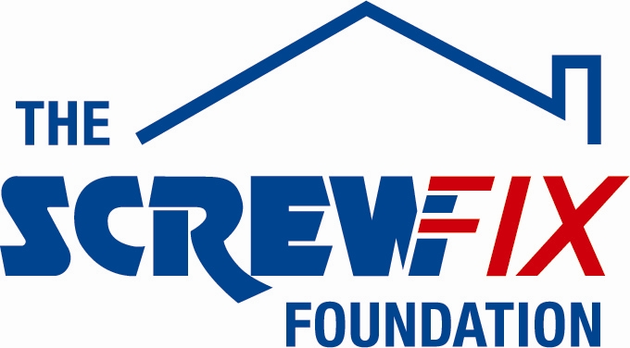
February 2019

FAIR FROME GETS A HELPING HAND FROM THE SCREWFIX FOUNDATION

Fair Frome based in Frome, is celebrating after being awarded £5000 worth of funding from The Screwfix Foundation, a charity which supports projects to fix, repair, maintain and improve properties and facilities for those in need.

Wendy Miller-Williams from Fair Frome comments: “We are very grateful to The Screwfix Foundation for donating these much-needed funds to support our charity. Fair Frome runs the town’s food and furniture banks and other projects aimed at alleviating hardship during crisis. They also champion greater financial, educational, social and health equality for people living in Frome and the surrounding area. The funding will be used for updating tenants’ accommodation, wire cookers for clients & help with repairs to appliances/ furniture items and to improve flooring. We’d like to thank everyone who was involved in the fundraising – it’s been a great help to us.”

Oliver Davis Store Manager of the Frome Screwfix store, comments: “We’re really pleased that one of our local charities has been awarded funding by The Screwfix Foundation. Staff from across the business have held a variety of fundraising events to raise vital funds for The Screwfix Foundation, so it’s fantastic to see the money we have raised being invested back into such a worthwhile community project.”

The Screwfix Foundation, which launched in April 2013 donates much needed funding to help a variety of local projects throughout the UK, from repairing buildings and improving community facilities, to improving the homes of people living with sickness or disability.

It also works closely with two national charity partners, Barnardo’s children’s charity and Macmillan Cancer Support, as well as supporting smaller, local registered charities like Fair Frome.

Relevant projects from across Somerset are invited to apply online for a share of the funding at screwfixfoundation.com.

For more information about The Screwfix Foundation, visit screwfixfoundation.com.
Picture Caption LtoR – Oliver Davis, Wendy Miller-Williams Co-ordinator, Fair Frome and Mark Dorrington Fair Frome Trustee.

-ENDS-
Note to editors
About The Screwfix Foundation:
The Screwfix Foundation is a charity set up by Screwfix in April 2013. We have a clear purpose of raising funds to support projects that will fix, repair, maintain and improve properties and community facilities specifically for those in need in the UK.
The Screwfix Foundation raises funds throughout the year to support causes that will change people’s lives. Working with both national and local charities, The Screwfix Foundation donates much needed funding to help all sorts of projects, from repairing buildings and improving community facilities, to improving the homes of people living with sickness or disability.

PRESS information:
For more information, please contact:
The Screwfix Foundation,
E: Foundation@screwfix.com

