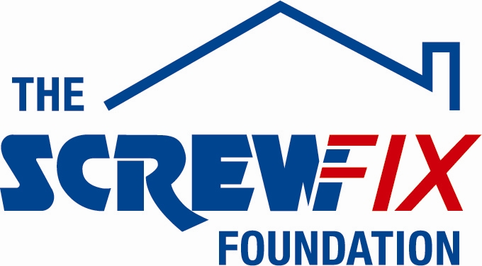
6th December 2018

FAIR SHARES GLOUCESTER GETS A HELPING HAND FROM THE SCREWFIX FOUNDATION

Fair Shares in Gloucester is celebrating after being awarded £4,133 worth of funding from The Screwfix Foundation, a charity which supports projects to fix, repair, maintain and improve properties and facilities for those in need.

XXXXX Name and position/roleSue Martin, Chief Executive from Fair Shares charity comments: “We are very grateful to The Screwfix Foundation for donating these much-needed funds to support our charity. WHAT YOU DO/services HERE
The funding was used to xxxxxxxx
We’d like to thank everyone who was involved in the fundraising – it’s been a great help to us.”

Vincent Lee, Store Manager of the Gloucester Screwfix store, comments: “We’re really pleased that one of our local charities has been awarded funding by The Screwfix Foundation. Staff from across the business have held a variety of fundraising events to raise vital funds for The Screwfix Foundation, so it’s fantastic to see the money we have raised being invested back into such a worthwhile community project.”

The Screwfix Foundation, which celebrates its fifth birthday this year, donates much needed funding to help a variety of local projects throughout the UK, from repairing buildings and improving community facilities, to improving the homes of people living with sickness or disability.

It also works closely with two national charity partners, Barnardo’s children’s charity and Macmillan Cancer Support, as well as supporting smaller, local registered charities like Fair Shares

Relevant projects from across Gloucester are invited to apply online for a share of the funding at screwfixfoundation.com.

For more information about The Screwfix Foundation, visit screwfixfoundation.com.
Picture Caption;- Left to right, xxxxxxxxxxxxxxxxxxxxxxxxxxxxxxxxxxxxxxxxxxxxxxxxxxxx
-ENDS-
Note to editors
About The Screwfix Foundation:
The Screwfix Foundation is a charity set up by Screwfix in April 2013. We have a clear purpose of raising funds to support projects that will fix, repair, maintain and improve properties and community facilities specifically for those in need in the UK.
The Screwfix Foundation raises funds throughout the year to support causes that will change people’s lives. Working with both national and local charities, The Screwfix Foundation donates much needed funding to help all sorts of projects, from repairing buildings and improving community facilities, to improving the homes of people living with sickness or disability.

PRESS information:
For more information, please contact:
The Screwfix Foundation,
E: Foundation@screwfix.com

