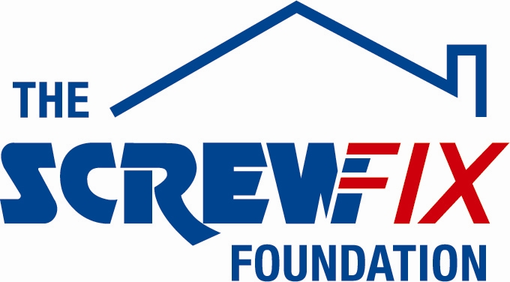

November 2020

FORGET ME NOT CHILDREN’S HOSPICE GETS A HELPING HAND FROM THE SCREWFIX FOUNDATION

Forget Me Not Children's Hospice Charity, based in Huddersfield, is celebrating after being awarded £5,000 worth of funding from The Screwfix Foundation, a charity which supports projects to fix, repair, maintain and improve properties and facilities for those in need.

Debs Davies from Forget Me Not Children's Hospice comments: “We are very grateful to The Screwfix Foundation for donating these much-needed funds to support our charity. We offer support to mums and dads to be, babies and children with life-limiting conditions and their families across our region. We have supported over 500 families since opening our hospice; this includes families caring for a child with a life-limiting condition and bereaved families. Over the past year we have cared for over 170 children and their families through our Hospice at Home service, day care, planned short breaks, 24/7 residential provision, and end-of-life care in our hospice (Russell House, Huddersfield). Families also have access to bereavement and sibling support. The much-needed funding will be used towards our much needed refurbishment before our 10th Anniversary. We’d like to thank everyone at Screwfix who was involved in the fundraising – you are amazing.”

Steve Dunston, Screwfix Foundation Trustee said: “Supporting charities such as Forget Me Not Children's Hospice with much-needed funding to help fix, repair, maintain and improve their facilities is vital. It’s great to see this donation go toward such an important project that benefits those in need.”

The Screwfix Foundation, which launched in April 2013 donates much needed funding to help a variety of local projects throughout the UK, from repairing buildings and improving community facilities, to improving the homes of people living with sickness or disability.

It also works closely with Macmillan Cancer Support, as well as supporting smaller, local registered charities like Forget Me Not Children's Hospice.

Relevant projects from across West Yorkshire are invited to apply online for a share of the funding at screwfixfoundation.com.

For more information about The Screwfix Foundation, visit screwfixfoundation.com.

-ENDS-
Note to editors
About The Screwfix Foundation:
The Screwfix Foundation is a charity set up by Screwfix in April 2013. We have a clear purpose of raising funds to support projects that will fix, repair, maintain and improve properties and community facilities specifically for those in need in the UK.
The Screwfix Foundation raises funds throughout the year to support causes that will change people’s lives. Working with both national and local charities, The Screwfix Foundation donates much needed funding to help all sorts of projects, from repairing buildings and improving community facilities, to improving the homes of people living with sickness or disability.

PRESS information:
For more information, please contact:
The Screwfix Foundation,
E: Foundation@screwfix.com

