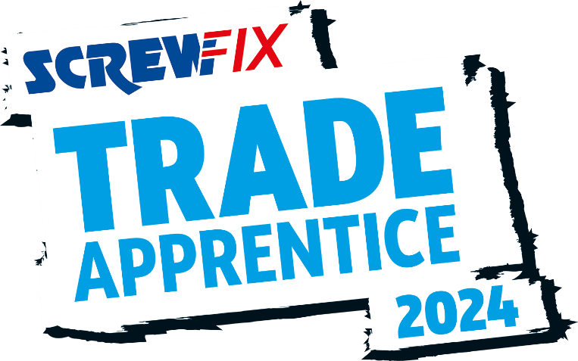

15 April 2024
FUTURE JOINER FROM DEVIZES IS A SCREWFIX TRADE APPRENTICE FINALIST!
- Alice Nerger-Jones, an apprentice joiner from Devizes, is in the running to be named the Screwfix Trade Apprentice 2024.
- Just ten have made it to the final, to be held in London in May
- One apprentice will be named the winner and receive a career-boosting trade bundle worth £10,000.
Alice Nerger-Jones, an aspiring joiner from Devizes, has secured her place in the final of the coveted Screwfix Trade Apprentice award.
From over 1,800 initial applications, just ten apprentices have made the grade and are heading to the two-day event in London next month.
As well as competing for this prestigious award, which aims to highlight the hard work and dedication of trade apprentices across the UK and Ireland, Alice, 24, is focused on becoming a professional joiner. Currently studying Joinery at Wiltshire College in Chippenham, she hopes to impress a judging panel of industry experts for a chance to be named the winner at the event on 3rd May.
Alice was shortlisted for demonstrating her passion, dedication and future ambition for setting up her own business employing apprentices, which shone through during the semi-finals.
Alice is also the only female apprentice studying joinery at her college, and the first female employee at Forest To Home where she currently works. She found her passion for joinery during the Covid-19 pandemic when she completed a van conversion which helped her develop her skills.
She said: “I can’t believe that I’ve made it to the last stage of Screwfix Trade Apprentice 2024! I’m so glad that my skills, dedication, and achievements have secured me a place in the national final.
“I’m very proud to be representing the hard work and dedication of all trade apprentices and I’m looking forward to showcasing my passion in front of the judges. I think it’s important that apprentices make sustainability a priority, to secure the future of the trade and ensure it is making a contribution to protecting the climate. I’m incredibly passionate about reducing waste and sourcing materials from sustainable businesses.
“To be crowned the winner would be a huge personal achievement and a highlight of my career. I would absolutely love to be an ambassador for young people, particularly women, who are considering a career in the trade.”
The Screwfix Trade Apprentice 2024 champion will receive a career boosting trade bundle of tools, tech and training worth £10,000. This, alongside the coveted Screwfix Trade Apprentice title, is everything an apprentice needs to excel within their chosen career.
This year’s judging panel includes representatives from the Chartered Institute of Plumbing and Heating Engineering, the Federation of Master Builders, the National Inspection Council of Electrical Installation Contracting along with Screwfix Top Tradesperson 2023 winner, Astrid Arnold.
Jack Wallace, Marketing Director at Screwfix says: “As always, we have been blown away with the calibre of entries, and every one of the finalists have an incredible work ethic. It is no easy feat to make the final of this competition all whilst maintaining their study and work commitments. They should be extremely proud of making it this far.
“It has never been more important to acknowledge the fantastic work of the nation’s trade apprentices. As the industry skills gap continues to grow, highlighting the most rewarding and fulfilling aspects of the trade is vital to attracting new talent.
“Our previous winners have gone on to be trailblazers in their respective trades. I wish our 2024 finalists the best of luck and I’m sure they too will achieve great things.”
To find out more about the Screwfix Trade Apprentice award, please visit www.screwfix.com/landingpage/tradeapprentice

-ends-

About Screwfix:

With over 900 stores across the UK, Ireland and France, and an extensive product range of over 57,000 products, Screwfix is convenient, straightforward, and affordably priced, helping busy tradespeople get their jobs done quickly, affordably, and right first time.

Screwfix is part of Kingfisher plc, the international home improvement company with more than 2000 stores, supported by a team of over 80,000 colleagues.

From power tools and work wear to cables and pipe fittings, Screwfix offers over 10,000 products available to pick up from over 880 conveniently located stores across the UK.

- Over 57,000 products can be ordered over the phone, online, app or from a local store, with orders taken up until 8pm (weekdays) for next day delivery to home or site.
- Unbeatable value at Screwfix is prices, quality and convenience you can trust - helping tradespeople to get what they need, when they need it. Screwfix is committed to meeting the need of its customers.
- The Screwfix Click & Collect service enables customers to pick-up their goods in as little as one minute after ordering online or over the phone
- Screwfix Sprint enables customers to order to home or site in 60 minutes or less. Available exclusively through the Screwfix App on more than 9500 products.
- Screwfix is committed to minimising its environmental impact to help create a better future for its customers, colleagues, communities, and the planet. Our ambition is to offer sustainable choices and source products that are made to last. At Screwfix, we believe if a job’s worth doing, it’s worth doing well.
- Screwfix.com and the Screwfix app attract over 7 million visits per week.
- We have over 11 million active customers a year.
- For more information visit screwfix.com screwfix.ie, screwfix.fr or Screwfix.eu
- Screwfix Sprint awarded ‘Best Innovation in Delivery’ at the eCommerce Awards 2023 and ‘Best Customer Experience’ at the Retail Week Awards 2022.
- RAD 2022, Best Employer Website
- Screwfix awarded for ‘Reducing Emission in Transport and Logistics’ at the BRC’s Climate Action Roadmap Showcase 2023 and recognised in 2022 for ‘Driving towards net zero properties’.

Press Information:
Please visit the Screwfix Media Centre: www.screwfixmedia.com
For press enquiries, please contact:
screwfix@mccann.com

