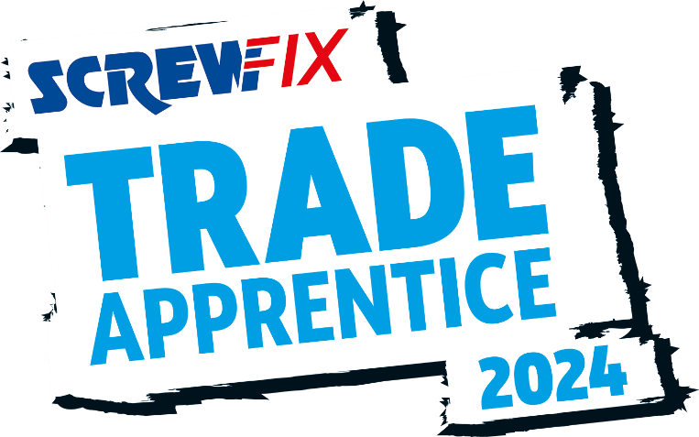

15 April 2024
FUTURE PAINTER AND DECORATOR FROM BOLTON IS A SCREWFIX TRADE APPRENTICE FINALIST!
- Lily Moore, an apprentice painter & decorator from Bolton, is in the running to be named the Screwfix Trade Apprentice 2024.
- Just ten finalists have made it to the final, to be held in London in May.
- One apprentice will be named the winner and receive a career-boosting trade bundle worth £10,000.
Lily Moore, an aspiring painter & decorator from Bolton, has secured her place in the final of the coveted Screwfix Trade Apprentice award.
From over 1,800 initial applications, just ten apprentices have made the grade and are heading to the two-day event in London next month.
As well as competing for this prestigious award, which aims to highlight the hard work and dedication of trade apprentices across the UK and Ireland, Lily, who is just 18 years old, is focused on becoming a professional painter & decorator. Currently studying Painting and Decorating at Bolton College, she hopes to impress a judging panel of industry experts for a chance to be named the winner at the event on 3rd May.
Lily was shortlisted for demonstrating her passion, dedication and ambition for her chosen trade, which shone through during the semi-finals. Lily is dedicated to completing her apprenticeship, and in the future, would like to start up her own business – having already envisioned what her brand will look like.
She said: “I can’t believe I have made it to this stage of Screwfix Trade Apprentice 2024! I’m so glad that my skills, dedication, and achievements have secured me a place in the national final.
“I love my trade and I’m really passionate about promoting painting and decorating as an attractive career for young people. I’ve built up a following on Instagram and TikTok where I enjoy sharing my latest projects.
“I’m very proud to be representing the hard work and dedication of all trade apprentices and I’m looking forward to showcasing my passion in front of the judges. To be crowned the winner would be a huge personal achievement and a highlight of my career.”
The Screwfix Trade Apprentice 2024 champion will receive a career boosting trade bundle of tools, tech and training worth £10,000. This, alongside the coveted Screwfix Trade Apprentice title, is everything an apprentice needs to excel within their chosen career.
This year’s judging panel includes representatives from the Chartered Institute of Plumbing and Heating Engineering, the Federation of Master Builders, the National Inspection Council of Electrical Installation Contracting along with Screwfix Top Tradesperson 2023 winner, Astrid Arnold.
Jack Wallace, Marketing Director at Screwfix says: “As always, we have been blown away with the calibre of entries, and every one of the finalists have an incredible work ethic. It is no easy feat to make the final of this competition all whilst maintaining their study and work commitments. They should be extremely proud of making it this far.
“It has never been more important to acknowledge the fantastic work of the nation’s trade apprentices. As the industry skills gap continues to grow, highlighting the most rewarding and fulfilling aspects of the trade is vital to attracting new talent.
“Our previous winners have gone on to be trailblazers in their respective trades. I wish our 2024 finalists the best of luck and I’m sure they too will achieve great things.”
To find out more about the Screwfix Trade Apprentice award, please visit www.screwfix.com/landingpage/tradeapprentice

-ends-

About Screwfix:

With over 900 stores across the UK, Ireland and France, and an extensive product range of over 57,000 products, Screwfix is convenient, straightforward, and affordably priced, helping busy tradespeople get their jobs done quickly, affordably, and right first time.

Screwfix is part of Kingfisher plc, the international home improvement company with more than 2000 stores, supported by a team of over 80,000 colleagues.

From power tools and work wear to cables and pipe fittings, Screwfix offers over 10,000 products available to pick up from over 880 conveniently located stores across the UK.

- Over 57,000 products can be ordered over the phone, online, app or from a local store, with orders taken up until 8pm (weekdays) for next day delivery to home or site.
- Unbeatable value at Screwfix is prices, quality and convenience you can trust - helping tradespeople to get what they need, when they need it. Screwfix is committed to meeting the need of its customers.
- The Screwfix Click & Collect service enables customers to pick-up their goods in as little as one minute after ordering online or over the phone
- Screwfix Sprint enables customers to order to home or site in 60 minutes or less. Available exclusively through the Screwfix App on more than 9500 products.
- Screwfix is committed to minimising its environmental impact to help create a better future for its customers, colleagues, communities, and the planet. Our ambition is to offer sustainable choices and source products that are made to last. At Screwfix, we believe if a job’s worth doing, it’s worth doing well.
- Screwfix.com and the Screwfix app attract over 7 million visits per week.
- We have over 11 million active customers a year.
- For more information visit screwfix.com screwfix.ie, screwfix.fr or Screwfix.eu
- Screwfix Sprint awarded ‘Best Innovation in Delivery’ at the eCommerce Awards 2023 and ‘Best Customer Experience’ at the Retail Week Awards 2022.
- RAD 2022, Best Employer Website
- Screwfix awarded for ‘Reducing Emission in Transport and Logistics’ at the BRC’s Climate Action Roadmap Showcase 2023 and recognised in 2022 for ‘Driving towards net zero properties’.

Press Information:
Please visit the Screwfix Media Centre: www.screwfixmedia.com
For press enquiries, please contact:
screwfix@mccann.com

