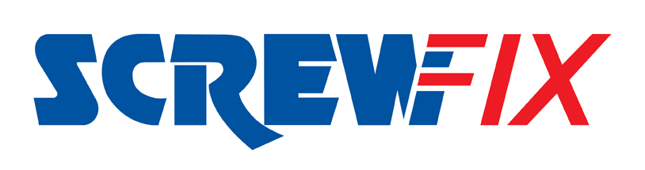

January 2017

Lancaster’s second Screwfix store to open in February

Multi-channel trade retailer Screwfix is to officially open its second store in Lancaster on Thursday 2nd February at Lake Enterprise Park. The new branch is building on the success at Lancaster store on White Lund Industrial Estate. The new Lancaster – Lake Enterprise Park store will create an additional 16 jobs and is part of the company’s ongoing expansion plans.

Screwfix’s new Lancaster – Lake Enterprise Park Store Manager, Dave Fisher is proud of the contribution the new store has made to local employment figures in the area. “We’ve created 16 brand new vacancies and have employed local people from around the Lancaster area. Our new team includes people of all ages and levels of experience, but the most important requirement is that they have the right attitude and can offer superb customer service. Everyone here is really looking forward to the store opening.”

Tradespeople and DIYers are all invited to attend the new Screwfix store opening at Lake Enterprise Park where they can also demonstrate their skills in a free-to-enter competition. The winner will receive a 40in smart TV.

Throughout the store’s launch celebration period from Thursday 2nd February and into the weekend until Sunday 5th February all product ranges within the Lancaster – Lake Enterprise Park store will carry a 10% discount and there will be product demonstrations taking place.

Dave believes that the store’s convenient location and the ability to provide a Click and Collect service in as little as one minute of ordering will be a real bonus to local tradespeople and DIY enthusiasts.

“I’m confident that we’ve got a great location here at the Lancaster – Lake Enterprise Park store. My team and I have already been out and about getting to know local businesses and tradesmen and we’ve been really pleased with how supportive everybody has been.

“At Screwfix we pride ourselves on meeting the needs of today’s busy tradesmen and DIY enthusiasts with a speedy, reliable and convenient service, plus quality value-for-money products. By opening a second store here in Lancaster we are able to provide our customers with even more opportunities to conveniently pick up the supplies they need for the job.”
The brand’s huge range of products and exceptional deals are also available online at www.screwfix.com, on Screwfix’s mobile site or over the phone on 03330 112 112.

Visit Screwfix’s Lancaster – Lake Enterprise Park store at Unit 32 & 33 Lake Enterprise Park, Lancaster, Lancashire, LA1 3NX or Lancaster’s first store at Unit 3 Northgate, White Lund Industrial Estate, Morcambe, Lancashire, LA3 3AY. Monday to Friday 7am-8pm, Saturday 7am-6pm and Sunday 10am-4pm.

-ENDS-

Note to editors
About Screwfix:
Screwfix is part of Kingfisher plc, the international home improvement company, with over 1,100 stores in 10 countries in Europe, Russia and Turkey. For further information go to www.kingfisher.com.
Screwfix is recognised as being “where the trade buys”, offering a straightforward and transparently-priced retail experience that enables busy trade customers to shop 27,000 products over the phone, online, via their mobile or from their local store.
- From power tools and work wear to cables and pipe fittings, more than 11,000 products are available to pick up from the national network of over 490 stores. A further range of over 16,000 products can be ordered over the phone, online or from a local store, with orders taken up until 7pm for next day delivery to home or site.
- Screwfix.com attracts 2.2 million unique visitors per week and the Screwfix Click & Collect service means customers can conveniently purchase supplies online (or over the phone) and then collect from store in as little as one minute.
- Customers can call the UK-based Screwfix Contact Centre 24 hours a day, 7 days a week (including bank holidays) on 03330 112 112.
- UK stores are open 7 days a week, from 7am – 8pm Weekdays, 7am – 6pm Saturdays and 10am – 4pm Sundays.
- 9 out of 10 customers would recommend Screwfix to a friend.
- Screwfix was voted the 5th highest rated UK company for work-life balance by Glassdoor Employees' Choice Awards 2016.
- Screwfix was publicly honoured as one of the Glassdoor Best Places
to Work 2017.

PRESS information:
For more information, please contact:
Screwfix Press Office
Tel: 01935 446706
E: Danielle.Sweet@screwfix.com

