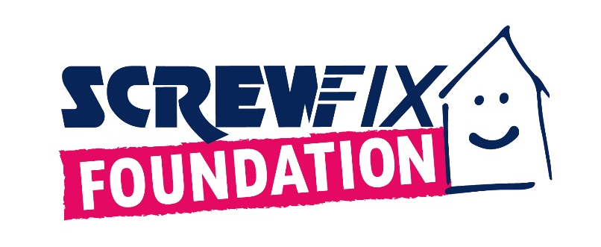
LEEDS BASED CHARITY, BATTLE SCARS, TO DEVELOP A NEW MENTAL HEALTH HUB WITH FUNDS FROM THE SCREWFIX FOUNDATION
- With a fund worth £5,000 from the Screwfix Foundation, Battle Scars is working on a new mental health hub to support people affected by self-harm.
- Due to an increase in demand, a safe, welcoming and accepting environment will be crucial to reinforce the sense of community amongst people working for Battle Scars and people using their services.
- Set up in 2013, The Screwfix Foundation has raised over £13m and helped over 2,600 local registered charities and not-for-profit-organisations in need across the UK.
Battle Scars, based in Leeds, is celebrating after receiving £5,000 worth of funding from the Screwfix Foundation, the charity which supports charities and not-for-profit organisations in need across the UK to fix, maintain and improve properties and facilities.
Battle Scars is 100% survivor-led and run and offers local, regional, and national support around self-harm. Their services include a variety of peer support options, including groups for family and friends of people who self-harm, training for professionals, awareness raising events, and support in schools.
The Screwfix Foundation decided to support Battle Scars to develop a new mental health hub in South Leeds, which will also be the first ever charity's premises. The support from the Screwfix Foundation will help Battle Scars to provide more well-being and mental health support.
The new hub will also contribute to face the increase in demand that the charity is facing. According to Battle Scars, more and more people in the area need support to face life’s pressures. To provide with timely help without waiting lists, the new hub will be crucial for staff and volunteers to assist anybody struggling in a welcoming, safe and accepting environment and reinforce the sense of community.
Jenny Groves, Founder and CEO of Battle Scars said: “Thank you Screwfix Foundation for the £5,000 grant! It will allow us to create the safe, welcoming spaces we need in the new Onward Mental Health Hub to support people of all ages and genders who are affected by self-harm.”
Claire Flory, Screwfix Foundation Manager said: “What Battle Scars does is vital for the local community. The much-needed funding used to create the new mental health hub will be key to help even more people affected by self-harm and their families. We are proud to see that our donation has gone towards such an important project, for the benefit of those in need”.
Set up in 2013 after recognising the need to give back, the Screwfix Foundation has donated over £13m for good causes and helped over 2,600 local registered charities and not for profit organisations across the UK.
Charities and not for profit organisations with relevant projects are invited to apply online for a share of the funding at screwfixfoundation.com.
To know more about fundraising events and charities helped, keep an eye on Facebook and Instagram.

- ENDS -
ABOUT THE SCREWFIX FOUNDATION:
Set up in 2013 after recognising the need to give back, the Screwfix Foundation is a grant-giving charity with the clear purpose to support local charities and not-for-profit organisations in need across the UK by fixing, maintaining, and improving community facilities and homes.
Thanks to the generosity of Screwfix customers and staff, the Screwfix Foundation raises money throughout the year with activities in store, charity champions’ missions, Foundation weeks and raffles.
Currently, the Screwfix Foundation offers local registered charities and not-for-profit organisations funding up to the region of £5,000. All applications are reviewed individually by the team in March, June, September, and December. Please, see here full eligibility criteria.
Local registered charities and registered not for profit organisations are welcome to apply for funding from The Screwfix Foundation by completing an application form available on www.screwfixfoundation.com.
In addition to supporting local communities in need, a proportion of the funds raised through The Screwfix Foundation are donated to its charity partner, Macmillan Cancer Support to their home improvement programme, which helps people suffering from cancer in financial need with minor home improvements.
- Since 2013, the Screwfix Foundation has helped over 2,600 local charities and not-for-profit organisations and raised over £13 million.
- to date, more than £700,000 has been donated to the Macmillan Grant Scheme which provides home improvements for those affected by cancer.
- Through Screwfix’s partnership with micro-donation charity Pennies, The Screwfix Foundation has received more than 34 million micro-donations from customers rounding up their online orders, raising over £5million for charity.
- People can see all the charities the Screwfix Foundation has supported here.

