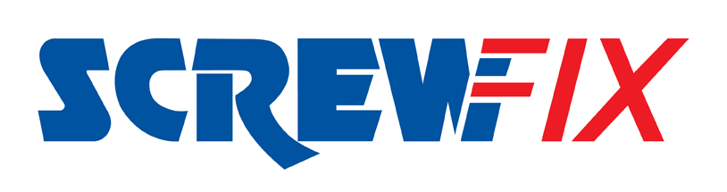

Feburary 2018

Leeds fourth Screwfix store to open in February

Omni-channel retailer Screwfix is to officially open its fourth store in Leeds on Thursday 22nd February at Roundhay Road. The new branch is building on the success of the Leeds – Holbeck, Leeds – Stourton and Leeds – Seacroft stores. The new Leeds - Sheepscar store will create an additional 13 jobs and is part of the company’s ongoing expansion plans.
Screwfix’s new Leeds - Sheepscar Store Manager, Paul Olley is proud of the contribution the new store has made to local employment figures in the area. “We’ve created 13 brand new vacancies and have employed local people from around the Leeds area. Our new team includes people of all ages and levels of experience, but the most important requirement is that they have the right attitude and can offer superb customer service. Everyone here is really looking forward to the store opening.”

Tradespeople and DIYers are all invited to attend the new Screwfix store opening at Roundhay Road, where they can also demonstrate their skills in a free-to-enter competition. The winner will receive a 40in smart TV.

Throughout the store’s launch celebration period from Thursday 22nd February and into the weekend until Sunday 25th February all product ranges within the Leeds – Sheepscar store will carry a 10% discount and there will be product demonstrations taking place.

Paul believes that the store’s convenient location and the ability to provide a Click and Collect service in as little as one minute of ordering will be a real bonus to local tradespeople and DIY enthusiasts.

“I’m confident that we’ve got a great location here at the Leeds - Sheepscar store. My team and I have already been out and about getting to know local businesses and tradesmen and we’ve been really pleased with how supportive everybody has been.

“At Screwfix we pride ourselves on meeting the needs of today’s busy tradesmen and DIY enthusiasts with a speedy, reliable and convenient service, plus quality value-for-money products. By opening a fourth store here in Leeds we are able to provide our customers with even more opportunities to conveniently pick up the supplies they need for the job.”
The brand’s huge range of products and exceptional deals are also available online at www.screwfix.com, on Screwfix’s mobile site or over the phone on 03330 112 112.

Visit Screwfix’s New Leeds – Sheepscar Store at: Roundhay Road, LS7 3BG. Monday to Friday 7am-8pm, Saturday 7am-6pm and Sunday 9am-4pm.

-ENDS-

Note to editors
About Screwfix:
Screwfix is part of Kingfisher plc, the international home improvement company, with nearly 1,200 stores in 10 countries in Europe, Russia and Turkey. For further information go to www.kingfisher.com.
Screwfix is convenient, straightforward and affordably-priced, helping its trade customers get the job done quickly, affordably and right first time. Tradespeople can shop 29,000 products over the phone, online, via their mobile or in-person from their local store.
- From power tools and work wear to cables and pipe fittings, Screwfix offers over 11,000 products available for pick up from over 550 stores nationwide. Our full range of over 29,000 products can be ordered over the phone, online or from a local store, with orders taken up until 8pm (weekdays) for next day delivery to home or site.
- Screwfix.com attracts 2.6 million unique visitors per week.
- The Screwfix Click & Collect service means customers can conveniently purchase supplies online or over the phone and then collect from the store in as little as one minute.
- Customers can call the UK-based Screwfix Contact Centre 24 hours a day, 7 days a week (including bank holidays) on 03330 112 112.
- UK stores are open 7 days a week, from 7am – 8pm Weekdays, 7am – 6pm Saturdays and 9am – 4pm Sundays. Excludes selected stores. See www.screwfix.com/stores for details.
- 9 out of 10 customers would recommend Screwfix to a friend.
- Screwfix was voted the 5th highest rated UK company for work-life balance by Glassdoor Employees' Choice Awards in 2016.
- Screwfix was awarded Glassdoor’s Best Places to Work in 2017 and 2018.
- Screwfix was awarded Retail Week’s Customer Experience Initiative in 2017.
- In 2016, Screwfix sales surpassed £1bn for the first time.
- Screwfix was awarded 2nd place in Retail Week’s Best Employer Rankings in 2017.
- Screwfix was awarded South West Contact Centre Forum’s Large Contact Centre of the Year Award in 2017.
- For more information about Screwfix please visit our media centre: www.screwfixmedia.co.uk

PRESS information:
For more information, please contact:
Screwfix Press Office
Tel: 01935 446706
E: Danielle.Sweet@screwfix.com

