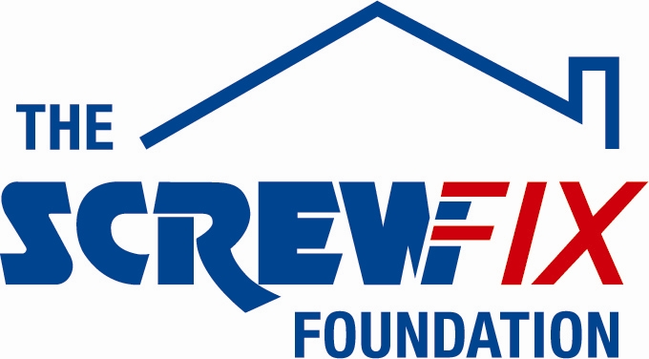

20th July 2018

LOWLANDS FARM RDA GETS A HELPING HAND FROM THE SCREWFIX FOUNDATION

Lowlands Farm RDA near Warwick, is celebrating after being awarded £5,000 worth of funding from The Screwfix Foundation, a charity which supports projects to fix, repair, maintain and improve properties and facilities for those in need.

David Elliston, Chairman of Lowlands Farm RDA, comments: “We are incredibly grateful to The Screwfix Foundation for awarding this large grant to Lowlands Farm RDA, and to the staff from Screwfix who have worked so hard to raise the funds. Lowlands Farm RDA works with both children and adults, many of whom have extremely limited mobility. With this funding now in place, we can now make firm plans to buy a much-needed hoist to assist riders in mounting our mechanical horse, Charley - opening up the benefits of riding to more people than ever before. This will have such a positive impact on our group!”

Adrian Witten, Store Manager of the Leamington Spa Screwfix store, comments: “We’re really pleased that one of our local charities has been awarded funding by The Screwfix Foundation. Staff from across the business have held a variety of fundraising events to raise vital funds for The Screwfix Foundation, so it’s fantastic to see the money we have raised being invested back into such a worthwhile community project.”

The Screwfix Foundation, which launched in April 2013 donates much needed funding to help a variety of local projects throughout the UK, from repairing buildings and improving community facilities, to improving the homes of people living with sickness or disability.

It also works closely with two national charity partners, Barnardo’s children’s charity and Macmillan Cancer Support, as well as supporting smaller, local registered charities like United Response

Relevant projects from across Warwickshire are invited to apply online for a share of the funding at screwfixfoundation.com.

For more information about The Screwfix Foundation, visit screwfixfoundation.com.

Pictured are Screwfixs' Adrian Witten, David Elliston (Group Chairman), Julie Elliston (Trustee), David Ivens (Trustee and Fundraising Manager) with Henry the pony

-ENDS-
Note to editors
About The Screwfix Foundation:
The Screwfix Foundation is a charity set up by Screwfix in April 2013. We have a clear purpose of raising funds to support projects that will fix, repair, maintain and improve properties and community facilities specifically for those in need in the UK.
The Screwfix Foundation raises funds throughout the year to support causes that will change people’s lives. Working with both national and local charities, The Screwfix Foundation donates much needed funding to help all sorts of projects, from repairing buildings and improving community facilities, to improving the homes of people living with sickness or disability.

PRESS information:
For more information, please contact:
The Screwfix Foundation,
E: Foundation@screwfix.com

