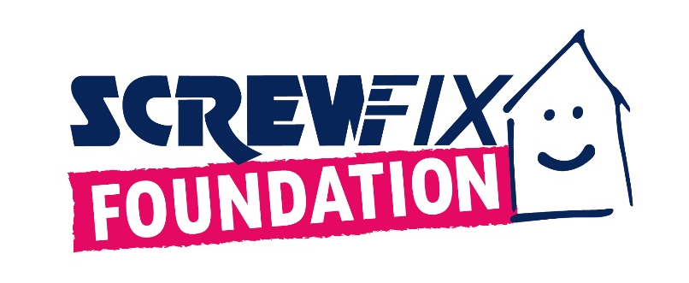
Luton based charity, Caraline, to welcome more people with funds from the Screwfix Foundation
- With a fund worth £5,000 from the Screwfix Foundation, Caraline aims to refurbish the entrance area and the waiting room.
- Due to an increase in demand, a warm and inviting environment will be crucial to make people who live with eating disorders feel safe and relaxed.
- Set up in 2013, The Screwfix Foundation has raised over £13m and helped over 2,600 local registered charities and not-for-profit-organisations in need across the UK.
Caraline, based in Luton, is celebrating after receiving £5,000 worth of funding from the Screwfix Foundation, the charity which supports not-for-profit organisations and charities in need across the UK to fix, maintain and improve properties and facilities.
Since 1994, Caraline is committed to providing therapeutic support to individuals who live with eating disorders and their families and loved ones. Started as a helpline in memory of Caraline in the front room of her home using her own home telephone number, the charity now has a team of therapists and support staff, working closely with schools, universities and places of work.
The Screwfix Foundation decided to support Caraline to refurbish the entrance area and the waiting room to make people more comfortable and feel safe in a warm environment.
The project comes from a considerable rise in demand for Caraline’s services, with impact on their waiting lists.
Kelly Voller, Practice Manager at Caraline, said: “Our waiting area and entrance are very outdated, and with poor lighting. The carpets are the original from when we moved into the building in 1999! Clients are often anxious when coming to visit Caraline for support, so it will be lovely for them to walk into a warm, inviting space where they can feel relaxed and safe. Not only this, for staff who spend much time here, it will just be wonderful for them to work in a modern environment.”
Claire Flory, Screwfix Foundation Manager said: “What Caraline does is vital for the local community. The much-needed funding used to refurbish the entrance and the waiting room the new will be key to help even more people who live with eating disorders and their families. We are proud to see that our donation has gone towards such an important project, for the benefit of those in need”.
Set up in 2013 after recognising the need to give back, the Screwfix Foundation has donated over £13m for good causes and helped over 2,600 local registered charities and not for profit organisations across the UK.
Charities and not for profit organisations with relevant projects are invited to apply online for a share of the funding at screwfixfoundation.com.
To know more about fundraising events and charities helped, keep an eye on Facebook and Instagram.

- ENDS -
ABOUT THE SCREWFIX FOUNDATION:
Set up in 2013 after recognising the need to give back, the Screwfix Foundation is a grant-giving charity with the clear purpose to support local charities and not-for-profit organisations in need across the UK by fixing, maintaining, and improving community facilities and homes.
Thanks to the generosity of Screwfix customers and staff, the Screwfix Foundation raises money throughout the year with activities in store, charity champions’ missions, Foundation weeks and raffles.
Currently, the Screwfix Foundation offers local registered charities and not-for-profit organisations funding up to the region of £5,000. All applications are reviewed individually by the team in March, June, September, and December. Please, see here full eligibility criteria.
Local registered charities and registered not for profit organisations are welcome to apply for funding from The Screwfix Foundation by completing an application form available on www.screwfixfoundation.com.
In addition to supporting local communities in need, a proportion of the funds raised through The Screwfix Foundation are donated to its charity partner, Macmillan Cancer Support to their home improvement programme, which helps people suffering from cancer in financial need with minor home improvements.
- Since 2013, the Screwfix Foundation has helped over 2,600 local charities and not-for-profit organisations and raised over £13 million.
- to date, more than £700,000 has been donated to the Macmillan Grant Scheme which provides home improvements for those affected by cancer.
- Through Screwfix’s partnership with micro-donation charity Pennies, The Screwfix Foundation has received more than 34 million micro-donations from customers rounding up their online orders, raising over £5million for charity.
- People can see all the charities the Screwfix Foundation has supported here.

