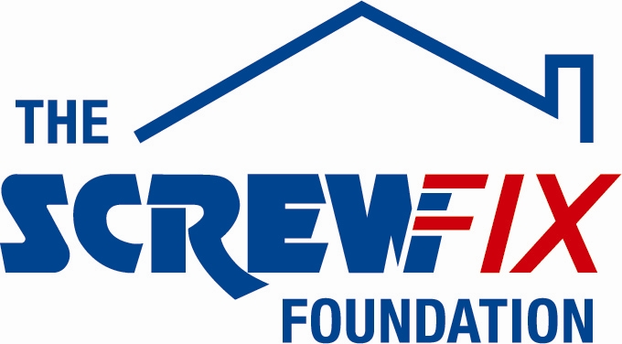

July 2017

NORTH SHIELDS BASED CHARITY GETS A HELPING HAND FROM THE SCREWFIX FOUNDATION

Meadow Well Connected based in North Shields, is celebrating after being awarded £3,000 worth of funding from The Screwfix Foundation, a charity which supports projects to fix, repair, maintain and improve properties and facilities for those in need.

Mandi Cresswell from Meadow Well Connected comments: “We are very grateful to The Screwfix Foundation for donating these much-needed funds to support our charity. Meadow Well Connected is a community hub serving the two highest areas of deprivation in North Tyneside and in the top 5% in England. For 20 years, we have supported more than 250,000 people with a wide range of issues and needs. Most recently, our focus has been on helping those furthest from the labour market; in dependent care situations; and young people experiencing difficulty in education and life in general, to be more independent. The funding will be used towards the cost of redecorating the community café, renewing the furniture which was old and broken to make a more modern and pleasant environment. We’d like to thank everyone who was involved in the fundraising – it’s been a great help to us.”

Simon Rogers, Store Manager of the Screwfix store in North Shields comments: “We’re really pleased that one of our local charities has been awarded funding by The Screwfix Foundation. Staff from across the business have held a variety of fundraising events to raise vital funds for The Screwfix Foundation, so it’s fantastic to see the money we have raised being invested back into such a worthwhile community project.”

The Screwfix Foundation, which launched in April 2013 donates much needed funding to help a variety of local projects throughout the UK, from repairing buildings and improving community facilities, to improving the homes of people living with sickness or disability.

It also works closely with two national charity partners, Barnardo’s children’s charity and Macmillan Cancer Support, as well as supporting smaller, local registered charities like Meadow Well Connected.

Relevant projects from across North Shields are invited to apply online for a share of the funding at screwfixfoundation.com.

For more information about The Screwfix Foundation, visit screwfixfoundation.com.

-ENDS-
Note to editors
About The Screwfix Foundation:
The Screwfix Foundation is a charity set up by Screwfix in April 2013. We have a clear purpose of raising funds to support projects that will fix, repair, maintain and improve properties and community facilities specifically for those in need in the UK.
The Screwfix Foundation raises funds throughout the year to support causes that will change people’s lives. Working with both national and local charities, The Screwfix Foundation donates much needed funding to help all sorts of projects, from repairing buildings and improving community facilities, to improving the homes of people living with sickness or disability.

PRESS information:
For more information, please contact:
The Screwfix Foundation,
E: Foundation@screwfix.com

