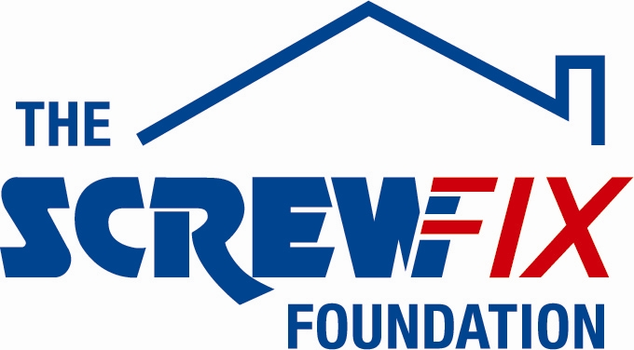
15th March 2019

me&dee CHARITY GETS A HELPING HAND FROM THE SCREWFIX FOUNDATION

me&dee, a charity based in Derby, is celebrating after being awarded £618 worth of funding from The Screwfix Foundation, a charity which supports projects to fix, repair, maintain and improve properties and facilities for those in need.

Maria Hanson from me&dee comments: “We are very grateful to The Screwfix Foundation for donating these much-needed funds to support our charity. Our charity provides a sea side holiday free of charge, including a private sea front beach hut, for families facing very short and uncertain futures together to make memories when their time is short and precious. The funding will be used towards an extended decking area on the back of the caravan, which enjoys beautiful panoramic views, with access for wheelchairs and medical equipment. We’d like to thank everyone who was involved in the fundraising – it’s been a great help to us.”

William Taylor, Store Manager of the Derby Screwfix store, comments: “We’re really pleased that one of our local charities has been awarded funding by The Screwfix Foundation. Staff from across the business have held a variety of fundraising events to raise vital funds for The Screwfix Foundation, so it’s fantastic to see the money we have raised being invested back into such a worthwhile community project.”

The Screwfix Foundation, which launched in April 2013 donates much needed funding to help a variety of local projects throughout the UK, from repairing buildings and improving community facilities, to improving the homes of people living with sickness or disability.

It also works closely with two national charity partners, Barnardo’s children’s charity and Macmillan Cancer Support, as well as supporting smaller, local registered charities like me&dee

Relevant projects from across Derbyshire are invited to apply online for a share of the funding at screwfixfoundation.com.

For more information about The Screwfix Foundation, visit screwfixfoundation.com.
Picture Caption L to R- Screwfix Store manager Will Taylor from the Derby – Ascot Drive Store Presents the cheque to maria hanson , with Rick Mallin on the right

-ENDS-
Note to editors
About The Screwfix Foundation:
The Screwfix Foundation is a charity set up by Screwfix in April 2013. We have a clear purpose of raising funds to support projects that will fix, repair, maintain and improve properties and community facilities specifically for those in need in the UK.
The Screwfix Foundation raises funds throughout the year to support causes that will change people’s lives. Working with both national and local charities, The Screwfix Foundation donates much needed funding to help all sorts of projects, from repairing buildings and improving community facilities, to improving the homes of people living with sickness or disability.
About HarmonI

HarmonI is celebrating 140 years of compassionate support and care to people living with a disability or disadvantage. The charity has been based at Stricklands Glen Bangor for over 120 of those years delivering services as diverse as an infirmary to service personnel returning from the second Boer war to a residential school for children living with the affects of Polio to a Nursing Home provision. Today it delivers support and care in 25 apartments on the Bangor site and also continues after 140 years to deliver homeless services at the Belfast Hostel for 59 men each night.

PRESS information:
For more information, please contact:
The Screwfix Foundation,
E: Foundation@screwfix.com

