PRESS RELEASE FOR ISSUE TO: | Trade and DIY media
WITH/WITHOUT PHOTOGRAPH: | With product images
FOR ISSUE ON: | 4 September
FOR APPROVAL BY: | KM/GS
DEADLINE FOR APPROVAL: | 4 September

EXCLUSIVE INNOVATIONS FOR THE NEW SEASON AVAILABLE FROM SCREWFIX
New catalogue features best ever product range, exclusives and deals!

With the summer drawing to a close and the longer nights setting in, the heating and lighting season is now upon us. Not only is leading trade omnichannel retailer, Screwfix opening a new store at the rate of one per week to help the trade in gearing up for the busiest season, but tradespeople and serious DIYers can also now stock up on its biggest and best range of new and innovative products in its much-anticipated catalogue.

Full of tools, workwear and essentials, the latest catalogue features industry-leading brands and trade favourites from the likes of DeWalt, Bosch and Titan, just in time for the cooler months.

Graham Smith, Marketing Director, at Screwfix, commented: “We understand how important it is that tradespeople are well-equipped for the demanding season ahead, so they can make the most of the business opportunities it offers. That’s why our new catalogue is our best yet, perfect for tradespeople looking to stock up, and with over 530 stores, 24/7 contact centre and Click & Collect in as little as one minute, they can do so quickly so they are back on site as soon as possible.”

The new catalogue is available to collect for free from all 530 Screwfix stores nationwide and features on the Screwfix App, which is available to download in the ‘App Store’.

Exclusive DeWalt 18v Brushless Combi Drill

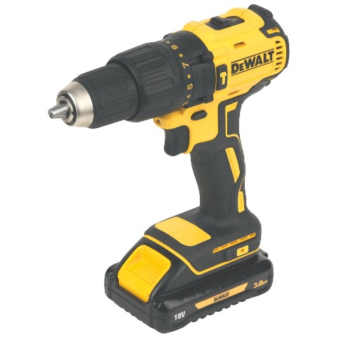
This season’s must-have power drill is the brand new 18v Brushless Combi Drill from DeWalt available only at Screwfix. This state-of-the-art power tool is intended for tradespeople looking to do some serious work on the toughest tasks. Compact and lightweight and built for comfort with a soft grip handle, it not only provides maximum control for precise drilling, but enables tradespeople to ta ke on more tasks with ease. Accompanied with two 3.0 Ah Li-lon batteries, charger and a convenient TSTAK kit box for easy transportation, this DeWalt Brushless Combi Drill is a definite must-have for all tradespeople and will help with all tasks this season and the next. Costing £149.99, it comes with a three year manufacturer’s guarantee and is available exclusively at Screwfix.

Long lasting LAP LED multi-packs
As the industry demands more efficient lighting solutions, many are turning to LEDs to help save on energy bills. LED lights represent great value as well as being beneficial to the environment. To maximise value, the new catalogue offers its biggest and best ever range of LAP LED multi-packs. Featuring bulbs that last up to an impressive 25,000 hours, the new multi-packs will provide long lasting peace of mind. Included in the new range and available at £9.99 for a pack of five, the dimmable GLS multi-pack resourcefully uses energy, resulting in brighter and cooler bulbs. Built with epoxy lenses instead of glass, the LED bulbs are also more resistant to breakage.

Exclusive DeWalt workwear
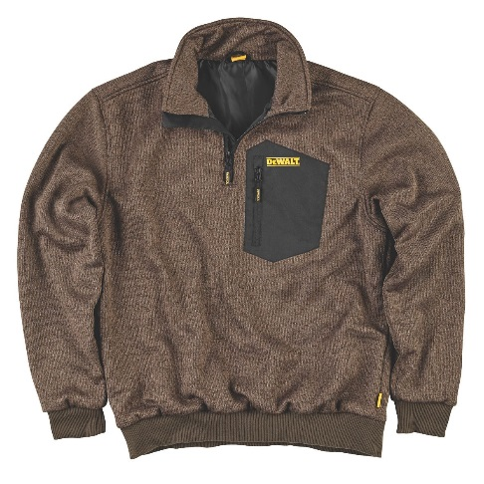
Constructed with the needs of the trade in mind, DeWalt Workwear is hard wearing, practical and comfortable. The new catalogue features an exclusive range of workwear and footwear from DeWalt. One product is the new Brunswick Knitted Jumper with a windproof lining. Ideally suited for transitional months, the Brunswick will keep the tradespeople warm whilst working outside this Autumn. This stylish & practical jumper looks the part and is available for £36.99.
Also included in the exclusive range are the DeWalt Hydrogen Safety Boots, which combine quality, comfort and safety. They have a 200J Steel toe cap, are designed with a nubuck leather upper and have a padded collar and tongue. This means they look fantastic, are comfortable and hardwearing whilst also protecting feet. The DeWalt Hydrogen Safety Boots are priced at £49.99.

DeWalt DCM575 XR FlexVolt Chainsaw

This high-efficiency 54V brushless motor chainsaw with 65 cuts per charge* is a new innovative power tool that makes heavy duty tasks easy. With its variable speed trigger and 40cm Oregon bar and chain, the DCM575 XR FlexVolt Chainsaw from DeWalt delivers maximum performance and impressive precision with ease and control. Designed with an automatic oiling feature and a chain brake to stop from rotating around the bar, it is safe and long-lasting. Including batteries and a charger, this top-of-the-range chainsaw is available at £529.99.
*may vary depending on the size of log

Chint Consumer Units
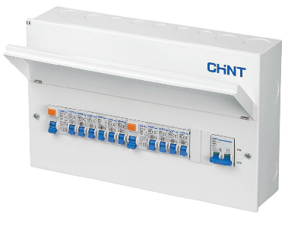
Chint specialise in domestic and commercial circuit protection in the UK market, manufacturing products that are both easy to install and easy to use. The NX3 range of consumer units are designed to comply with the latest regulations and are fully Amendment 3 compliant. Built with quality and reliability in mind, the entirety of the range is tested and approved to those standards by independent third parties. Shower Units available from £29.99 and populated boards available from £74.99.

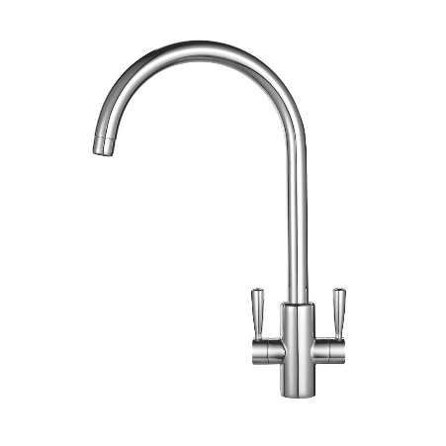
‘Trade Rated’ Taps

‘Trade Rated’, which means they have been given independent approval by tradespeople, and super stylish, this Franke Ascona Mono Mixer is designed with a long curved spout ideal for any contemporary kitchen. With a built-in aerator to achieve a seamless Champagne-like flow, the Ascona Mono Mixer is suitable for low or high pressure systems. A modern must-have for any kitchen, this season’s hottest tap is available in both a chrome and silk steel finish from £99.99.

Self-Levelling Laser
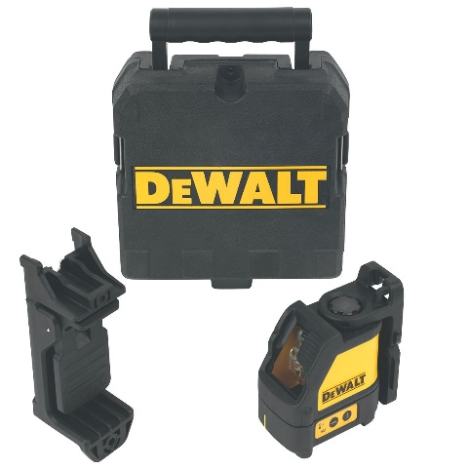
The DeWalt Self-Levelling Laser is a state-of-the-art gadget, designed for precision and convenience. With a 2-button operation, out of level sensor and a low battery indicator, tradespeople can ensure perfect levelling anywhere. With a working range of 10m-50m, this self-leveller is suitable for both indoor and outdoor use, and is perfect for a variety of tasks. Accompanied with a TSTAK deep tool box for easy transportation around the site, this tool is available at £169.99.

Versatile Vacuums
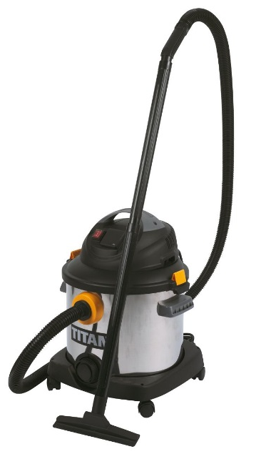
The Titan 30LTR Wet and Dry Vacuum is a multi-purpose, practical and powerful must-have tool. It is ‘Trade Rated’, which means it is given independent approval by tradespeople and is equipped with a high performance motor providing superior cleaning power. This vacuum also features a heavy duty stainless tank, a 2.4m suction tool and tank drain proving to be the trades’ favourite vacuum. Built with a handle and wheeled platform dolly base for easy transportation, this vacuum has an onboard tool storage section for multiple heads making it easier than ever to get into any nook and crevice, leaving no area untouched. Every aspect of this compact, versatile and efficient vacuum has been considered, making jobs easier for tradespeople and serious DIYers this season. Available at £69.99.

Popular Pumps
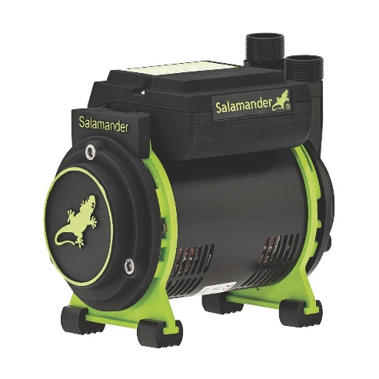
The Salamander CT + Xtra is Screwfix’s best-selling ‘Trade Rated’ range of shower pumps. Where low pressure is an issue, these are a perfect solution to give a power shower performance.
The range is available in both single and twin impeller designs to boost the water pressure to a shower. The range used for gravity feed systems has positive head and universal (negative head) options.
It is also compact, low noise and can be easily fitted, suitable for any bathroom redesign. Featuring 15mm Anti-Vibration couplers and a continuous rating motor, it is available from only £99.99.
Slim Sockets

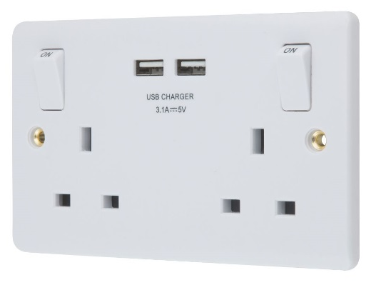
This subtle and stylish LAP 13A 2G SP Switched Socket is ASTA approved and designed for the trade. Featuring two USB ports at 3.1A, it meets the demands of modern technology charging requirements including phones, tablets and laptops making this device both multi-functional and practical. With angled in-line terminals and captive screws, this socket was designed for new and retrofit projects with easy installation in mind. These stylish, modern sockets are available at 2 for £15 at Screwfix.

All products ordered are available for next day delivery seven days a week, or via the convenient Click & Collect service, which allows products to be picked-up from one of Screwfix’s 530 stores in as little as 1 minute after ordering.

For more information on Screwfix’s new range of products, visit www.screwfix.com, call 03330 112 112, pick up a copy of the new catalogue at a local Screwfix store or download the Screwfix App.

ENDS

Note to editors
About Screwfix:
Screwfix is part of Kingfisher plc, the international home improvement company, with nearly 1,200 stores in 10 countries in Europe, Russia and Turkey. For further information go to www.kingfisher.com.
Screwfix is convenient, straightforward and affordably-priced, helping its trade customers get the job done quickly, affordably and right first time. Tradespeople can shop 29,000 products over the phone, online, via their mobile or in-person from their local store.
- From power tools and work wear to cables and pipe fittings, Screwfix offers over 11,000 products available for pick up from over 530 stores nationwide. Our full range of over 29,000 products can be ordered over the phone, online or from a local store, with orders taken up until 8pm (weekdays) for next day delivery to home or site.
- Screwfix.com attracts 2.6 million unique visitors per week.
- The Screwfix Click & Collect service means customers can conveniently purchase supplies online or over the phone and then collect from the store in as little as one minute.
- Customers can call the UK-based Screwfix Contact Centre 24 hours a day, 7 days a week (including bank holidays) on 03330 112 112.
- UK stores are open 7 days a week, from 7am – 8pm Weekdays, 7am – 6pm Saturdays and 9am – 4pm Sundays. Excludes selected stores. See www.screwfix.com/stores for details.
- 9 out of 10 customers would recommend Screwfix to a friend.
- Screwfix was voted the 5th highest rated UK company for work-life balance by Glassdoor Employees' Choice Awards in 2016.
- Screwfix was awarded Glassdoor’s Best Places to Work in 2017.
- Screwfix was awarded Retail Week’s Multichannel Retailer of the Year in 2017.
- In 2016, Screwfix sales surpassed £1bn for the first time.
- Screwfix was awarded 2nd place in Retail Week’s Best Employer Rankings in 2017.
- Screwfix was awarded South West Contact Centre Forum’s Large Contact Centre of the Year Award in 2017.
- For more information about Screwfix please visit our media centre: www.screwfixmedia.co.uk

