September 2018

NEW MILWAUKEE IS HERE
EXCLUSIVE PRODUCTS UNVEILED IN LATEST SCREWFIX CATALOGUE

Milwaukee exclusives are here! The UK’s tradespeople can now get an exclusive deal on Milwaukee’s most powerful, compact 18V drill complete with 2 lithium ion batteries and case, to celebrate the launch of the Milwaukee range, which features in the latest Screwfix catalogue.

Milwaukee’s popular range of heavy duty products, including the M18V Brushless Combi Drill and the M18 Brushless Impact Driver, both exclusively available at Screwfix, are perfect for both tradespeople and the serious DIY enthusiast and are recognised for their durability and performance.

Rhian Bartlett, Trading Director at Screwfix, says: “We know this is a brand that tradespeople want so we are delighted to include them in our latest catalogue. Milwaukee is an industry-leading manufacturer and it is fantastic to be able to offer our customers exclusive products alongside the extensive product range. “

“Tradespeople can now get their hands on Milwaukee exclusives at our events and in-store, including via our Click & Collect service. Not only is the new Milwaukee range the highlight of our latest catalogue, it will also be a key feature at Screwfix Live in Farnborough at the end of September, so register now and keep an eye on regular updates’’.

In addition, there is 20% off all Milwaukee accessories when bought with any Milwaukee power tool during the introductory period*.

Other highlights in the new catalogue include seasonally focused HIVE smarter heating controls, LED Lighting and radiators.

KEY HIGHLIGHTS

MILWAUKEE M18 18V BRUSHLESS COMBI DRILL
Exclusive to Screwfix, Milwaukee’s most compact combi-drill is in a class of its own. The 165mm drill has a torque of 60Nm to give the best power to size ratio. For increased efficiency, the Milwaukee drill is built with a brushless motor to last longer and continually deliver optimum power and unmatched durability. The 18V combi drill is even capable of working at as little as -20ºc. Priced at £199.99 for the Exclusive New Introductory Offer**
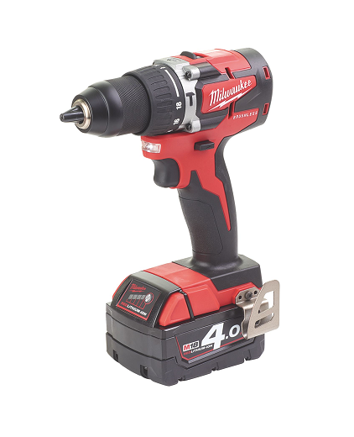
MILWAUKEE M18 BRUSHLESS IMPACT DRIVER - BARE
Another exclusive to Screwfix is Milwaukee’s compact impact driver. Measuring only 137 mm in length with a 99 mm head height, the driver is ideal for overhead applications or working in tight spaces. Thanks to its brushless motor technology, Milwaukee’s latest impact driver delivers 170 Nm torque. As part of the industry’s best performing and most durable range, the driver uses Redlink intelligence for temperature management and overload protection to safeguard the tool and battery during the toughest of jobs. Priced at £109.99 (without battery or charger)
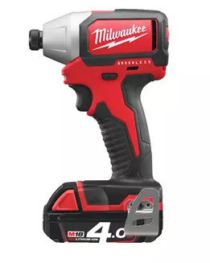

MILWAUKEE M18 JOBSITE RADIO DAB+
Tradespeople can be sure to never miss a beat thanks to the high-performance audio system from Milwaukee. The DAB+/FM tuner with digital processor delivers the highest reception accuracy and signal clarity as well as providing additional information such as song/artist name and time. Whilst the radio delivers loud, clear sound, the Milwaukee jobsite radio also includes shock absorbing end caps and metal speaker grills – protecting it from drops, water and debris when on location. Priced at £149.99, this impressive radio also includes a USB power outlet and weather sealed device compartment that protects and charges mobile devices. Available for £149.99
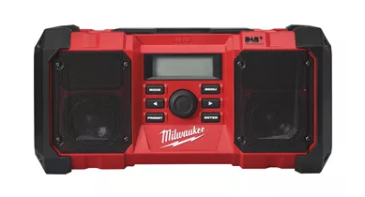

HIVE ACTIVE CENTRAL HEATING THERMOSTATS
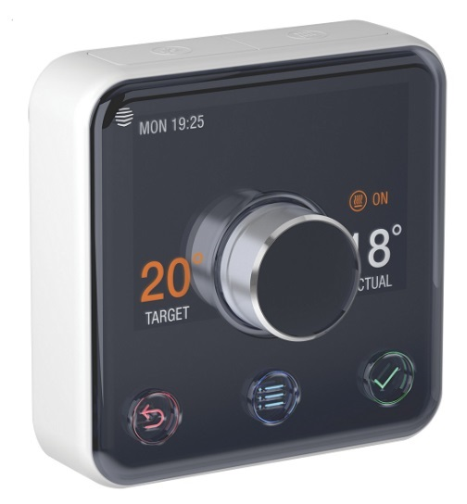
Introducing smarter heating to the home or office, these Hive thermostats control the central heating system using your smartphone. Available in a variety of models such as heating only, heating and hot water and even multi-zone control options. This smart piece of tech can be controlled from anywhere using your smartphone and includes impressive functions such as holiday mode which ensures your heating at home is correct while you are away and geolocation which sends you a reminder if you have gone out and left the heating on. Users can access temperature graphs to monitor heating usage and efficiency in and around the home. Priced at £134.99

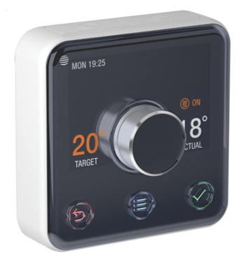

RADIUS EDGE SEMI FRAMED BATH SCREEN
With toughened slimline safety glass, this adjustable bath screen is the perfect addition to any bathroom thanks to its simplistic design and classic. This bath screen will fit any standard flat-edged bath and includes a high-quality seal for use between the screen and bath. Priced at £54.99
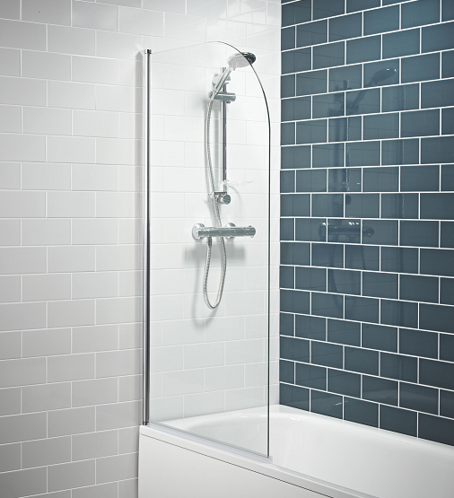

EVOLUTION SINGLE-BEVEL SLIDING COMPOUND MITRE SAW
This multipurpose saw from Evolution is perfect for cutting through wood, even if nails are still in the material, aluminium, plastic and mild steel. The trade rated precision saw cuts cleanly and leaves no burrs on steel. Supplied with a durable die-cast aluminium base to support heavy duty materials and a laser cutting guide to enhance accuracy, this saw features a dual-handle with a comfortable grip allowing for right or left-handed usage. Priced at £99.99
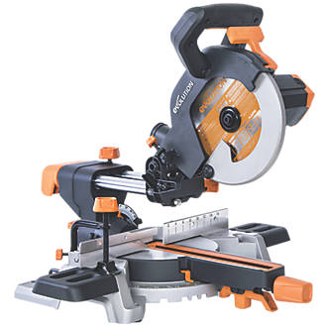
NEW LADIES RANGE AVAILABLE- DICKIES REDHAWK LADIES ZIP-FRONT COVERALL NAVY
These cover-alls are highly rated by the trade and have been recently introduced as part of a new ladies range available in Trade Counters. Durable, comfortable and reasonably priced they feature 2 chest and 2 swing pockets plus lower leg pockets with velcro-fastened flaps and contrasting piping detail. Velcro-fastened over placket, contrast colour collar and inner storm flap. Raglan sleeves. Full waist elastication for comfort, fit and flexibility and pleated action back. 260g/m².
Available in sizes 10 to 20. See our latest catalogue, go online or now visit in store to see the full range of women’s work wear. Priced at only £23.99
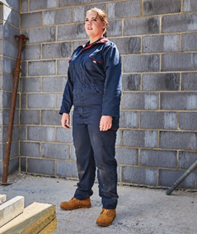
ACOVA HORIZONTAL COLUMN RADIATORS VOLCANIC
Built in Germany using laser-welding technology, these classic steel column radiators feature a stylish and timeless design. Available in two, three and four column styles, this trade rated product comes with brackets and fixings and for heavier sizes a support foot (3471H) is available to purchase. As well as a five-year manufacturers guarantee, when bought, the Acova column radiator comes with a FREE Drayton TRV4 and lockshield (worth £32.99). Priced at £195.69
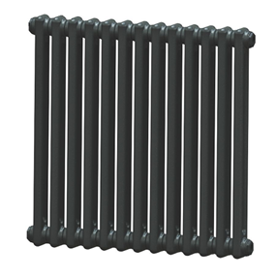

LUCECO LED PIR SLIM FLOODLIGHT
As the darker nights draw in, this energy efficient, LED floodlight is easy to install and features an adjustable tilting head. With up to 30,000 hours of life, the 8-watt light sits within a sleek black housing that also includes an adjustable dusk-to-dawn sensor. Pre-wired with 1m HO5RN-F rubber cable, the trade rated LED floodlight has a 120° 10m PIR Detection Range that switches the light into motion. Priced at £55.99
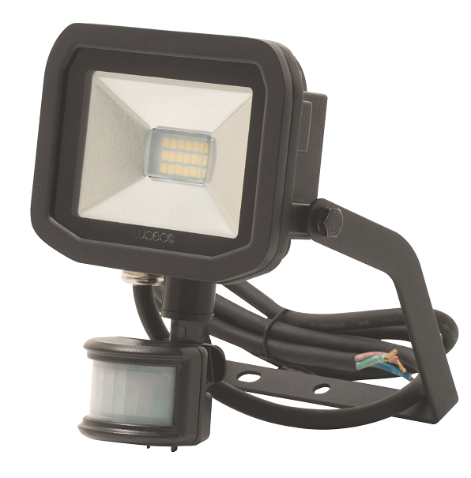
STANLEY SOFT TOOL BAG TWIN PACK
A must-have bargain for all tradespeople. This Stanley twin pack includes both a 16” and 12” soft tool bag, which is strong and durable. This tool bag has six outer pockets and two inner pockets allowing for easy organisation and access to tools. To prevent scuffs and tears, both tool bags include four rubber feet to prevent it from falling over or from being damaged when placed down. Available for only £19.99
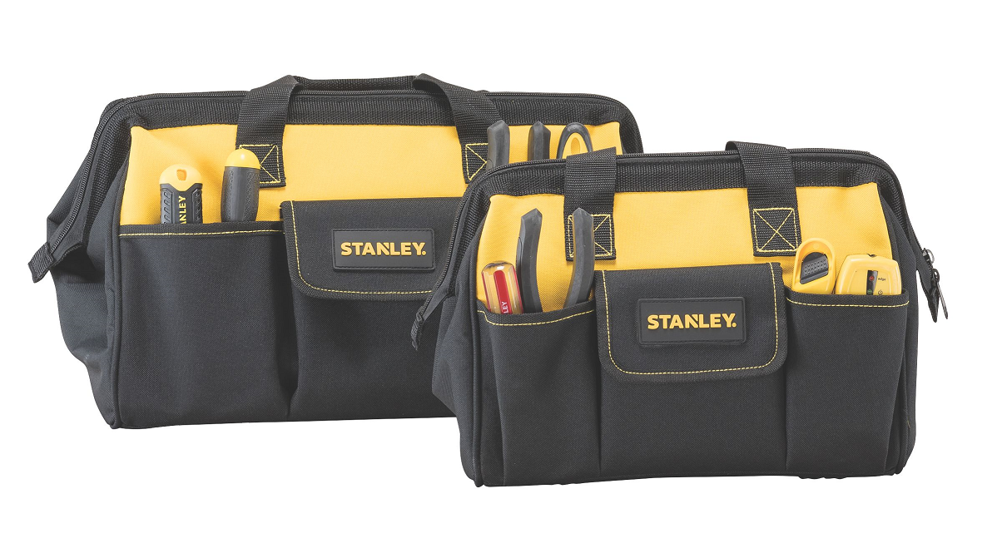
For more information on Screwfix’s range of products, visit www.screwfix.com or pick up a copy of the new catalogue at a local Screwfix store.

* The introductory period and price offer runs from 3rd September and 26th September 2018

ENDS
Note to editors
About Screwfix:
Screwfix is part of Kingfisher plc, the international home improvement company, with over 1,200 stores in 10 countries in Europe, Russia and Turkey. For further information go to www.kingfisher.com.
Screwfix is convenient, straightforward and affordably-priced, helping its trade customers get the job done quickly, affordably and right first time. Tradespeople can shop 32,000 products over the phone, online, via their mobile or in-person from their local store.
- From power tools and work wear to cables and pipe fittings, Screwfix offers over 11,000 products available to pick up from over 590 stores nationwide. Our full range of over 32,000 products can be ordered over the phone, online or from a local store, with orders taken up until 8pm (weekdays) for next day delivery to home or site.
- Screwfix.com attracts 5 million visits per week.
- The Screwfix Click & Collect service means customers can conveniently purchase supplies online or over the phone and then collect from the store in as little as one minute.
- Customers can call the UK-based Screwfix Contact Centre 24 hours a day, 7 days a week (including bank holidays) on 03330 112 112.
- UK stores are open 7 days a week, from 7am – 8pm Weekdays, 7am – 6pm Saturdays and 9am – 4pm Sundays. Excludes selected stores. See www.screwfix.com/stores for details.
- London stores are open from 6am – 10pm on weekdays
- In 2016, Screwfix sales surpassed £1bn for the first time
- World leading customer satisfaction levels.
- Screwfix was awarded Retail Week’s Customer Experience Initiative in 2017.
- Screwfix was awarded 2nd place in Retail Week’s Best Employer Rankings in 2017.
- Screwfix was awarded South West Contact Centre Forum’s Large Contact Centre of the Year Award in 2017. Screwfix was awarded Glassdoor’s Best Places to Work in 2017 and 2018.
- Screwfix was awarded Retail Week’s ‘Best Retailer over £250m’ and ‘Digital Pioneer’ awards in 2018
- For more information about Screwfix please visit our media centre: www.screwfixmedia.co.uk

PRESS information:
For more information, please contact:
Matthew Allen, McCann Public Relations, Tel: 0121 713 3579 / Matthew.thomas-allen@Mccann.com

