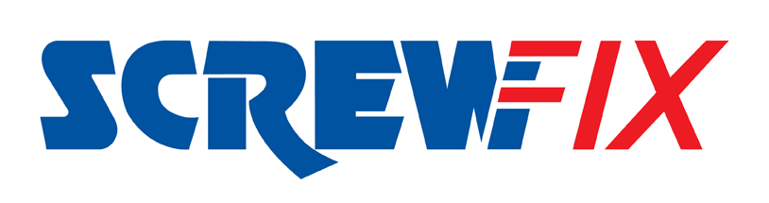

September 2020

New Screwfix Store welcomed Ulverston

- 10 jobs created as new Screwfix store opens in Ulverston
- Local Charities encouraged to apply for funding from The Screwfix Foundation
- Visit Screwfix’s Ulverston store at Beehive Business Park, Thomas Way, Ulverston, LA12 7NJ, See Screwfix.com for the latest opening hours

Screwfix has opened its latest store on Beehive Business Park, LA12 7TW. The new store officially opened its doors on Thursday 17th September with eager customers ready to stock up on the latest tools and trade essentials.

The Ulverston Screwfix store is part of the company’s growing network of over 680 stores nationwide, meaning over 98% of the UK population is within a 30-minute drive of a store. Open seven days a week, the store also provides a convenient Click & Collect service where customers can order their goods online or over the phone and pick them up from store.

Screwfix’s Ulverston Store Manager, Gavin Matthew, said: “We chose to open a new store in Ulverston to better meet the needs of the local tradespeople. Many of our new customers previously shopped with Screwfix at our Barrow-in-Furness and Kendall stores, so we’re delighted to bring Screwfix even closer to them for greater convenience.

“Our opening weekend, which ran from Thursday 17th until Sunday 20th September, attracted many customers. We have received fantastic support from the local community and are looking forward to supporting more busy tradespeople and serious DIYers in Ulverston.”

Qualified tradespeople can apply for a Plumbfix or Electricfix account and get access to a exclusive deals, credit facility and more. For more information visit the Ulverston store.

Since starting in 2013 The Screwfix Foundation has donated more than £5m to local charities and community projects enabling them to fix, repair or maintain facilities. Screwfix staff are directly involved in helping community projects and host charity fundraising events across the estate.

Ulverston local registered charities are welcome to apply for funding from The Screwfix Foundation by visiting www.screwfixfoundation.com

Visit Screwfix’s Ulverston store at: Beehive Business Park, Thomas Way, Ulverston, LA12 7NJ.

The brand’s huge range of products and exceptional deals are also available online at www.screwfix.com, or over the phone on 03330 112 112.

For our latest opening times visit Screwfix.com

-ENDS-

Note to editors

About Screwfix:
Screwfix is part of Kingfisher plc, the international home improvement company with over 1,300 stores in 9 countries across Europe, Russia and Turkey, supported by a team of over 77,000 colleagues. It operates under retail brands including B&Q, Castorama, Brico Dépôt, Screwfix and Koçtaş. It offers home improvement products and services to nearly six million consumers and trade professionals who shop in its stores and through its digital channels every week.

It believes everyone should have a home they feel good about, so its purpose is to make home improvement accessible for everyone. www.kingfisher.com

Screwfix is convenient, straightforward and affordably-priced, helping its trade customers get the job done quickly, affordably and right first time. Tradespeople can shop 33,000 products over the phone, online, via their mobile or in-person from their local store.

- From power tools and work wear to cables and pipe fittings, Screwfix offers over 11,000 products available to pick up from over 680 UK stores nationwide.
- Over 33,000 products can be ordered over the phone, online or from a local store, with orders taken up until 8pm (weekdays) for next day delivery to home or site.*
- Screwfix.com attracts over 6 million visits per week.
- We have over 10 million active customers a year.
- The Screwfix Click & Collect service, which enables customers to pick-up their goods in as little as one minute after ordering online or over the phone, is used more than 10 million times a year.*
- UK-based Screwfix Contact Centre open 24 hours a day, 7 days a week (including bank holidays) on 03330 112 112.
- See www.screwfix.com/stores for store opening information.
- Next day delivery is available within store opening hours.*
- World leading customer satisfaction levels.
- Screwfix was awarded in the A-Z of Recognised Retailers in the Retail Top 100 Movers & Shakers Report 2019
- Screwfix was awarded Retail Week’s Mark of Excellence’ for Best Place to Work in 2019
- The Screwfix and Wincanton team came highly commended in the Chep Award for Supply Chain Strategy and Design at the Logistics Manager Supply Chain Excellence Awards 2019.
- For more information please visit the Screwfix Media Centre: www.screwfixmedia.com

*Please see Screwfix.com for our latest service updates.

PRESS INFORMATION:
For press enquiries, please contact:
Ian Perkins, Screwfix Press Officer, Tel: 01935 401599 ian.perkins@screwfix.com
Laura Westcott, McCann, Tel: +44 (0) 7813 562717 laura.westcott@McCann.com
Matthew Allen, McCann, Matthew.thomas-allen@McCann.com

For Advertising enquiries, please contact:
!Mediaenquiries@screwfix.com

