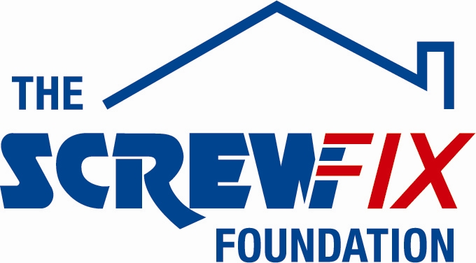

AUGUST 2017

PERTH AND KINROSS FOODBANK GETS A HELPING HAND FROM THE SCREWFIX FOUNDATION

Perth and Kinross Foodbank, based in Perthshire, is celebrating after being awarded £5,000 worth of funding from The Screwfix Foundation, a charity which supports projects to fix, repair, maintain and improve properties and facilities for those in need.

Eleanor Kelleher, Project Coordinator comments: “We are very grateful to The Screwfix Foundation for donating these much needed funds. The money has not only been used towards maintenance of the facility but also to repair our goods lift and ongoing maintenance and repairs to our van. The Perth and Kinross Foodbank is a charity that provide nutritionally balanced emergency food and support to local people in a crisis. We’d like to thank everyone who was involved in the fundraising – it’s been a great help to us.”

Ben Bennett, Store Manager of the Screwfix store in Inveralmond Trade Park, Perth comments: “We’re really pleased that one of our local charities has been awarded funding by The Screwfix Foundation. Staff from across the business have held a variety of fundraising events to raise vital funds for The Screwfix Foundation, so it’s fantastic to see the money we have raised being invested back into such a worthwhile community project.”

The Screwfix Foundation, which launched in April 2013 donates much needed funding to help a variety of local projects throughout the UK, from repairing buildings and improving community facilities, to improving the homes of people living with sickness or disability.

It also works closely with two national charity partners, Barnardo’s children’s charity and Macmillan Cancer Support, as well as supporting smaller, local registered charities like Perth and Kinross Foodbank.

Relevant projects from across Perth are invited to apply online for a share of the funding at screwfixfoundation.com.

For more information about The Screwfix Foundation, visit screwfixfoundation.com.

-ENDS-
Note to editors
About The Screwfix Foundation:
The Screwfix Foundation is a charity set up by Screwfix in April 2013. We have a clear purpose of raising funds to support projects that will fix, repair, maintain and improve properties and community facilities specifically for those in need in the UK.
The Screwfix Foundation raises funds throughout the year to support causes that will change people’s lives. Working with both national and local charities, The Screwfix Foundation donates much needed funding to help all sorts of projects, from repairing buildings and improving community facilities, to improving the homes of people living with sickness or disability.

PRESS information:
For more information, please contact:
The Screwfix Foundation,
E: Foundation@screwfix.com

About Perth and Kinross Foodbank:
We are a registered charity - SC044158.

The Perth and Kinross Foodbank was established in 2013 by a group of Christians from local churches. The initial funding was supplied by the churches, and support to link with the Trussell Trust was provided by Perth and Kinross Council.
The local community donate non-perishable food which is sorted and distributed from premises in Cutlog Vennel, in central Perth. There are two branches, one in Blairgowrie and one in Crieff.
On the last 12 months a total of 2363 parcels were prepared, which fed 4273 people (3193 adults and 1080 children).
Financial support from individuals, churches, schools, local businesses, Tesco and grant-making bodies enables the foodbank to meet its expenses.
Recipients of food parcels are referred through a voucher system from one of many partner agencies and organisations.

