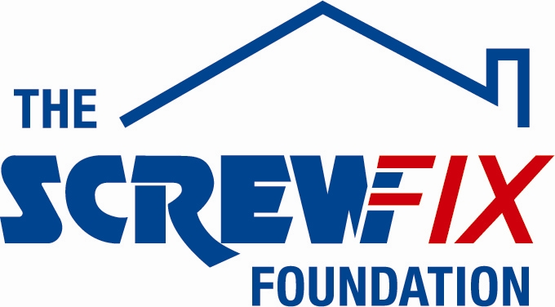

March 2019

PRODIGAL BIKES GETS A HELPING HAND FROM THE SCREWFIX FOUNDATION

Prodigal Bikes, a new charity based in Crewkerne, is celebrating after being awarded £2600 worth of funding from The Screwfix Foundation, a charity which supports projects to fix, repair, maintain and improve properties and facilities for those in need.

Anthony Raybould, Founder of Prodigal Bikes comments: “We are very grateful to The Screwfix Foundation for donating these much-needed funds to support our charity. Prodigal Bikes has two goals: We refurbish unwanted mountain bikes that we send out to people living in remote areas of Africa to help them gain access to education, employment and healthcare. We refurbish the bikes with ex-offenders, long term unemployed people and excluded school children from the South Somerset area - teaching them basic engineering skills to inspire them towards working in engineering-related jobs. The funding has been used to repaint and fit out our new workshop. We’d like to say a big thank you to everyone who was involved in the fundraising. We have further fund raising to do to ship our next batch of bikes to Kenya in June. To do this we are holding a sponsored cycle ride from the South Somerset village of Merriott down to Lands’ End in May, over 4 days. If anyone would like to ride, please visit our website at www.prodigalbikes.co.uk/events for more details.”

Danielle Sweet PR Manager at Screwfix Head Office based in Yeovil, comments: “We’re really pleased that one of our local charities has been awarded funding by The Screwfix Foundation. Staff from across the business have held a variety of fundraising events to raise vital funds for The Screwfix Foundation, so it’s fantastic to see the money we have raised being invested back into such a worthwhile community project.”

The Screwfix Foundation, which launched in April 2013 donates much needed funding to help a variety of local projects throughout the UK, from repairing buildings and improving community facilities, to improving the homes of people living with sickness or disability.

It also works closely with two national charity partners, Barnardo’s children’s charity and Macmillan Cancer Support, as well as supporting smaller, local registered charities like Prodigal Bikes.

Relevant projects from across Somerset are invited to apply online for a share of the funding at screwfixfoundation.com.

For more information about The Screwfix Foundation, visit screwfixfoundation.com.

Picture Caption LtoR: Calum McFarlane, volunteer, Anthony Raybould, Founder and Stephen Crane, Trustee, from Prodigal Bikes and Lauren George PR Campaign Coordinator at Screwfix.

-ENDS-
Note to editors
About The Screwfix Foundation:
The Screwfix Foundation is a charity set up by Screwfix in April 2013. We have a clear purpose of raising funds to support projects that will fix, repair, maintain and improve properties and community facilities specifically for those in need in the UK.
The Screwfix Foundation raises funds throughout the year to support causes that will change people’s lives. Working with both national and local charities, The Screwfix Foundation donates much needed funding to help all sorts of projects, from repairing buildings and improving community facilities, to improving the homes of people living with sickness or disability.

PRESS information:
For more information, please contact:
The Screwfix Foundation,
E: Foundation@screwfix.com

About Prodigal Bikes:

Prodigal Bikes was set up in 2016 by Trustees Anthony Raybould, Stephen Crane and Tim Neville. Graduate Trainees from Leonardo Helicopters also helped with starting the charity for its first 12 months as part of Leonardo's Corporate Social Responsibility programme.
Prodigal Bikes is Charitable Incorporated Organisation, Registered Charity number 1170845. Prodigal Bikes has so far supplied 120 bikes to school children, teachers and health workers in North Eastern Kenya in partnership with Somerset-based charity Akamba Aid Fund, and 10 bikes to school teachers in Malawi in partnership with Dorset-based charity Hooke Court in Malawi.
With the new workshop funded by The Screwfix Foundation now operational, we are starting to work with groups of long-term unemployed people, ex-offenders and excluded school children, teaching them basic engineering skills as we work on the bikes together. We are currently working on our next shipment of 125 bikes to be sent to Kenya in June this year.
Please visit our website www.prodigalbikes.co.uk and find us on Facebook as Prodigal Bikes, to see more of what we do.

For more information contact Anthony Raybould on
E: aj@prodigalbikes.co.uk

