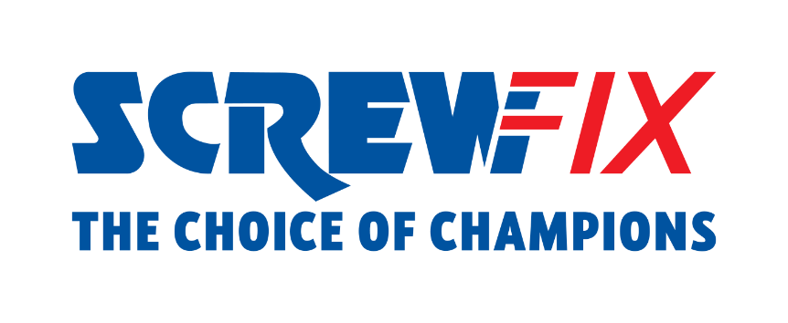

December 2022

Screwfix extends refurbished power tools offering and launches new Sustainability commitment

Screwfix, the omnichannel retailer, is proud to extend its range of refurbished power tools, supporting even more tradespeople and serious DIYers to get their job done quickly, affordably and right first time, with responsibly manufactured products made to last.
Earlier this year, the retailer launched a successful trial on Screwfix.com, with the trade showing how it values the opportunity to give tools a second and longer life. To give customers more sustainable product options, Screwfix has decided to grow its refurb offer.

Initially set up with 12 units, the range now counts over 700 products, with over 75,000 items successfully refurbished in 2022.

When products are returned, they are fully PAT and functionality tested. All components and instructions are checked, cleaned, and refurbished so contractors have everything they need to get the job done. The refurbished tools are also supplied with all accessories and benefit from a one-year guarantee.

Where it is not possible to repair and refurbish a faulty product, Screwfix recover spare parts and recycle in line with Waste Electrical and Electronic Equipment (WEEE) regulations, with zero waste to landfill.

Matt Compton, Commercial Director at Screwfix, says: “We know that many tradespeople are already making more sustainable choices when sourcing products and Screwfix is committed to supporting them. Refurb products are available for next day delivery from our distribution centre to stores or directly delivered on site. Our customers love the offering, and we are planning to add more categories to grow our range even further in 2023.”

Keeping products in use for longer forms a key part of a wider Screwfix’s environmental strategy. There are six key priority areas that ensure a meaningful difference to customers, colleagues, community and the planet, the other five being eliminating carbon emissions, reducing and recycling waste, sourcing responsibly, selling sustainable products, and providing sustainable packaging.

With its new campaign “Let’s Fix Tomorrow Today”, which involves colleagues and partners, Screwfix aims to become a sector leader in sustainability, encouraging other retailers to take action to tackle climate change and secure a greener future for the next generations.

To find out more about Screwfix’s bold strategy, please visit: https://www.screwfix.com/landingpage/screwfix-sustainability

-ENDS-

About Screwfix:
With over 800 stores across the UK and Ireland, and an extensive product range of over 38,000 products, Screwfix is convenient, straightforward, and affordably priced, help busy tradespeople get their jobs done quickly, affordably, and right first time.
Screwfix is part of Kingfisher plc, the international home improvement company with more than 1,490 stores, supported by a team of over 80,000 colleagues.
From power tools and work wear to cables and pipe fittings, Screwfix offers over 10,000 products available to pick up from over 775 UK stores nationwide.
- Over 38,000 products can be ordered over the phone, online or from a local store, with orders taken up until 8pm (weekdays) for next day delivery to home or site.*
- Unbeatable value at Screwfix is prices, quality and convenience you can trust. Over 1,000 prices cuts, hundreds of prices locked until the end of the year, and more than 8,000 bulk save items, helping tradespeople to get what they need, when they need it. Screwfix is committed to meeting the need of its customers.
- Screwfix is committed to minimising its environmental impact to help create a better future for its customers, colleagues, communities, and the planet. Our ambition is to offer sustainable choices and source products that are made to last. At Screwfix, we believe if a job’s worth doing, it’s worth doing well.
- Screwfix.com attracts over 7 million visits per week.
- We have over 11 million active customers a year.
- The Screwfix Click & Collect service enables customers to pick-up their goods in as little as one minute after ordering online or over the phone
- UK-based Screwfix Contact Centre open 24 hours a day, 7 days a week (including bank holidays) on 03330 112 112.
- See www.screwfix.com/stores for store opening information.
- Next day delivery is available within store opening hours.*
- Screwfix Sprint awarded ‘Best Customer Experience’ at the Retail Week Awards 2022. Introduced in 2021, Screwfix Sprint allows customers to place an order on the Screwfix app and get it delivered straight to their location – either at home or on site, in less than an hour.
- RAD 2022, Best Employer Website
- Screwfix recognised at the BRC’s Climate Action Roadmap Showcase 2022 for “Driving towards net zero properties”.
- For more information, please visit the Screwfix Media Centre: www.screwfixmedia.com

*Please see Screwfix.com for our latest service updates.

PRESS INFORMATION:
For press enquiries, please contact:
screwfix@mccann.com

