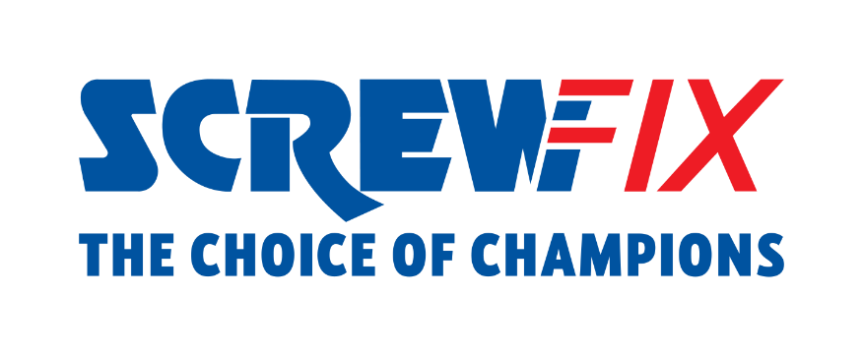
Robert Halfon MP visits Screwfix store in Harlow

Screwfix welcomed Robert Halfon MP for Harlow, Essex, to its Harlow store to meet with colleagues on the retailer's successful Apprenticeship programme.
On Friday 3rd November, Robert Halfon MP was hosted by the store team and Screwfix HR Director, Liz Bell. Robert Halfon MP had the opportunity to learn about the business and Screwfix’s commitment in supporting colleagues' development through its apprenticeship programme.
They also met with a colleague who is currently on his apprenticeship program and customers in store, highlighting the importance and benefits of a career in the trade.
Speaking about his visit, Robert Halfon MP said: "I was delighted to visit Screwfix last week, it was great to not only tour the site and sign up as a customer but also to meet their incredible Level 3 Apprentice, Sam, who was training to become an Assistant Manager. As Harlow’s MP, I am proud to represent one of the best, biggest and oldest Screwfix branches in the country, which is helping the local and national economy by employing 16 residents and creating £4 million in revenue every year.”
Liz Bell, Screwfix HR Director, commented: “It was a pleasure to welcome Robert Halfon MP to our Harlow store and share some of the stories of our apprenticeship programme. At Screwfix, we want our colleagues reach their potential and our programme is vital to that.”
Internally, Screwfix colleagues’ growth is a priority. More than 600 apprentices are currently training across the business in areas such as Retail Management, HR, Finance, Data and Legal, and over 85% of Screwfix’s apprentices who complete the programmes are promoted.
Screwfix was included in the Top 100 Apprenticeship Employers for 2023, the annual accolade compiled by the Department for Education that celebrates England’s outstanding apprenticeship employers.
Screwfix was recognised for its commitment to creating new apprenticeships, the diversity of apprentices, and the number of apprentices who successfully achieve their apprenticeships.
Staff from Harlow store – located in Ascent Park, Edinburgh Way, CM20 2HW – can participate in the retailer’s apprenticeship scheme, joining 5 colleagues in the area.
Screwfix is also committed the future of the Trade industry through its Trade Apprentice competition and its partnership with TrAC, the Flexi-Job Apprenticeship agency. A recent Kingfisher study shows a national shortage of tradespeople is set to cost the UK £98bn in missed economic growth by 2030.
The Harlow store is part of the company’s growing network of over 870 stores across the UK and Republic of Ireland, with 80 new stores set to open by January 2023.Visit Screwfix’s Harlow store, open 7 days a week from 7am from Monday to Saturday.

- ENDS -
About Screwfix:
With over 870 stores across the UK, Ireland and France, and an extensive product range of over 50,000 products, Screwfix is convenient, straightforward, and affordably priced, help busy tradespeople get their jobs done quickly, affordably, and right first time.
Screwfix is part of Kingfisher plc, the international home improvement company with more than 1,500 stores, supported by a team of over 80,000 colleagues.
From power tools and work wear to cables and pipe fittings, Screwfix offers over 10,000 products available to pick up from over 870, conveniently located stores.
- Over 50,000 products can be ordered over the phone, online or from a local store, with orders taken up until 8pm (weekdays) for next day delivery to home or site.*
- Unbeatable value at Screwfix is prices, quality and convenience you can trust - helping tradespeople to get what they need, when they need it. Screwfix is committed to meeting the need of its customers.
- Screwfix is committed to minimising its environmental impact to help create a better future for its customers, colleagues, communities, and the planet. Our ambition is to offer sustainable choices and source products that are made to last. At Screwfix, we believe if a job’s worth doing, it’s worth doing well.
- Screwfix.com and the Screwfix app attract over 7 million visits per week.
- We have over 11 million active customers a year.
- The Screwfix Click & Collect service enables customers to pick-up their goods in as little as one minute after ordering online or over the phone
- For more information visit screwfix.com screwfix.ie or screwfix.fr
- Screwfix Sprint awarded ‘Best Innovation in Delivery’ at the eCommerce Awards 2023 and ‘Best Customer Experience’ at the Retail Week Awards 2022. Introduced in 2021, Screwfix Sprint allows customers to place an order on the Screwfix app and get it delivered straight to their location – either at home or on site, in 60 minutes or less.
- RAD 2022, Best Employer Website
- Screwfix recognised at the BRC’s Climate Action Roadmap Showcase 2022 for “Driving towards net zero properties”.
- For more information, please visit the Screwfix Media Centre: www.screwfixmedia.com

PRESS INFORMATION:
For press enquiries, please contact:
screwfix@mccann.com

