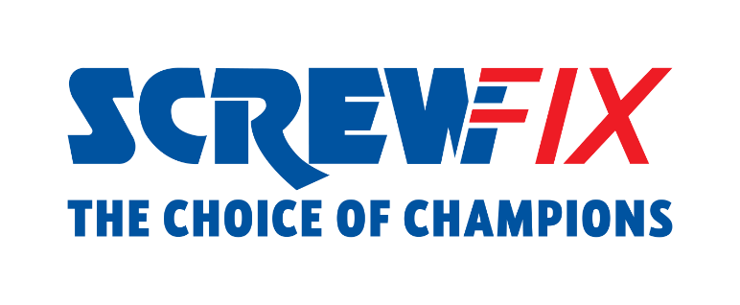
July 2023
Screwfix appointed to the Top 100 Apprenticeship Employers
List compiled by the Department for Education celebrates England’s outstanding apprenticeship employers

Screwfix, the leading multi-channel trade retailer, is proud to announce it has been included in the Top 100 Apprenticeship Employers for 2023, the annual accolade compiled by the Department for Education that celebrates England’s outstanding apprenticeship employers.
The retailer has been ranked 69th place after applying for the first time for the highly esteemed accolade. Screwfix has been recognised for its commitment to creating new apprenticeships, the diversity of apprentices, and the number of apprentices who successfully achieve their apprenticeships.
Over 500 colleagues across the business have already completed an apprenticeship programme, ranging across areas such as Retail Management, Customer Service, HR Management, Finance, and Data. Apprenticeships are offered at all levels from Level 2 apprenticeships to Level 7 postgraduate level apprenticeships.
John Mewett, Screwfix CEO says: To be in the Department for Education’s Top 100 Apprenticeship Employers 2023 is a massive recognition for the Screwfix Leadership and Talent team and I am incredibly proud of all our colleagues who have completed or are progressing in their programme. 83% of our colleagues who complete their apprenticeship get promoted to a new role and this is testament to Screwfix culture and how encourages our colleagues to reach their potential.
More than 640 colleagues are now on their way to completing their apprenticeship, and I would like to wish them all the best in their future career at Screwfix.”
With apprenticeships representing a vital part of Screwfix culture, the retailer is also committed to supporting trade apprentices across the UK and The Republic of Ireland.
Screwfix crowned Katie Jones, a Heating Engineer from Burscough, as the winner of Trade Apprentice 2023 earlier this year. The annual competition champions the new talent in the industry and shines a light on the positive impact that apprenticeships make to individuals, businesses and the wider economy.

- ENDS -

About Screwfix:
With over 870 stores across the UK, Ireland and France, and an extensive product range of over 47,000 products, Screwfix is convenient, straightforward, and affordably priced, help busy tradespeople get their jobs done quickly, affordably, and right first time.
Screwfix is part of Kingfisher plc, the international home improvement company with more than 1,500 stores, supported by a team of over 80,000 colleagues.
From power tools and work wear to cables and pipe fittings, Screwfix offers over 10,000 products available to pick up from over 870, conveniently located stores.
- Over 38,000 products can be ordered over the phone, online or from a local store, with orders taken up until 8pm (weekdays) for next day delivery to home or site.*
- Unbeatable value at Screwfix is prices, quality and convenience you can trust - helping tradespeople to get what they need, when they need it. Screwfix is committed to meeting the need of its customers.
- Screwfix is committed to minimising its environmental impact to help create a better future for its customers, colleagues, communities, and the planet. Our ambition is to offer sustainable choices and source products that are made to last. At Screwfix, we believe if a job’s worth doing, it’s worth doing well.
- Screwfix.com and the Screwfix app attract over 7 million visits per week.
- We have over 11 million active customers a year.
- The Screwfix Click & Collect service enables customers to pick-up their goods in as little as one minute after ordering online or over the phone
- For more information visit screwfix.com screwfix.ie or screwfix.fr
- Screwfix Sprint awarded ‘Best Customer Experience’ at the Retail Week Awards 2022. Introduced in 2021, Screwfix Sprint allows customers to place an order on the Screwfix app and get it delivered straight to their location – either at home or on site, in less than an hour.
- RAD 2022, Best Employer Website
- Screwfix recognised at the BRC’s Climate Action Roadmap Showcase 2022 for “Driving towards net zero properties”.
- For more information, please visit the Screwfix Media Centre: www.screwfixmedia.com

PRESS INFORMATION:
For press enquiries, please contact:
screwfix@mccann.com

