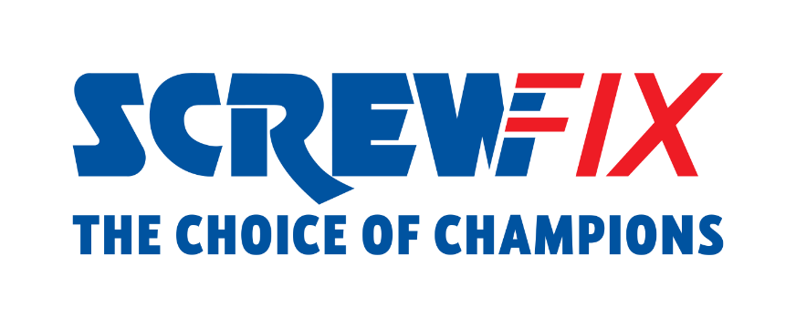
25th April 2023

Screwfix installs lifesaving defibrillators in all its stores in UK and Ireland in partnership with the British Heart Foundation

Screwfix has partnered with the British Heart Foundation (BHF) to roll out defibrillators in all of its stores across the UK and Ireland, becoming the first trade retailer to roll-out defibrillators on this scale.
With more than 870 stores across the UK and Ireland, Screwfix is perfectly placed to provide the lifesaving devices in the communities it serves and has worked with BHF to determine what would be best the approach to take to help save more lives.
A defibrillator is a device that gives a controlled high energy electric shock to the heart of someone who is in cardiac arrest. This shock is called defibrillation, and it's an essential part in trying to save the life of someone who’s in cardiac arrest.
It’s estimated that tens of thousands of defibrillators remain unknown to ambulance services, meaning emergency services cannot direct bystanders to them in the event of a cardiac arrest.
To help tackle this, Screwfix is registering its network of defibrillators onto The Circuit: The National Defibrillator Network, which was developed by the British Heart Foundation in partnership with Resuscitation Council UK, St John Ambulance, and the Association of Ambulance Chief Executives.
The Circuit’s aim is to map all public access defibrillators, so that when someone has a cardiac arrest, 999 call handlers can direct bystanders to the nearest registered defibrillator while they wait for the ambulance to arrive.
Screwfix will also begin the roll out the BHF’s first-of-its-kind CPR training tool RevivR to its colleagues. RevivR is an innovative tool that teaches the user CPR and defibrillation skills in just 15 minutes.
With just a phone and a firm cushion, the training tool teaches users how to recognise a cardiac arrest. It gives feedback on chest compressions and outlines the correct steps of defibrillator use, giving anyone the confidence to step in and save a life in the event of the ultimate medical emergency.
There are over 30,000 out-of-hospital cardiac arrests every year in the UK, but currently, fewer than one in ten people survive. However, immediate CPR and defibrillation can more than double the chances of survival from a cardiac arrest.
Scott Parsons, Screwfix Operations Director, says: “We are extremely proud to join forces with The British Heart Foundation and support our local communities with the tools to help potentially save a life. We believe this roll out of defibrillators at Screwfix stores will help make a significant difference, meaning more lifesaving defibs are close to hand in the event of a cardiac arrest.

“Working together with our colleagues on our People Forum we are delighted to have been able to roll out this initiative across our network of over 870 stores in the UK and Republic of Ireland.”
Mike Taylor, Commercial Director, at the British Heart Foundation, said: “Every minute without CPR or defibrillation reduces a person’s chance of surviving a cardiac arrest by up to 10 per cent, so we are delighted that Screwfix has installed lifesaving defibrillators in all its stores and started to roll out RevivR, our CPR training to its colleagues.
“Screwfix is helping communities by providing its colleagues and customers with the information and tools they need to potentially save a life and help to triple the number of people surviving a cardiac arrest.”
For more information about defibrillators and The Circuit – The National Defibrillator Network please visit: www.the circuit.uk

- ENDS -
About Screwfix

With over 870 stores across the UK and Ireland, and an extensive product range of over 38,000 products, Screwfix is convenient, straightforward, and affordably priced, help busy tradespeople get their jobs done quickly, affordably, and right first time.
Screwfix is part of Kingfisher plc, the international home improvement company with more than 1,5000 stores, supported by a team of over 80,000 colleagues.
From power tools and work wear to cables and pipe fittings, Screwfix offers over 10,000 products available to pick up from over 870, conveniently located stores.

About RevivR
The British Heart Foundation's innovative CPR training tool RevivR can help you save a life. RevivR is easy, quick, and free. Anyone can gain the skills to save a life through the first-of-its kind tool - all you need is a mobile phone and a firm cushion. In 15 minutes, the training tool teaches you how to recognise a cardiac arrest, gives feedback on chest compressions and outlines the correct steps of defibrillator use, giving anyone the confidence to step in and save a life in the event of the ultimate medical emergency. Brush up on your skills or learn lifesaving CPR for the first time here: https://www.bhf.org.uk/revivr
About the British Heart Foundation

It is only with donations from the public that the BHF can keep its lifesaving research going. Help us turn science fiction into reality. With donations from the public, the BHF funds ground-breaking research that will get us closer than ever to a world free from the fear of heart and circulatory diseases. A world where broken hearts are mended, where millions more people survive a heart attack, where the number of people dying from or disabled by a stroke is slashed in half. A world where people affected by heart and circulatory diseases get the support they need. And a world of cures and treatments we can’t even imagine today. Find out more at bhf.org.uk

