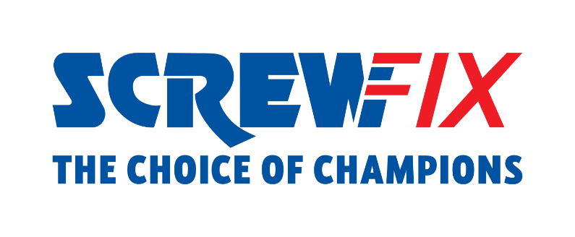

January 2023

Screwfix keeps driving its expansion in the Republic of Ireland with new stores and jobs created across the country

- The omnichannel retailer currently has vacancies available in several roles including Assistant Managers and Retail Assistants
- In 2023 the ambition is to open even more new stores and create additional jobs in local communities
- Screwfix is growing rapidly in Ireland and has opened more than 30 stores since launching in 2019, including opening 12 stores during the pandemic

Screwfix, the omnichannel retailer, is driving forward its expansion in the Republic of Ireland, with the aim of helping even more busy tradespeople get their jobs done quickly, affordably, and right first time and create jobs in local communities.

With a customer and colleague focused vision, Screwfix is committed to opening even more new stores in the Republic of Ireland and creating new jobs in 2023.

Counting over 30 stores across the country, including Dublin, Limerick and Cork, with over 450 jobs created, Screwfix is actively recruiting for roles, including Assistant Managers, Supervisors and Retail Assistants. Colleagues at Screwfix can benefit from extensive training and development opportunities, with over 50 colleagues currently training in areas such as retail management.

With more branches opened in 2022 than ever before, stores play a key part in Screwfix’s omnichannel customer journey.

Scott Parsons, Operations Director at Screwfix, says: “We opened our first Screwfix store in Ireland in 2019 and have continued to expand at a fast pace ever since.

“Our colleagues in store are vital to the business’ success, they thrive in providing customers with the ultimate convenience, alongside building a deep bond with the local community.

“Our expansion in the country is testimony to the business’ serious intention to get even closer to busy tradespeople and we are keen to achieve Screwfix’s next milestones with people at the heart of what we do.”

A full list of job vacancies in Ireland can be found on Screwfix Careers.

Screwfix’s growth plans are supported by Kingfisher, the retailer’s parent company, whose ‘Powered by Kingfisher’ strategy aims to maximise the benefits of combining its distinct retail banners with the scale, strength, and expertise of the Group.

About Screwfix:

As a multi-channel trade retailer, customers and colleagues sit at the heart of everything we do. With over 850 stores across the UK and Ireland our aim is to help busy tradespeople get their jobs done quickly, affordably, and right first time.

Screwfix is part of Kingfisher plc, the international home improvement company with more than 1,490 stores, supported by a team of over 80,000 colleagues. Kingfisher operates in eight countries across Europe under retail banners including B&Q, Castorama, Brico Dépôt, Screwfix, TradePoint and Koçtaş. We offer home improvement products and services to consumers and trade professionals who shop in our stores and via our e-commerce channels.
Screwfix is convenient, straightforward, and affordably priced, helping its trade customers shop 24,000 products over the phone, online, via their mobile or in-person from their local store.
- From power tools and work wear to cables and pipe fittings, Screwfix offers over 10,000 products available to pick up from over 30 ROI stores.
- Screwfix is committed to minimising its environmental impact to help create a better future for its customers, colleagues, communities, and the planet. Our ambition is to offer sustainable choices and source products that are made to last. At Screwfix, we believe if a job’s worth doing, it’s worth doing well.
- The Screwfix Click & Collect service enables customers to pick-up their goods in as little as one minute after ordering online or over the phone
- UK-based Screwfix Contact Centre open 24 hours a day, 7 days a week (including bank holidays) on 1800 946 602.
- See www.screwfix.ie/stores for store opening information.
- World leading customer satisfaction levels.
- Screwfix won the Pennies Outstanding Achievement award in 2020
- The Wincanton for Screwfix team won the Operational Excellence Award at the Motor Transport Awards 2020.
- For more information, please visit the Screwfix Media Centre: www.screwfixmedia.com

*Please see Screwfix.com for our latest service updates.

PRESS INFORMATION:
For press enquiries, please contact:
Lia Stokes, Legacy Communications - lia@legacycommunications.ie / 0857054444

