28th March 2019

Screwfix Launch Low Price Offers in New Catalogue
In addition to thousands of products and special offers from leading brands, the new Screwfix catalogue also features great deals on everyday essentials, offered at everyday low prices.
By understanding the products regularly used by their customers, Screwfix are supporting busy trades people and serious DIYers by keeping prices low.
Trusted by the trade for 40 years, Screwfix have highlighted these special deals in their latest catalogue, online and instore, using the Low-Price badge below.

These special prices offer great value for money and range from bathroom and plumbing products through to electrical, painting and decorating, security, landscaping and power tools.
Everything ordered through the catalogue is available for next day delivery seven days a week, or via Screwfix’s Click & Collect service at one of 620 stores in as little as one minute.
Here are a few of our favourite low-cost essentials; -

MK SENTRY 16-MODULE 10-WAY POPULATED SPLIT LOAD MAIN SWITCH CONSUMER UNIT
Perfect for electrical installations, this main switch is of corrosion-resistant Zintec steel construction. With multiple extra-large knockouts for easy installation. Smart and modern in design, it looks good even in visible installations. Its top hinged door prevents door being left open after use, reducing possible fire risk. Continual earthing through casing and door, only need to earth once via base.
Cost £69.99
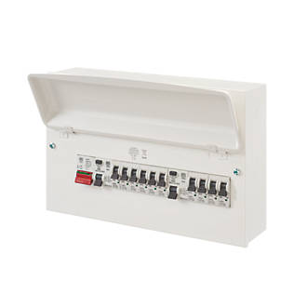

FROGTAPE PAINTERS DELICATE SURFACE MASKING TAPE 24MM X 41M
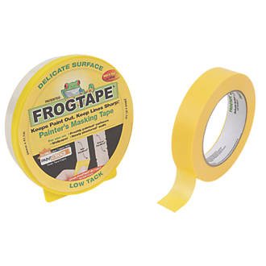
You can never have enough frogtape- this low tack masking tape is specifically designed for a crisp, sharp line on delicate surfaces, such as freshly painted or plastered walls, wallpaper, treated wood and emulsion paint. UV resistant. Can be applied up to 60 days before you paint.
Stock up now £4.89

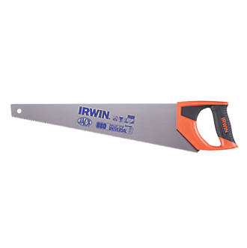
IRWIN JACK 880 UNIVERSAL SAW 20”
Razor-sharp triple-ground teeth for cutting all materials. Cuts on the push and pull. Water-based lacquer gives up to 4 times more rust protection. Comfortable handle for prolonged use.
It’s a steal at just £7.49

WD - 40 AEROSOL LUBRICANT 600ML
Needs no introduction with over 2000 known uses. This popular lubricant is a staple of many tradespersons tool box. Special low price of just £5.99
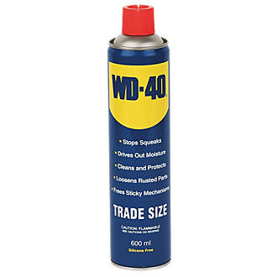

TITAN TTB430VAC 1400W 30LTR WET & DRY VACUUM CLEANER 240
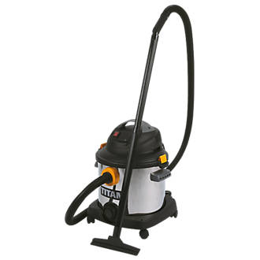
Wet and dry vacuum with heavy-duty stainless-steel tank, tank drain, synchro feature and onboard tool storage. The high-performance motor provides superior cleaning power.
£69.99

About Screwfix:
Screwfix is part of Kingfisher plc, the international home improvement company, with 1,302 stores in 10 countries in Europe, Russia and Turkey. For further information go to www.kingfisher.com.
Screwfix is convenient, straightforward and affordably-priced, helping its trade customers get the job done quickly, affordably and right first time. Tradespeople can shop 33,000 products over the phone, online, via their mobile or in-person from their local store.
- From power tools and work wear to cables and pipe fittings, Screwfix offers over 11,000 products available to pick up from over 620 UK stores nationwide.
- Over 33,000 products can be ordered over the phone, online or from a local store, with orders taken up until 8pm (weekdays) for next day delivery to home or site.
- Screwfix.com attracts over 5 million visits per week.
- Store network is visited by 7.1m customers a year
- The Screwfix Click & Collect service which enables customers to pick-up their goods in as little as one minute after ordering online or over the phone, has already received more than 27 million orders.
- UK-based Screwfix Contact Centre open 24 hours a day, 7 days a week (including bank holidays) on 03330 112 112.
- See www.screwfix.com/stores for store opening information.
- Next day delivery is available within store opening hours.
- World leading customer satisfaction levels.
- Screwfix was awarded Glassdoor’s Best Places to Work in 2017 and 2018.
- Screwfix was awarded Retail Week’s ‘Best Retailer over £250m’ and ‘Digital Pioneer’ awards in 2018
- For more information about Screwfix please visit our media centre: www.screwfixmedia.co.uk

PRESS information:
For more information, please contact:
Danielle Sweet, PR Manager, Tel: 01935 441706

