Screwfix Opens Its Doors On Safety Products
#Firedoorsafetyweek this September

Once again Screwfix are supporting #FireDoorsafetyWeek, from 25th September to 1st October and as part of this support there is up to 25% off fire safety products in their latest catalogue, in-store or online at www.screwfix.com.

With around 3 million new fire doors bought and installed every year in the UK, they are an important first line of defense in the case of a fire outbreak. It is therefore vital that they are correctly specified, maintained and managed. Installing an internal fire door correctly, helps to prevent the spread of fire throughout a building and helps to give people time to vacate safely.

Screwfix offer an extensive range of fire doors and fire safety equipment such as smoke and CO alarms, emergency exit/panic hardware, signage, door releases and fire extinguishers.

The fire doors are available in various finishes to match homes or businesses and are rated to FD30, offering 30 minutes fire resistance. Every fire door has to be tested and certified with all its components in place. All components that are fitted to the fire doors must be compatible to ensure the correct performance. Fire doors are functional items and have to meet a number of regulations such as sound, accessibility, ventilation, thermal efficiency and safety glazing as well as the other obvious fire safety requirements.

Unfortunately, wherever fire doors are installed they are often overlooked, neglected or worse still, get wedged open! In fact, in a recent government survey, just over one third (39%) of those with fire doors admitted they have seen one propped open in their building, as a result they are putting lives at risk.

Some of the fire safety product available from Screwfix include;-

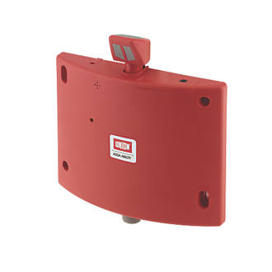
UNION DOORSENSE J-8755 ACOUSTIC RELEASE HOLD-OPEN UNIT RED
Holds the door open, but releases upon the sound of a fire alarm being activated. Timer included for automatic closing. Completely retrofits similar products. Price £99.99
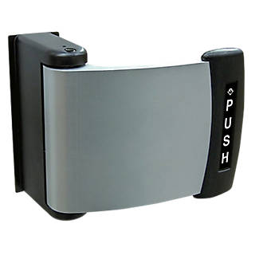
UNION 4591ADAMS RITE METAL DOOR PADDLE HANDLES (3673P/8012P)

Paddle handle – right or left-hand fitting, designed for simple push or pull operation as an alternative to a lever handle. For use with the Union 4710 Adams Rite Deadlatch. Suitable for use on aluminum and steel doors. Can be used on timber doors when used with Union Mounting Plate. Price £114.99.

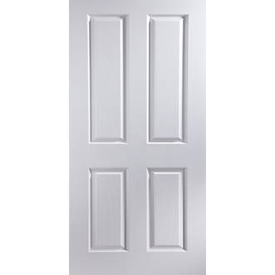

JELD-WEN OAKFIELD 4-PANEL INTERIOR FIRE DOOR PRIMED 1981 X 838MM (2258G
4-panel, fire-resistant door with woodgrain effect finish for a traditional look that brightens up any home. Supplied unfinished with a base coat primer for your choice of paint or stain. Provides 30 minutes fire protection. £99.99
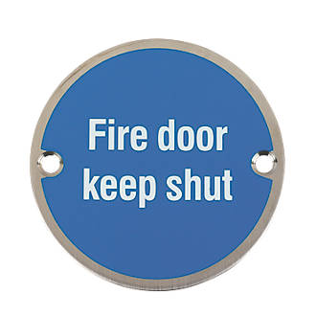

FIRE DOOR KEEP SHUT SIGN SATIN STAINLESS STEEL 76MM (42461)
Satin stainless steel Fire Door Keep Shut Sign. £3.29. Bulk save offer- save up to 10%

Go online at www.screwfix.com for more information.
Spread the word #FireDoorSafetyWeek | www.firedoorsafetyweek.co.uk

-ENDS-

Note to editors

About Screwfix:
Screwfix is part of Kingfisher plc, the international home improvement company, with 1,300 stores in 10 countries in Europe, Russia and Turkey. For further information go to www.kingfisher.com.
Screwfix is convenient, straightforward and affordably-priced, helping its trade customers get the job done quickly, affordably and right first time. Tradespeople can shop 32,000 products over the phone, online, via their mobile or in-person from their local store.
- From power tools and work wear to cables and pipe fittings, Screwfix offers over 11,000 products available to pick up from over 590 stores nationwide. Our full range of over 32,000 products can be ordered over the phone, online or from a local store, with orders taken up until 8pm (weekdays) for next day delivery to home or site.
- Screwfix.com attracts 5 million visits per week.
- The Screwfix Click & Collect service means customers can conveniently purchase supplies online or over the phone and then collect from the store in as little as one minute.
- See www.screwfix.com/stores for details of opening hours.
- Screwfix was awarded Glassdoor’s Best Places to Work in 2017 and 2018.
- Screwfix was awarded Retail Week’s ‘Best Retailer over £250m’ and ‘Digital Pioneer’ awards in 2018
- For more information about Screwfix please visit our media centre: www.screwfixmedia.co.uk

Or call Claire Hart on 01935 401975 email Claire.hart@screwfix.com

