September 2018

SCREWFIX SECURE MILWAUKEE PRODUCT EXCLUSIVES FOR SEPTEMBER LAUNCH

Milwaukee is here! The UK’s tradespeople can now get an exclusive deal on Milwaukee’s most powerful, compact 18V drill complete with 2 lithium ion batteries and case to celebrate the launch of the Milwaukee range.

Milwaukee’s popular range of heavy duty products, including the M18V Brushless Combi Drill and the M18 Brushless Impact Driver, both exclusively available at Screwfix, are perfect for both tradespeople and the serious DIY enthusiast and are recognised for their durability and performance.

Rhian Bartlett, Trading Director at Screwfix, says: “We know this is a brand that tradespeople want to get their hands on and we are really proud to welcome Milwaukee to Screwfix. Milwaukee is an industry-leading manufacturer and it is fantastic to be able to offer our customers exclusive products alongside the extensive product range. “

“Tradespeople can now get their hands on Milwaukee exclusives at our events and in-store, including via our Click & Collect service. Not only is the new Milwaukee range the highlight of our latest catalogue, it will also be a key feature at Screwfix Live in Farnborough at the end of September, so register now and keep an eye on regular updates’’.

New & Exclusive Introductory Offer and Iconic Motor Bike Competition
To celebrate the launch of the new range, there is an introductory offer on Milwaukee’s most compact 18V combi-drill, which is exclusive to Screwfix. At just 165mm, the drill has a torque of 60Nm to give the best power to size ratio. For increased efficiency, the Milwaukee drill has a brushless motor to deliver optimum power and unmatched durability. The 18V combi drill is even capable of working at as little as -20ºc. This exclusive drill is available at £199.99 (RRP £249.99)

Win A Harley Davidson (made in Milwaukee USA)
Anyone purchasing a Milwaukee Combi Drill from Screwfix this Autumn* will be entered into a prize draw to win a custom motorbike worth £15,000!
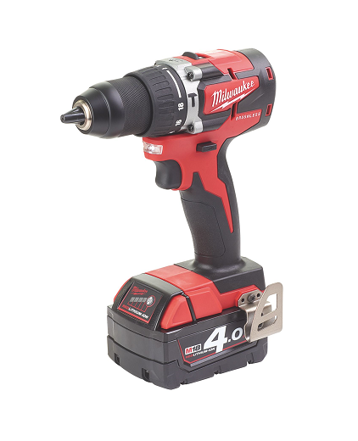
Another exclusive to Screwfix is Milwaukee’s compact impact driver. Measuring only 137 mm in length with a 99 mm head height, the driver is ideal for overhead applications or working in tight spaces. Thanks to its brushless motor technology, Milwaukee’s latest impact driver delivers 170 Nm torque. As part of the industry’s best performing and most durable range, the driver uses Redlink intelligence for temperature management and overload protection to safeguard the tool and battery during the toughest of jobs. Available at £109.99 (Without battery or charger)
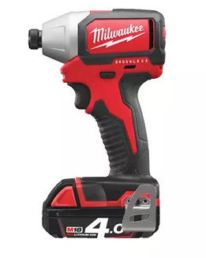

Other new products available at Screwfix from Milwaukee include the M18 Jobsite Radio DAB+ that includes shock absorbing end caps and metal speaker grills – protecting it from drops, water and debris when on location. Priced at £149.99 this impressive radio also includes a USB power outlet and weather sealed device compartment that protects and charges mobile devices.

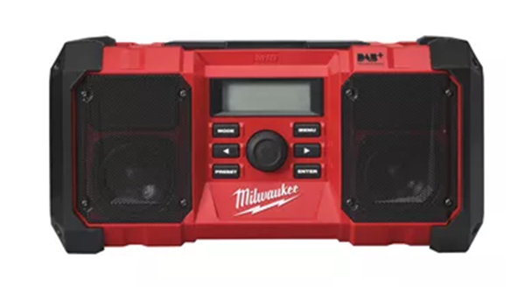
Overall, the new range will feature more than 81 products compatible with Milwaukee’s market-leading lithium-ion M12 and M18 battery systems, plus an extensive range of hand tools and compatible accessories.

In addition, there is 20% off all Milwaukee accessories when bought with any Milwaukee power tool during the introductory period*.

For more information on Screwfix’s range of products, visit www.screwfix.com or pick up a copy of the new catalogue at a local Screwfix store.

*Introductory offer applies to 702FH. Prize Draw entries are for product purchases made between 3rd September and 26th September 2018
ENDS

Note to editors
About Screwfix:
Screwfix is part of Kingfisher plc, the international home improvement company, with over 1,200 stores in 10 countries in Europe, Russia and Turkey. For further information go to www.kingfisher.com.
Screwfix is convenient, straightforward and affordably-priced, helping its trade customers get the job done quickly, affordably and right first time. Tradespeople can shop 32,000 products over the phone, online, via their mobile or in-person from their local store.
- From power tools and work wear to cables and pipe fittings, Screwfix offers over 11,000 products available to pick up from over 590 stores nationwide. Our full range of over 32,000 products can be ordered over the phone, online or from a local store, with orders taken up until 8pm (weekdays) for next day delivery to home or site.
- Screwfix.com attracts 5 million visits per week.
- The Screwfix Click & Collect service means customers can conveniently purchase supplies online or over the phone and then collect from the store in as little as one minute.
- Customers can call the UK-based Screwfix Contact Centre 24 hours a day, 7 days a week (including bank holidays) on 03330 112 112.
- UK stores are open 7 days a week, from 7am – 8pm Weekdays, 7am – 6pm Saturdays and 9am – 4pm Sundays. Excludes selected stores. See www.screwfix.com/stores for details.
- London stores are open from 6am – 10pm on weekdays
- In 2016, Screwfix sales surpassed £1bn for the first time
- World leading customer satisfaction levels.
- Screwfix was awarded Retail Week’s Customer Experience Initiative in 2017.
- Screwfix was awarded 2nd place in Retail Week’s Best Employer Rankings in 2017.
- Screwfix was awarded South West Contact Centre Forum’s Large Contact Centre of the Year Award in 2017. Screwfix was awarded Glassdoor’s Best Places to Work in 2017 and 2018.
- Screwfix was awarded Retail Week’s ‘Best Retailer over £250m’ and ‘Digital Pioneer’ awards in 2018
- For more information about Screwfix please visit our media centre: www.screwfixmedia.co.uk

PRESS information:
For more information, please contact:
Matthew Allen, McCann Public Relations, Tel: 0121 713 3822 Matthew.thomas-allen@Mccann.com

