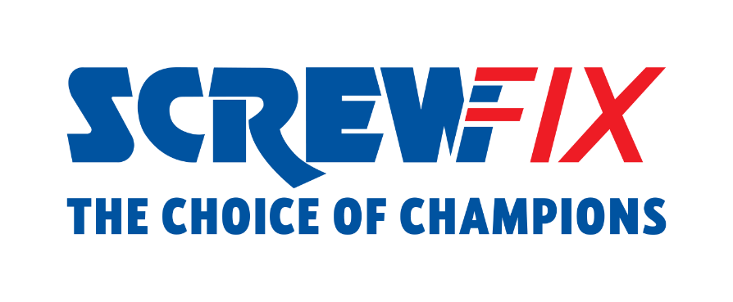
SCREWFIX WORKS WITH PRO-PANEL TO STRESS TEST NEW WOMEN’S WORKWEAR RANGE
________________________________________________________________________________
- Research from Screwfix highlights the challenges female tradespeople face when buying workwear
- Customers say sizing, material and cost are key issues
- Screwfix works with all-female Pro-Panel to test new workwear range
________________________________________________________________________________
Most female tradespeople say buying workwear is difficult due to poor sizing and lack of available sizes, according to a snapshot poll.
Screwfix, the omni-channel retailer, has carried out a sample survey with 40 female tradespeople to uncover the challenges they face when buying clothing for their job.
More than eight in ten said buying workwear is difficult, with almost half (48%) highlighting that poor sizing and lack of available sizes is a key issue.
Not designed for my body type and ill fitting (35%), too expensive (26%) and uncomfortable, stiff materials (24%) are other problems associated with purchasing essential clothes for the trade as a woman.
Female tradespeople admit to making their own moderations to clothes with more than half rolling up sleeves and trousers (54%) and adding additional holes to belts (15%), buttons or zips (11%).
Furthermore, almost one in ten (9%) use scissors to adapt items including cutting off and shortening trousers, sleeves, and tops.
The issue is so problematic that it’s a key barrier for women entering the trade with 68% saying more inclusive PPE, workwear and products need to be designed with female tradespeople in mind.
Katie Jones, Screwfix Trade Apprentice 2023 and member of the all-female Pro-Panel, says: “As a woman in the trade, I think it’s really important the industry is as inclusive as possible. Having female tradespeople able to access workwear that’s not only fit for the job, but also comfortable, is a key part of this.
“I’m excited to be a part of Screwfix’s Pro Panel and look forward to meeting the other members to share our thoughts and experiences and to be among the first to put Screwfix’s latest women’s workwear range to the test out on the job.”
Matt Compton, Commercial Director at Screwfix, comments: “We want the trade to be as inclusive as possible, and not being able to find suitable protective clothing has been highlighted as an issue for female tradespeople.
“Participants in our poll told us that comfort is key when looking for workwear, followed by durability then protection, so we have recruited a Pro-Panel to stress test our latest range and feedback findings. We’ll be sharing their honest reviews with our customers, based on their experiences on site, to make it easier for all to source clothing that is fit for purpose.”
The research found that T-shirts and polo shirts, safety boots, trousers and cargo pants are the most worn items of women’s workwear. Some of these items have been provided to the Pro-Panel comprising previous winners and finalists of Screwfix Trade Apprentice and Screwfix Top Tradesperson - plus content creator, Els Electric.
Feedback will be shared on Screwfix website and social channels in the coming months.
For more information about the new workwear range for women, please visit: https://www.screwfix.com/c/safety-workwear/womens-workwear/cat8510001

ENDS
The online survey took place in August 2023, with 40 female respondents.

About Screwfix:
With over 870 stores across the UK, Ireland and France, and an extensive product range of over 47,000 products, Screwfix is convenient, straightforward, and affordably priced, help busy tradespeople get their jobs done quickly, affordably, and right first time.
Screwfix is part of Kingfisher plc, the international home improvement company with more than 1,500 stores, supported by a team of over 80,000 colleagues.
From power tools and work wear to cables and pipe fittings, Screwfix offers over 10,000 products available to pick up from over 870, conveniently located stores.
- Over 38,000 products can be ordered over the phone, online or from a local store, with orders taken up until 8pm (weekdays) for next day delivery to home or site.*
- Unbeatable value at Screwfix is prices, quality and convenience you can trust - helping tradespeople to get what they need, when they need it. Screwfix is committed to meeting the need of its customers.
- Screwfix is committed to minimising its environmental impact to help create a better future for its customers, colleagues, communities, and the planet. Our ambition is to offer sustainable choices and source products that are made to last. At Screwfix, we believe if a job’s worth doing, it’s worth doing well.
- Screwfix.com and the Screwfix app attract over 7 million visits per week.
- We have over 11 million active customers a year.
- The Screwfix Click & Collect service enables customers to pick-up their goods in as little as one minute after ordering online or over the phone
- For more information visit screwfix.com screwfix.ie or screwfix.fr
- Screwfix Sprint awarded ‘Best Customer Experience’ at the Retail Week Awards 2022. Introduced in 2021, Screwfix Sprint allows customers to place an order on the Screwfix app and get it delivered straight to their location – either at home or on site, in less than an hour.
- RAD 2022, Best Employer Website
- Screwfix recognised at the BRC’s Climate Action Roadmap Showcase 2022 for “Driving towards net zero properties”.
- For more information, please visit the Screwfix Media Centre: www.screwfixmedia.com

PRESS INFORMATION:
For press enquiries, please contact:
screwfix@mccann.com

