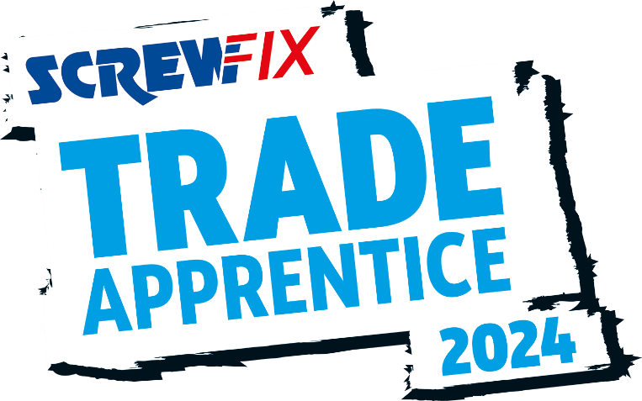

April 2024
FUTURE PLUMBING AND HEATING ENGINEER FROM CORK IS A SCREWFIX TRADE APPRENTICE FINALIST!
- Sean O’Shea, an apprentice Plumbing and HeaTing Engineer from Cork is in the running to be named the Screwfix Trade Apprentice 2024.
- Ten finalists have made it to the final, held in London in May
- One contestant will be named the winner and receive a career-boosting trade bundle worth €10,000.
Sean O’Shea, an aspiring Plumbing and Heating Engineer from Cork is in the national final of the annual Screwfix Trade Apprentice 2024 award.
From over 1,800 initial applications, ten apprentices have made the grade and are heading to the two-day final in London in May.
As well as competing for this prestigious award, which aims to highlight the hard work and dedication of trade apprentices across the UK and Ireland, Sean, 18, is focused on becoming a professional Plumbing and Heating Engineer. Currently studying heating and plumbing engineering at Cork College FET with Glenview Heating, he hopes to impress a panel of industry experts for a chance to be named the winner at the event on 3rd May.
Sean was shortlisted for demonstrating his passion, dedication and ambition for their chosen trade, which shone through during the semi-finals. He is hugely passionate about his career and works across domestic, industrial and commercial projects and routinely demonstrates his ambitions and always goes the extra mile.
He said: “I’m overjoyed to have made it to this stage of Screwfix Trade Apprentice 2024! I’m so glad that my skills, dedication, and achievements have secured me a place in the national final.
“I’m very proud to be representing the hard work and dedication of all trade apprentices and I’m looking forward to showcasing my passion in front of the renowned judges. To be crowned the winner would be a huge personal achievement and a highlight of my career.
One of Sean’s’ greatest achievements is winning the west cork business awards with Glenview Heating and talking on local radio stations and podcast about the importance of the trade and getting the recognition it deserves as a great career path. Sean is passionate about plumbing and furthering his qualification and getting more and more involved with social media through Instagram Facebook and TikTok to encourage more people into a trade.

The Screwfix Trade Apprentice 2024 champion will receive a career boosting trade bundle of tools, trade and tech worth €10,000. This, alongside the coveted Screwfix Trade Apprentice title, is everything an apprentice needs to excel within their chosen career.
This year’s judging panel includes representatives from the Chartered Institute of Plumbing and Heating Engineering, the Federation of Master Builders, the National Inspection Council of Electrical Installation Contracting along with Screwfix Top Tradesperson 2023 winner, Astrid Arnold.
Jack Wallace, Marketing Director at Screwfix says: “As always, we have been blown away with the calibre of entries, and every one of the finalists have an incredible work ethic. It is no easy feat to make the final of this competition all whilst maintaining their study and work commitments. They should be extremely proud of making it this far.
“It has never been more important to reward the fantastic work of our trade apprentices. As the industry skills gap continues to grow, highlighting the most rewarding and fulfilling aspects of the trade is vital to attracting new talent.
“Our previous winners have gone on to be trailblazers in their respective trades. I wish our 2024 finalists the best of luck and I’m sure they too will achieve great things.”
-ENDS-
PRESS INFORMATION:
For press enquiries, please contact:
Michelle Sweeney, Legacy Communications michelle@legacycommunications.com 083 007 9730

About Screwfix:

As a multi-channel trade retailer, customers and colleagues sit at the heart of everything we do. With over 900 stores across the UK, Ireland, and France our aim is to help busy tradespeople get their jobs done quickly, affordably, and right first time.

Screwfix is part of Kingfisher plc, the international home improvement company with more than 2000 stores, supported by a team of over 80,000 colleagues.
Screwfix is convenient, straightforward, and affordably priced, helping its trade customers shop 27,000 products over the phone, online, via their mobile or in-person from their local store.
- From power tools and work wear to cables and pipe fittings, Screwfix offers over 10,000 products available to pick up from over 35 ROI stores.
- Screwfix is committed to minimising its environmental impact to help create a better future for its customers, colleagues, communities, and the planet. Our ambition is to offer sustainable choices and source products that are made to last. At Screwfix, we believe if a job’s worth doing, it’s worth doing well.
- We have over 11 million active customers a year.
- The Screwfix Click & Collect service enables customers to pick-up their goods in as little as one minute after ordering online or over the phone
- UK-based Screwfix Contact Centre open 24 hours a day, 7 days a week (including bank holidays) on 1800 946 602.
- See www.screwfix.ie/stores for store opening information.
- World leading customer satisfaction levels.
- For more information, please visit the Screwfix Media Centre: www.screwfixmedia.com
- Screwfix’s growth plans are supported by Kingfisher, the retailer’s parent company, whose ‘Powered by Kingfisher’ strategy aims to maximise the benefits of combining its distinct retail banners with the scale, strength, and expertise of the Group.

*Please see Screwfix.com for our latest service updates.

