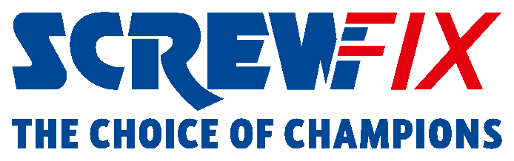

SHIFT IN ATTITUDES AS MORE THAN HALF OF JOBS CARRIED OUT BY UK TRADESPEOPLE ARE GEARED TOWARDS ENERGY SAVING

Against the ongoing cost of living crisis, a Screwfix survey* has found more than half (54%) of all jobs being carried out by UK tradespeople over the past year have had an energy saving focus, up by a third when compared to 2022**.
More than 400 tradespeople took part in the survey, with 86% saying that homeowners were motivated to make the switch to energy saving products to save money on their bills. Just over a third (36%) said their main reason was to help tackle climate change.
When questioned on what type of energy efficiency jobs tradespeople were getting in, energy saving lighting topped the list at 44%, followed by smart thermostats (26%), while loft insulation and new radiators followed closely behind with 25% and 24%, respectively.
Questioned on what else is needed to further increase the energy efficiency of UK homes, 74% of those working in the trades felt that a reduction or removal of current VAT rates on products was key, a figure which rose from 64% in 2022.
Meanwhile, when asked which potential government-led incentives would encourage more homeowners to invest in energy efficient measures, 61% of tradespeople said providing energy efficiency grants for home improvements. The removal of VAT on labour also scored highly at 33%.
Jack Wallace, Marketing Director at Screwfix, said: “With the twin pressures of a cost-of-living crisis and high energy costs, the past twelve months has seen the volume of energy efficiency related jobs undertaken by tradespeople rise significantly – with those surveyed saying over half of all their jobs (54%) are energy efficiency based - up from 38% a year ago.
“Screwfix has an important role to play in ensuring we offer unbeatable value across the innovative products and solutions tradespeople need to help them get their energy efficiency jobs done quickly, affordably, and right first time. And, by sharing their thoughts on this subject, we hope the industry can provide wider support to help in this crucial area.”
For more information, please visit www.screwfix.com
-ENDS-
* The 2023 Screwfix Energy Efficiency Survey polled 419 UK tradespeople to understand attitudes towards energy efficiency in the industry.
** The 2022 Screwfix Energy Efficiency Survey surveyed 599 UK tradespeople.

About Screwfix:
With over 900 stores across the UK, Ireland and France, and an extensive product range of over 57,000 products, Screwfix is convenient, straightforward, and affordably priced, help busy tradespeople get their jobs done quickly, affordably, and right first time.
Screwfix is part of Kingfisher plc, the international home improvement company with more than 2000 stores, supported by a team of over 80,000 colleagues.
From power tools and work wear to cables and pipe fittings, Screwfix offers over 10,000 products available to pick up from over 900, conveniently located stores.
- Over 57,000 products can be ordered over the phone, online or from a local store, with orders taken up until 8pm (weekdays) for next day delivery to home or site.*
- Unbeatable value at Screwfix is prices, quality, and convenience you can trust - helping tradespeople to get what they need, when they need it. Screwfix is committed to meeting the need of its customers.
- Screwfix is committed to minimising its environmental impact to help create a better future for its customers, colleagues, communities, and the planet. Our ambition is to offer sustainable choices and source products that are made to last. At Screwfix, we believe if a job’s worth doing, it’s worth doing well.
- Screwfix.com and the Screwfix app attract over 7 million visits per week.
- We have over 11 million active customers a year.
- The Screwfix Click & Collect service enables customers to pick-up their goods in as little as one minute after ordering online or over the phone
- For more information visit screwfix.com screwfix.ie or screwfix.fr
- Screwfix Sprint awarded ‘Best Customer Experience’ at the Retail Week Awards 2022. Introduced in 2021, Screwfix Sprint allows customers to place an order on the Screwfix app and get it delivered straight to their location – either at home or on site, in less than an hour.
- RAD 2022, Best Employer Website
- Screwfix recognised at the BRC’s Climate Action Roadmap Showcase 2022 for “Driving towards net zero properties”.
- For more information, please visit the Screwfix Media Centre: www.screwfixmedia.com

PRESS INFORMATION:
For press enquiries, please contact:
screwfix@mccann.com

