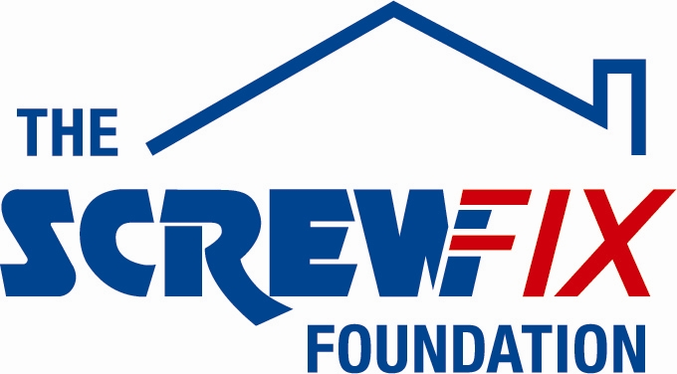

MARCH 2018

ST. FRANCIS’ CHILDREN’S SOCIETY RECEIVES GENEROUS DONATION FROM THE SCREWFIX FOUNDATION

St. Francis’ Children’s Society, based in Milton Keynes, is celebrating after being awarded £4,032 worth of funding from The Screwfix Foundation, a charity which supports projects to fix, repair, maintain and improve properties and facilities for those in need.

Fundraising Officer, Leanne Sinclair from St. Francis’ Children’s Society (SFCS) comments: “We are very grateful to The Screwfix Foundation for donating these much needed funds to support our charity. SFCS is an independent adoption agency and children’s charity and we specialise in finding families for children who wait the longest in the care system. The support we offer to our adopted families include therapy sessions, activity days, coffee mornings and 1-2-1 sessions which take place in our offices and family centre. The funding has enabled us to carry out vital repairs and maintenance within our family centre and offices, such as replacing our lighting fixtures and repainting some of the therapy rooms. This has made them more appealing and comfortable for the adopted children and their families who rely on our support. We’d like to thank everyone who was involved in the fundraising – it’s been a great help to us.”

Rod James, Store Manager of the Screwfix store in Milton Keynes, comments: “We’re really pleased that one of our local charities has been awarded funding by The Screwfix Foundation. Staff from across the business have held a variety of fundraising events to raise vital funds for The Screwfix Foundation, so it’s fantastic to see the money we have raised being invested back into such a worthwhile community project.”

The Screwfix Foundation, which launched in April 2013 donates much needed funding to help a variety of local projects throughout the UK, from repairing buildings and improving community facilities, to improving the homes of people living with sickness or disability.

It also works closely with two national charity partners, Barnardo’s children’s charity and Macmillan Cancer Support, as well as supporting smaller, local registered charities like St. Francis’ Children’s Society.

Relevant projects from across Milton Keynes are invited to apply online for a share of the funding at screwfixfoundation.com.

For more information about The Screwfix Foundation, visit screwfixfoundation.com.

-ENDS-
Note to editors
About The Screwfix Foundation:
The Screwfix Foundation is a charity set up by Screwfix in April 2013. We have a clear purpose of raising funds to support projects that will fix, repair, maintain and improve properties and community facilities specifically for those in need in the UK.
The Screwfix Foundation raises funds throughout the year to support causes that will change people’s lives. Working with both national and local charities, The Screwfix Foundation donates much needed funding to help all sorts of projects, from repairing buildings and improving community facilities, to improving the homes of people living with sickness or disability.

PRESS information:
For more information, please contact:
The Screwfix Foundation,
E: Foundation@screwfix.com

About St. Francis’ Children’s Society
St. Francis’ Children’s Society (SFCS) is an adoption charity which is committed to helping anyone whose life has been touched by adoption.

Our office is based in Milton Keynes, and we operate across Buckinghamshire, Bedfordshire, Northamptonshire, Hertfordshire, and parts of Cambridgeshire and East Anglia. As a registered charity and limited company, our work is entirely charitable and non-profit making.

Our Adoption Connections service, rated ‘Good’ by Ofsted, offers an open-door policy. Currently in the UK, there are over 3,000 children in need of an adoptive family, and we welcome all kinds of adopters for all kinds of children, regardless of age, race, cultural background, religion, marital status or sexual orientation.

As well as finding new families for children awaiting adoption, we offer an extensive range of support services for adopters and their children, such as counselling, Theraplay® and family support events.
Our Birth Connections service offers advice, support and counselling to birth parents and other family members who have lost a child to adoption and are struggling to come to terms with that loss.

We also, through our Building Connections service, offer family tracing services and appropriate counselling to adults who were adopted as children.
www.sfcs.org.uk

