March 2018

Start with Screwfix this spring!

This Spring, whatever the weather and whatever your project, start with Screwfix.
The latest edition of the renowned catalogue has over 950 pages and is jam packed with an extensive product range, covering all bases from landscaping and outdoor, to exterior lighting and plumbing – there’s also plenty for indoor projects too!
So whenever you’re working outside this Spring, you will find Screwfix have got all the tools for the job, plus loads of products you might not expect, from Lawn mowers to Decking.
Caroline Welsh, Brand and Retail Marketing Director at Screwfix, comments: “With every new catalogue, we bring tradespeople the top products available from the biggest brands in the Industry, at fantastic prices. Our latest edition has everything tradespeople or DIY enthusiasts need for outdoor and indoor projects, helping them to get the job done.
‘’With over 570 stores nationwide and even more set to open in 2018, tradespeople are never too far from your nearest Screwfix store. It doesn’t matter whether you are on site or at home, our Click & Collect service enables our busy tradespeople to order their selected products online or by phone and pick them up in as little as one minute from their nearest store, meaning no more waiting around for their delivery’’.
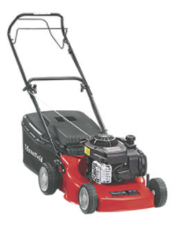
Key Highlights
MOUNTFIELD HP185 45CM 125CC HAND-PROPELLED ROTARY PETROL LAWN MOWER
At just £199.99, this lightweight yet robust hand-propelled lawn mower has five different cutting heights and comes with a free mulching plug. Taking pride of place on the front cover the new catalogue, the Mountfield lawn mower features the 125cc 4-Stroke Briggs & Stratton E Series Engine. It collects up to 55 litres of grass, making it convenient and easy to use – get through your mowing in no time!
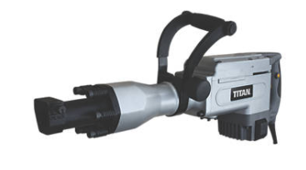
TITAN 15.5KG BREAKER
With both a flat and point chisel included, this Titan Breaker can be used on a variety of surfaces for a range of jobs. It’s highly effective and comes with a fan-cooled motor to reduce wear and tear in turn lasting much longer. Priced at £149.99, the tough and durable breaker also has a carry case for added protection.
.

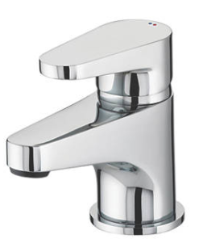
BRISTAN Quest Basin Mixer Tap
The Bristan basin mixer tap combines contemporary style with reliable function, making it ideal for any bathroom. For only £59.99, the Bristan tap has a top lever control and is supplied with a pop up basin waste. UK designed and engineered tap is suitable for all water systems and comes with a 5-year guarantee.
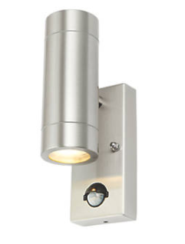

LAP BRONX Outdoor Wall Light
This stainless steel fitting from LAP, projects light both upwards and downwards. With a stylish design and maximum wattage of 35W, the Bronx Outdoor wall light is IP44 rated and is available now from only £11.99 (without a PIR sensor) per fitting.

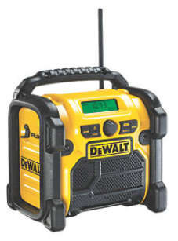
DEWALT DAB + XR Site Radio
Compact and robust, the DAB+ /FM job site radio is what every tradesperson needs whilst on a job. With a 3.5mm aux port for audio and a USB port for device charging, this radio is super durable to withstand knocks and bumps on site. For added ease, the £99.99 DEWALT compact site radio includes a 1.8m power cord with wraparound storage, but also works with slide pack batteries, allowing you to move it around from indoors to outdoors easily.

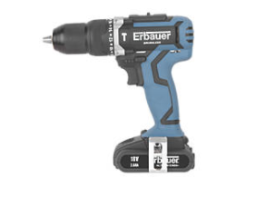
ERBAUER 18V Brushless Combi Drill
With a 2-year guarantee, this trade rated cordless drill from Erbauer features 2-speed variables and reverse settings. The combi drill includes a brushless motor to reduce friction, which provides longer tool life, run time and more power. The Erbauer drill comes with 21 Torque settings plus a hammer drill, carry case and charger. Not only that, the cordless drill is now only £89.99.

Touchstone Safety Boots
For maximum style and comfort whilst working, Site’s safety boots are available in both honey and dark honey. These work boots are designed for comfort and feature a steel penetration-resistant midsole. The 200j steel toe capped safety boots are just £34.99 a pair. Whilst being oil-repellent, Site’s touchstone safety boots are also weather-resistant and anti-static with a shock-absorbing and reinforced steel. A real lightweight yet durable work boot, ideal for both on-site and everyday use.

EASILOAD Wheelbarrow
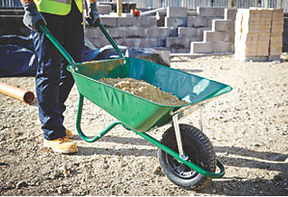
This easily assembled heavy-duty wheelbarrow is suitable for lugging heavy weight around. Manufactured in the UK, the EASILOAD wheelbarrow has a sturdy frame with a tipping nose. At 30% off, the now £39.99 wheelbarrow can cope with 85 litres, thanks to a heavy gauge pressure pan and robust front support straps.

British General 16 Module 10-Way High Integrity Dual RCD Consumer Unit
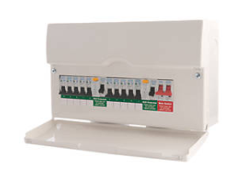
Quick and easy to install, the BG 10-Way Dual-RCD Consumer Unit boasts quality and value at £72.99. This High Integrity, all-metal consumer unit has a flexible wiring configuration, its own fitted spirit level, backed out and retained combi terminal screws, as well as a flexible busbar. Fully populated, it comes with a 100A Mains Switch, two 63A 30mA RCDs and 10 MCBs. Fitted with an easy clean cover, this BG Consumer Unit is the perfect fit for many a home.

With mornings and evenings getting lighter and our stores open from 7am weekdays, it’s never been easier to get hold of all the trade essentials before the start of the working day.
Free copies of the all-new Screwfix catalogue are available in store now, or customers can download the Screwfix catalogue app to their Apple or Android smartphone or tablet. Featured products can be ordered via Screwfix.com which hosts hundreds of extended online ranges, or via Screwfix’s mobile site, which allows tradespeople to check stock availability and locate their nearest store.
For more information on Screwfix’s new range of products, visit www.screwfix.com or pick up a copy of the new catalogue at a local Screwfix store.

-ENDS-

Note to editors
About Screwfix:
Screwfix is part of Kingfisher plc, the international home improvement company, with nearly 1,200 stores in 10 countries in Europe, Russia and Turkey. For further information go to www.kingfisher.com.
Screwfix is convenient, straightforward and affordably-priced, helping its trade customers get the job done quickly, affordably and right first time. Tradespeople can shop 30,000 products over the phone, online, via their mobile or in-person from their local store.
- From power tools and work wear to cables and pipe fittings, Screwfix offers over 11,000 products available to pick up from over 570 stores nationwide. Our full range of over 30,000 products can be ordered over the phone, online or from a local store, with orders taken up until 8pm (weekdays) for next day delivery to home or site.
- Screwfix.com attracts 2.6 million unique visitors per week.
- The Screwfix Click & Collect service means customers can conveniently purchase supplies online or over the phone and then collect from the store in as little as one minute.
- Customers can call the UK-based Screwfix Contact Centre 24 hours a day, 7 days a week (including bank holidays) on 03330 112 112.
- UK stores are open 7 days a week, from 7am – 8pm Weekdays, 7am – 6pm Saturdays and 9am – 4pm Sundays. Excludes selected stores. See www.screwfix.com/stores for details.
- London store are open from 6am – 10pm on weekdays
- World leading customer satisfaction levels.
- Screwfix was voted the 5th highest rated UK company for work-life balance by Glassdoor Employees' Choice Awards in 2016.
- Screwfix was awarded Glassdoor’s Best Places to Work in 2017 and 2018.
- Screwfix was awarded Retail Week’s Customer Experience Initiative in 2017.
- In 2016, Screwfix sales surpassed £1bn for the first time.
- Screwfix was awarded 2nd place in Retail Week’s Best Employer Rankings in 2017.
- Screwfix was awarded South West Contact Centre Forum’s Large Contact Centre of the Year Award in 2017.
- For more information about Screwfix please visit our media centre: www.screwfixmedia.co.uk

PRESS information: For more information, please contact: Matthew Allen, McCann Public Relations, Tel: 0121 713 3579 / Matthew.thomas-allen@Mccann.com

