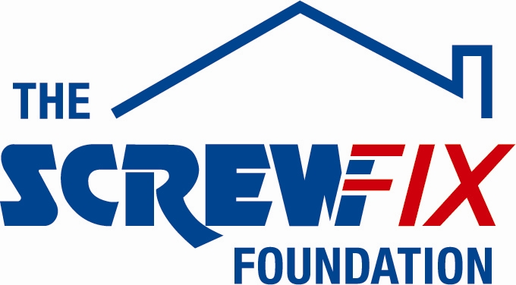
5th July 2018

THE AMELIA TRUST FARM, BARRY, WALES GETS A HELPING HAND FROM THE SCREWFIX FOUNDATION

The Amelia Trust Farm, based in Barry, South Wales, is celebrating after being awarded £5,000 worth of funding from The Screwfix Foundation, a charity which supports projects to fix, repair, maintain and improve properties and facilities for those in need.

Mal Jones, Education Manager at The Amelia Trust comments: “We are very grateful to The Screwfix Foundation for donating these much-needed funds to support our charity. We help young people facing multiple disadvantages to get their lives back on track by involving them in meaningful activities at the Farm. Without our support they enter adulthood without the life skills needed to cope let alone succeed and could end up unemployed, dependent on drugs or in prison. The funding will be used towards helping these young people with the resources they need whilst at the Farm but also creating a therapeutic environment for everyone to enjoy. We’d like to thank everyone who was involved in the fundraising – it’s been a great help to us.”

Samantha Knight, Store Manager of the Barry Screwfix store, comments: “We’re really pleased that one of our local charities has been awarded funding by The Screwfix Foundation. Staff from across the business have held a variety of fundraising events to raise vital funds for The Screwfix Foundation, so it’s fantastic to see the money we have raised being invested back into such a worthwhile community project.”

The Screwfix Foundation, which launched in April 2013 donates much needed funding to help a variety of local projects throughout the UK, from repairing buildings and improving community facilities, to improving the homes of people living with sickness or disability.

It also works closely with two national charity partners, Barnardo’s children’s charity and Macmillan Cancer Support, as well as supporting smaller, local registered charities like United Response

Relevant projects from across Glamorgan are invited to apply online for a share of the funding at screwfixfoundation.com.

For more information about The Screwfix Foundation, visit screwfixfoundation.com.
Image pictured are Mal Jones, Education Manager from Amelia Trust Farm and Sam Knight, Manager of the Barry Screwfix store.

-ENDS-
Note to editors
About The Screwfix Foundation:
The Screwfix Foundation is a charity set up by Screwfix in April 2013. We have a clear purpose of raising funds to support projects that will fix, repair, maintain and improve properties and community facilities specifically for those in need in the UK.
The Screwfix Foundation raises funds throughout the year to support causes that will change people’s lives. Working with both national and local charities, The Screwfix Foundation donates much needed funding to help all sorts of projects, from repairing buildings and improving community facilities, to improving the homes of people living with sickness or disability.

PRESS information:
For more information, please contact:
The Screwfix Foundation,
E: Foundation@screwfix.com

