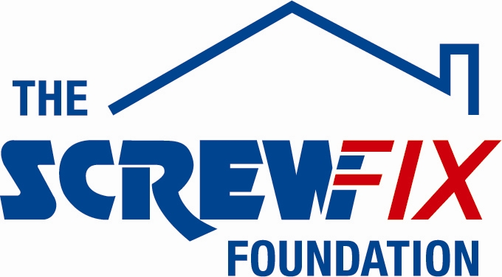

Tuesday July 3rd 2018

FOR IMMEDIATE RELEASE

THE CHARITY UNITED RESPONSE GETS A HELPING HAND FROM THE SCREWFIX FOUNDATION

Staff at a registered care home for people with disabilities are celebrating after being awarded £4,560 worth of funding from The Screwfix Foundation, a charity which supports projects to fix, repair, maintain and improve properties and facilities for those in need.

The money will help to pay for specialist equipment to help the disability charity United Response support people with learning and physical disabilities at its care home in Harrogate.
Service Manager Susie Harrison said: “We are incredibly grateful for this much-needed donation to help us enable those with disabilities live their lives to the full.
“Living with a disability can be challenging and there is a range of equipment – from hoists, wheelchairs, assistive technology – we use depending on the individual’s disability. But by having access to this, we can ensure that people are able to live as independently as they can.
“We’d like to thank everyone who was involved in the fundraising – it’s been a great help to us towards dramatically improving our outdoor area.”
United Response cares for four people at its Harrogate care home which it has been running since 1998.

David Wilkinson, Store Manager of the Screwfix store in Harrogate, comments: “We’re really pleased that one of our local charities has been awarded funding by The Screwfix Foundation. Staff from across the business have held a variety of fundraising events to raise vital funds for The Screwfix Foundation, so it’s fantastic to see the money we have raised being invested back into such a worthwhile community project.”

The Screwfix Foundation, which launched in April 2013 donates much needed funding to help a variety of local projects throughout the UK, from repairing buildings and improving community facilities, to improving the homes of people living with sickness or disability.

It also works closely with two national charity partners, Barnardo’s children’s charity and Macmillan Cancer Support, as well as supporting smaller, local registered charities like United Response

Relevant projects from across Harrogate are invited to apply online for a share of the funding at screwfixfoundation.com. For more information about The Screwfix Foundation, visit screwfixfoundation.com.

-ENDS-

Note to editors
About United Response

United Response is a top 100 national charity that provides person-centred support to around 3,000 adults and young people with learning disabilities, mental health needs or physical disabilities – including some of the most vulnerable people in our society.
Our vision is a society of equal rights and access where disabled people have the opportunity to live the lives they want to lead.
We provide bespoke support, from 24-hour care to a few hours a week, at around 400 locations across England and Wales. We employ approximately 4,000 staff and are regularly recognised with awards for our innovative, high quality range of services.
To find out more about United Response, please visit: www.unitedresponse.org.uk

About The Screwfix Foundation
The Screwfix Foundation is a charity set up by Screwfix in April 2013. We have a clear purpose of raising funds to support projects that will fix, repair, maintain and improve properties and community facilities specifically for those in need in the UK.
The Screwfix Foundation raises funds throughout the year to support causes that will change people’s lives. Working with both national and local charities, The Screwfix Foundation donates much needed funding to help all sorts of projects, from repairing buildings and improving community facilities, to improving the homes of people living with sickness or disability.

Picture caption [DA_SCREWFIX_UNITED_RESPONSE_01 - Copy]: Susie Harrison (United Response Service Manager), David Wilkinson (Screwfix), David Turner (Resident), Ruth Lee (Senior Support Worker), James Ferry (Resident), Andrea Radimerska (Support Worker), Victoria Crighton (Resident).

For more information, please contact The Screwfix Foundation via email at Foundation@screwfix.com.

To contact United Response, email Press & Communications Officer Imthiaz Rehman on Imthiaz.rehman@unitedresponse.org.uk or call 07768 925579.

