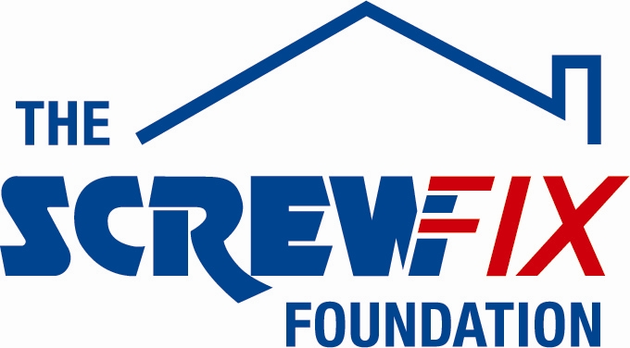

28th June 2018

THE ELIZABETH FOUNDATION GETS A HELPING HAND FROM THE SCREWFIX FOUNDATION

The Elizabeth Foundation in Portsmouth, is celebrating after being awarded £1,500 worth of funding from The Screwfix Foundation, a charity which supports projects to fix, repair, maintain and improve properties and facilities for those in need.

Karen Vaughan BEM, Deputy Chief Executive from The Elizabeth Foundation comments: “We are very grateful to The Screwfix Foundation for donating these much-needed funds to support our charity. The Elizabeth Foundation (www.elizabeth-foundation.org) has 37 years’ experience in the delivery of outstanding, education and welfare services for deaf and hearing impaired children (aged 0 – 5) and their families. Our aim is to teach deaf children to learn to Listen through their hearing technologies and to Talk with clarity and confidence. By doing so we enable them to join school at age 5, ready and able to access the school curriculum alongside their hearing peers, with a solid foundation for long-term academic success and social inclusion. The funding will be used towards vital improvements to our outdoor play equipment, keeping our children safe as they learn to develop their listening, language and social skills in a natural environment. We’d like to thank everyone who was involved in the fundraising – it’s been a great help to us.”

Kevin Rowe, Store Manager of the Portsmouth Screwfix store, comments: “We’re really pleased that one of our local charities has been awarded funding by The Screwfix Foundation. Staff from across the business have held a variety of fundraising events to raise vital funds for The Screwfix Foundation, so it’s fantastic to see the money we have raised being invested back into such a worthwhile community project.”

The Screwfix Foundation, which launched in April 2013 donates much needed funding to help a variety of local projects throughout the UK, from repairing buildings and improving community facilities, to improving the homes of people living with sickness or disability.

It also works closely with two national charity partners, Barnardo’s children’s charity and Macmillan Cancer Support, as well as supporting smaller, local registered charities like United Response

Relevant projects from across Portsmouth are invited to apply online for a share of the funding at screwfixfoundation.com.

For more information about The Screwfix Foundation, visit screwfixfoundation.com.

-ENDS-
Note to editors
About The Screwfix Foundation:
The Screwfix Foundation is a charity set up by Screwfix in April 2013. We have a clear purpose of raising funds to support projects that will fix, repair, maintain and improve properties and community facilities specifically for those in need in the UK.
The Screwfix Foundation raises funds throughout the year to support causes that will change people’s lives. Working with both national and local charities, The Screwfix Foundation donates much needed funding to help all sorts of projects, from repairing buildings and improving community facilities, to improving the homes of people living with sickness or disability.

PRESS information:
For more information, please contact:
The Screwfix Foundation,
E: Foundation@screwfix.com

