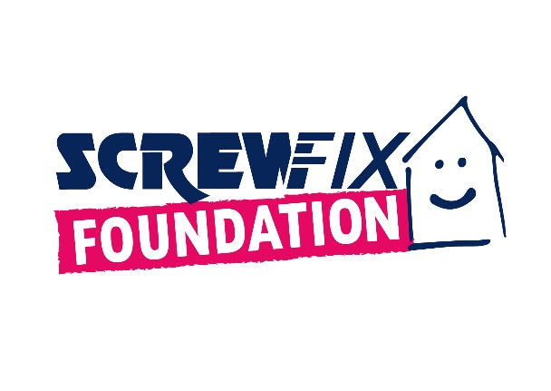
THE SCREWFIX FOUNDATION IS KEEN TO HELP EVEN MORE CHARITIES IN NEED AS IT CELEBRATES ITS 10TH ANNIVERSARY

Set up in 2013 to give back to local communities, The Screwfix Foundation has been donating to charities and not for profit organisations to help fix, repair, maintain and improve facilities for those in need.
Customers and suppliers of Screwfix, and colleagues at Screwfix, have raised an incredible £13m over the last 10 years, which has been donated to more than 2500 organisations. In the last two years alone, the more than half a million people have been impacted by donations from The Screwfix Foundation.
Every quarter Screwfix Foundation receives more than 1000 requests for funding. The need to support worthwhile causes in our communities is higher today than ever. John Mewett, Trustee, shared: “If we donated much-needed funds to every request we receive, we would have to raise over £20m each year!”
To celebrate The Screwfix Foundation’s 10th Anniversary, the Trustees decided to reinvigorate the charity, including its branding. Designed in-house by Spark Studio, the new brand is being launched to take on the next chapter of The Foundation’s journey.
Liz Bell, Trustee, explains: ¨Customers and colleagues enable us to donate around £400,000 every quarter to charities and not-for-profit organisations, no “thank you” is big enough for what they do to make this possible. As we head into Christmas, we are hoping to raise more than ever before in our raffle to help our communities. I especially love how our colleagues will go the extra mile to find ways to raise money too! ¨
The Screwfix Foundation has supported projects from renovating counselling rooms to funding kitchens for people with disabilities. Spadework, an independent charity based in Offham, provides opportunities for adults with disabilities and has been supported by The Screwfix Foundation to convert a room into a studio for their trainees to make their podcasts. A spokesperson said: “Sometimes, adults with learning disabilities are unable to get their voices heard. Creating podcasts is a brilliant way to explore creativity without fear of judgement and improve social skills and confidence at the same time. We would like to send a very big Spadework ‘Thank you’ to The Screwfix Foundation.”
The Vale Pantry, a social supermarket that helps over 360 families each week who struggle financially and face food insecurity, installed a new floor and air conditioning in its store with the donation it received from The Screwfix Foundation.

A refuge in Cambridgeshire, which provides safe and stable accommodation for women and children fleeing high risk domestic abuse, has refurbished the counselling rooms with its donation. A spokesperson said: “Having a room with new furniture and decoration means so much to the women and children we support. Moving to a refuge is very daunting and to walk into a room with home comforts, new beds, wardrobes, and floors makes the families feel valued and welcomed. Thank you to The Screwfix Foundation for supporting us in our refurbishment, and giving families who have suffered abuse the accommodation they deserve.”

Kelvin Jackson, Trustee of The Screwfix Foundation said, “Since becoming a Trustee in 2022, I was amazed at the requests we received. I had never thought about how charities often don’t get funding for fixing, repairing or maintaining their buildings, so being able to see how we can help is amazing. Visiting charities has shown me first-hand how the little things make a big difference.”
The generous donations from Screwfix’s customers, suppliers and colleagues have also enabled The Screwfix Foundation to donate funds to its charity partner, Macmillan Cancer Support. To date, more than £700,000 has been donated to the Macmillan Grant Scheme which provides home improvements for those affected by cancer.
In addition, through Screwfix’s partnership with micro-donation charity Pennies, The Screwfix Foundation has received more than 34 million donations from customers rounding up payment for their orders on Screwfix.com, raising over £5.6 million.
Tickets for the Christmas Raffle will be on sale from 30 October 2023. And applications for funding can be made at www.screwfixfoundation.com, or find out more on Facebook & Instagram.
- ENDS -

About The Screwfix Foundation
Set up in 2013 after Screwfix recognised the need to give back to the communities in which it operated, The Screwfix Foundation is a grant-giving charity with the clear purpose to support local charities and not-for-profit organisations in need across the UK by fixing, repairing, maintaining, and improving community facilities and homes.
Thanks to the generosity of Screwfix customers, suppliers and colleagues, The Screwfix Foundation raises money throughout the year with activities in-store, charity champions’ missions, Foundation weeks and raffles.
Currently, The Screwfix Foundation offers local registered charities and not-for-profit organisations funding up to the region of £5,000. All applications are reviewed individually by the team in March, June, September, and December. Please, see here full eligibility criteria.
Local registered charities and registered not for profit organisations are welcome to apply for funding from The Screwfix Foundation by completing an application form available on www.screwfixfoundation.com.
In addition to supporting local communities in need, a proportion of the funds raised through The Screwfix Foundation are donated to its charity partner, Macmillan Cancer Support to their home improvement programme, which helps people suffering from cancer in financial need with minor home improvements.
- Since 2013, The Screwfix Foundation has helped over 2,400 local charities and not-for-profit organisations and raised over £12 million.
- Through Screwfix’s partnership with micro-donation charity Pennies, The Screwfix Foundation has received more than 34 million micro-donations from customers rounding up their online orders, raising over £5.6 million.
- People can see all the charities that The Screwfix Foundation has supported here.

