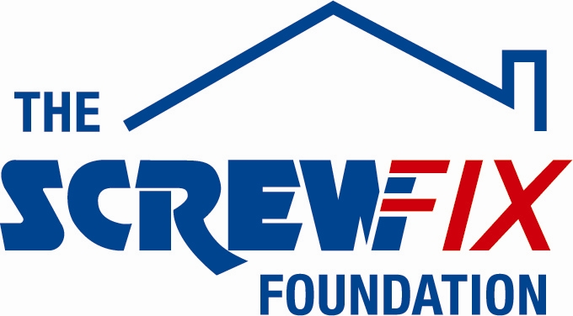

October 2019

The Screwfix Foundation supports Candlelighters in Leeds

Candlelighters is celebrating after being awarded £3,500 worth of funding from The Screwfix Foundation.

Chris Salt from Candlelighters said “We are very grateful to The Screwfix Foundation for donating these much-needed funds to support our charity. 150 children are diagnosed with childhood cancer across Yorkshire every year. Candlelighters exists to support these children and families emotionally, practically and financially, as well as to fund research into childhood cancer. Our support is extensive; from funding roles on the hospital wards and clinics, to holding family, patient, sibling, mum’s, dad’s and grandparent support groups, providing grants upon diagnosis and wellbeing sessions at our family support centre The Square. Our aim is to bring light and hope to our families. In the words of one Dad, “When your tower is crumbling down, Candlelighters is the scaffolding that holds you up.””

“The funding will be used towards our Candlelighters Cottage campaign to refurbish a property enabling parents and families to stay close to the hospital when their child is having treatment. The Cottage will provide safe, clean and convenient accommodation for four families and will provide a vital service for the families we support. We’d like to thank everyone who was involved in the fundraising – it’s been a great help to us,” he added.

Paul Olley, Screwfix Leeds Sheepscar Store Manager, said: “We’re so happy that one of our local charities has been awarded funding by The Screwfix Foundation.

“Screwfix customers are the driving force behind the Foundation, and without their generous donations, it wouldn’t be possible to support so many charities like Candlelighters.

“Over the past six years customers have been donating through sponsoring various staff fundraisers, in-store donation boxes and pennies online. It’s fantastic to see the money we have raised being invested back into such a worthwhile community project.”

The Screwfix Foundation, which launched in April 2013 has awarded more than £4 million of much-needed funding to help a variety of local projects throughout the UK. The charity supports projects to fix, repair, maintain and improve properties and facilities for those in need.

It also works closely with two national charity partners, Barnardo’s children’s charity and Macmillan Cancer Support, as well as supporting smaller, local registered charities.

Relevant projects from across Somerset are invited to apply online for a share of the funding at screwfixfoundation.com.

For more information about The Screwfix Foundation, visit screwfixfoundation.com.

-ENDS-
Note to editors
About The Screwfix Foundation:
The Screwfix Foundation is a charity set up by Screwfix in April 2013. We have a clear purpose of raising funds to support projects that will fix, repair, maintain and improve properties and community facilities specifically for those in need in the UK.
The Screwfix Foundation raises funds throughout the year to support causes that will change people’s lives. Working with both national and local charities, The Screwfix Foundation donates much needed funding to help all sorts of projects, from repairing buildings and improving community facilities, to improving the homes of people living with sickness or disability.

PRESS information:
For more information, please contact:
The Screwfix Foundation,
E: Foundation@screwfix.com

