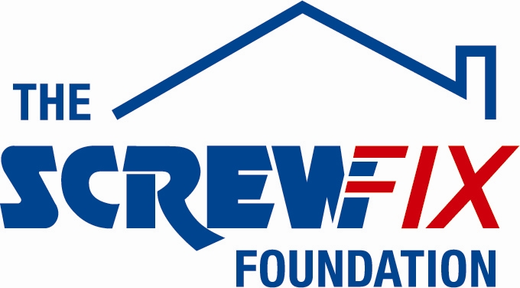
19th November 2018

THE SCREWFIX FOUNDATION SUPPORTS HENSHAWS SOCIETY FOR THE BLIND AT THEIR HARROGATE CENTRE

Henshaws Society For The Blind, a charity based in Manchester, is celebrating after being awarded £5,000 worth of funding from The Screwfix Foundation, a charity which supports projects to fix, repair, maintain and improve properties and facilities for those in need.

Aleena Khan, Fundraiser, comments: “We are very grateful to The Screwfix Foundation for donating these much-needed funds to support our charity. Henshaws is charity supporting people living with sight loss and a range of other disabilities to go beyond expectations. The funding will be used to help adapt and refurbish the former Principal’s house on our specialist college campus in Harrogate into urgently needed, modern and accessible accommodation for 4 students with complex needs. We provide support so that the young people living in our houses can build skills and be part of their local community whilst giving them the chance to live more independently and have a fully accessible and supportive place to call home. We’d like to thank everyone who was involved in the fundraising – it’s been a great help to us.”

Kris Almond-Riley, Store Manager of the Chorlton Screwfix store, comments: “We’re really pleased that one of our local charities has been awarded funding by The Screwfix Foundation. Staff from across the business have held a variety of fundraising events to raise vital funds for The Screwfix Foundation, so it’s fantastic to see the money we have raised being invested back into such a worthwhile community project.”

The Screwfix Foundation, which celebrates its fifth birthday this year, donates much needed funding to help a variety of local projects throughout the UK, from repairing buildings and improving community facilities, to improving the homes of people living with sickness or disability.

It also works closely with two national charity partners, Barnardo’s children’s charity and Macmillan Cancer Support, as well as supporting smaller, local registered charities like Charlies.
Relevant projects from across Harrogate are invited to apply online for a share of the funding at screwfixfoundation.com.

For more information about The Screwfix Foundation, visit screwfixfoundation.com.
From L-R - Shona Boyle, Chloe Ainscough, Screwfix Manager Kris Almond-Riley, Hayley Middleton, Alex Blythe.

-ENDS-
Note to editors
About The Screwfix Foundation:
The Screwfix Foundation is a charity set up by Screwfix in April 2013. We have a clear purpose of raising funds to support projects that will fix, repair, maintain and improve properties and community facilities specifically for those in need in the UK.
The Screwfix Foundation raises funds throughout the year to support causes that will change people’s lives. Working with both national and local charities, The Screwfix Foundation donates much needed funding to help all sorts of projects, from repairing buildings and improving community facilities, to improving the homes of people living with sickness or disability.

PRESS information:
For more information, please contact:
The Screwfix Foundation,
E: Foundation@screwfix.com

