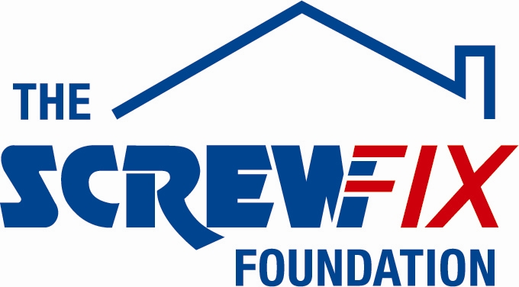
14th January 2019

THE SCREWFIX FOUNDATION SUPPORTS THE WOOLER COMMUNITY WORKSHOP

Wooler Community Workshop, based in Northumberland, is celebrating after being awarded £1,150 worth of funding from The Screwfix Foundation, a charity which supports projects to fix, repair, maintain and improve properties and facilities for those in need.

Ken Minshull, lead volunteer from Wooler Community Workshop comments: “We are very grateful to The Screwfix Foundation for donating these much-needed funds to support our charity. Wooler Community Workshop Ken Minshull, lead volunteer from Wooler Community Workshop comments: “We are hugely grateful to The Screwfix Foundation for donating these much-needed funds to support our charity, which provides the ‘hands on therapy’ of a wood based, craft environment for both men and women of all adult ages. An air filtration system was urgently required to ensure a safer and cleaner working environment, especially for elder members who were susceptible to breathing problems. The replacement mitre saw is also a huge benefit, as ours was on its last legs at the time! We are so fortunate that the grant came at just the right time, as we were running short of the necessary funds to provide such essential functionality. Currently we try to survive by making money from selling or fixing products at the workshop, much made to order locally or via our Facebook page. On behalf of the workshop I’d sincerely like to thank everyone who was involved in the fundraising – it’s been a great help to us.”

Ken Coon, Store Manager of the Screwfix store in Alnwick, comments: “We’re really pleased that one of our local charities has been awarded funding by The Screwfix Foundation. Staff from across the business have held a variety of fundraising events to raise vital funds for The Screwfix Foundation, so it’s fantastic to see the money we have raised being invested back into such a worthwhile community project.”

The Screwfix Foundation, which celebrates its fifth birthday this year, donates much needed funding to help a variety of local projects throughout the UK, from repairing buildings and improving community facilities, to improving the homes of people living with sickness or disability.

It also works closely with two national charity partners, Barnardo’s children’s charity and Macmillan Cancer Support, as well as supporting smaller, local registered charities like Wooler Community Workshop.

Relevant projects from across Northumberland are invited to apply online for a share of the funding at screwfixfoundation.com.

For more information about The Screwfix Foundation, visit screwfixfoundation.com.
Pictured are Jo Harbord from Beaumond House Community Hospice and Andy Clarke from Newark Yaxley Screwfix store

-ENDS-
Note to editors
About The Screwfix Foundation:
The Screwfix Foundation is a charity set up by Screwfix in April 2013. We have a clear purpose of raising funds to support projects that will fix, repair, maintain and improve properties and community facilities specifically for those in need in the UK.
The Screwfix Foundation raises funds throughout the year to support causes that will change people’s lives. Working with both national and local charities, The Screwfix Foundation donates much needed funding to help all sorts of projects, from repairing buildings and improving community facilities, to improving the homes of people living with sickness or disability.

PRESS information:
For more information, please contact:
The Screwfix Foundation,
E: Foundation@screwfix.com

