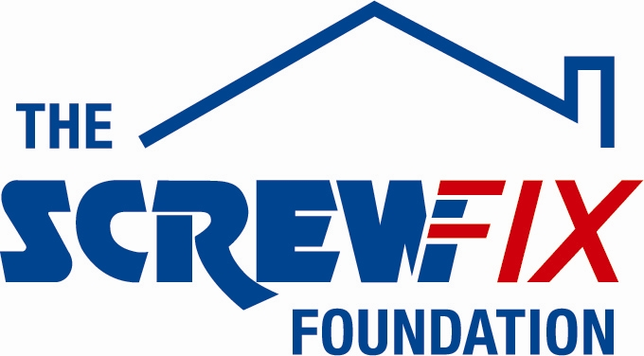
20th Septrember 2018

THE WEST NORTHUMBERLAND FOOD BANK, HEXHAM, GETS A HELPING HAND FROM THE SCREWFIX FOUNDATION
The West Northumberland food bank, based in Hexham, is celebrating after being awarded £2,800 worth of funding from The Screwfix Foundation, a charity which supports projects to fix, repair, maintain and improve properties and facilities for those in need.
Sam Gilchrist Project Manager at The Northumberland food bank comments: “We are very grateful to The Screwfix Foundation for donating these much-needed funds to support our charity. We provide food, household essentials and support to around 400 households a year, most people who come to the Food Bank are deeply ashamed to have to ask for food and feel overwhelmed and very alone with the problems they are facing. This funding has helped us make the Food Bank better equipped, warm and welcoming for people. We’d like to thank everyone who was involved in the fundraising – it’s been a great help to us.”

Nick Zinonos, Store Manager of the Hexham Screwfix store, and his store supervisor, Anthony Charlton, who suggested that they apply, comments: “We’re really pleased that one of our local charities has been awarded funding by The Screwfix Foundation. Staff from across the business have held a variety of fundraising events to raise vital funds for The Screwfix Foundation, so it’s fantastic to see the money we have raised being invested back into such a worthwhile community project.”

The Screwfix Foundation, which launched in April 2013 donates much needed funding to help a variety of local projects throughout the UK, from repairing buildings and improving community facilities, to improving the homes of people living with sickness or disability.

It also works closely with two national charity partners, Barnardo’s children’s charity and Macmillan Cancer Support, as well as supporting smaller, local registered charities like United Response

Relevant projects from across Northumberland are invited to apply online for a share of the funding at screwfixfoundation.com.

For more information about The Screwfix Foundation, visit screwfixfoundation.com.
Image pictured are L to R;- Owain Bennet, Nick Zinonos, John Stocker, Sam Gilchrist and Anthony Charlton.

-ENDS-
Note to editors
About The Screwfix Foundation:
The Screwfix Foundation is a charity set up by Screwfix in April 2013. We have a clear purpose of raising funds to support projects that will fix, repair, maintain and improve properties and community facilities specifically for those in need in the UK.
The Screwfix Foundation raises funds throughout the year to support causes that will change people’s lives. Working with both national and local charities, The Screwfix Foundation donates much needed funding to help all sorts of projects, from repairing buildings and improving community facilities, to improving the homes of people living with sickness or disability.

PRESS information:
For more information, please contact:
The Screwfix Foundation,
E: Foundation@screwfix.com

