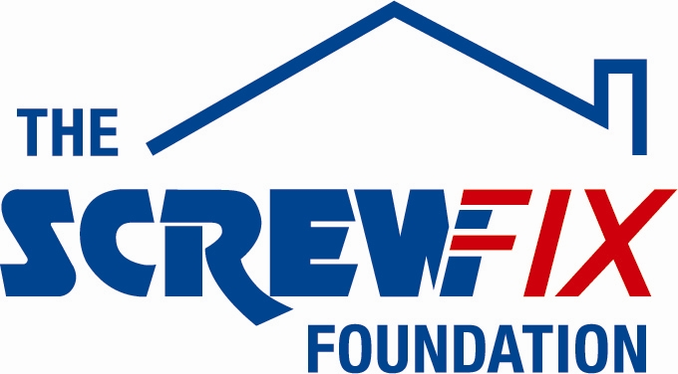

August 2017

THREE ROSES HOMES LIMITED RECEIVES GENEROUS DONATION FROM THE SCREWFIX FOUNDATION

Three Roses Homes Limited, based in Stourbridge is celebrating after being awarded £1,866 worth of funding from The Screwfix Foundation, a charity which supports projects to fix, repair, maintain and improve properties and facilities for those in need.

Erin Hoskins from Three Roses Homes Limited comments: “We are very grateful to The Screwfix Foundation for donating these much needed funds to support our charity. Three Roses Homes Limited is a residential home providing full-time care for adults with learning disabilities. The funding will be used to repair the roof, including replacing the felt, broken tiles and fitting a dry verge. We’d like to thank everyone who was involved in the fundraising – it’s been a great help to us.”

Laurence Lingard-Lane, Area Manager of the Screwfix store in Stourbridge, comments: “We’re really pleased that one of our local charities has been awarded funding by The Screwfix Foundation. Staff from across the business have held a variety of fundraising events to raise vital funds for The Screwfix Foundation, so it’s fantastic to see the money we have raised being invested back into such a worthwhile community project.”

The Screwfix Foundation, which launched in April 2013 donates much needed funding to help a variety of local projects throughout the UK, from repairing buildings and improving community facilities, to improving the homes of people living with sickness or disability.

It also works closely with two national charity partners, Barnardo’s children’s charity and Macmillan Cancer Support, as well as supporting smaller, local registered charities like Three Roses Homes Limited.

Relevant projects from across Stourbridge are invited to apply online for a share of the funding at screwfixfoundation.com.

For more information about The Screwfix Foundation, visit screwfixfoundation.com.

-ENDS-
Note to editors
About The Screwfix Foundation:
The Screwfix Foundation is a charity set up by Screwfix in April 2013. We have a clear purpose of raising funds to support projects that will fix, repair, maintain and improve properties and community facilities specifically for those in need in the UK.
The Screwfix Foundation raises funds throughout the year to support causes that will change people’s lives. Working with both national and local charities, The Screwfix Foundation donates much needed funding to help all sorts of projects, from repairing buildings and improving community facilities, to improving the homes of people living with sickness or disability.

PRESS information:
For more information, please contact:
The Screwfix Foundation,
E: Foundation@screwfix.com

