Tradespeople and DIYers help support charities with much-needed makeovers

As the charitable arm of the UK’s leading multi-channel supplier of trade tools, accessories and materials, The Screwfix Foundation provides funding to local charities and not for profit organisations to support repair projects and improve facilities.
Since May 2013, Screwfix customers have been rounding up their online purchases with Pennies in support of the Screwfix Foundation, giving their digital change to support hundreds of local causes and charities. An extraordinary £1.2million has been raised so far, from almost 8,000,000 individual micro-donations, benefitting charities including Brendoncare, Beaumond House Community Hospice and Lowlands Farm RDA.
Bringing wellbeing back to Brendoncare
Brendoncare is a charity dedicated to improving the quality of life for older people through a number of services, including friendship and wellbeing clubs that give people opportunities for social interaction and a place to meet new friends. The charity contacted the Screwfix Foundation when one of their centres in Gosport, Hampshire, was in need of new heating facilities.
The £5,000 they received helped cover the cost of new heaters, ensuring elderly people who had stopped attending the clubs due to the bitter temperature were able to return and enjoy their favourite social activities once again.
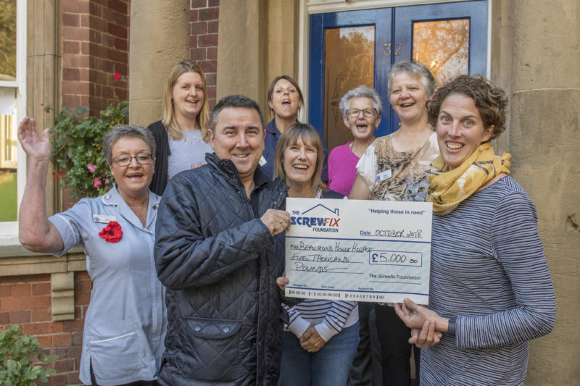
A safe place for patients at Beaumond House
Based in Newark, Beaumond House Community Hospice provides palliative care to over 500 patients with life limiting or terminal illnesses and offers support to the patients’ families. The hospice is the hub of the charity but being an old Victorian building, it needs continual up-keep. In 2017, the charity planned to refurbish the building to offer their patients better facilities in a fresh environment but needed funding to make it all happen.
Thanks to the Screwfix Foundation, the Beaumond House received enough money to improve patient accessibility and ensure the building met the latest fire safety regulations – as well as giving all of the doors a fresh coat of paint.
The level of support and particularly the swiftness in response to our application has been wonderful, to receive this grant has reminded us all how genuinely supportive local organisations are. This pleasant, light and contemporary environment will offer the best possible quality of life where patients can feel at home.
Stuart Hendry, Beaumond House Community Hospice
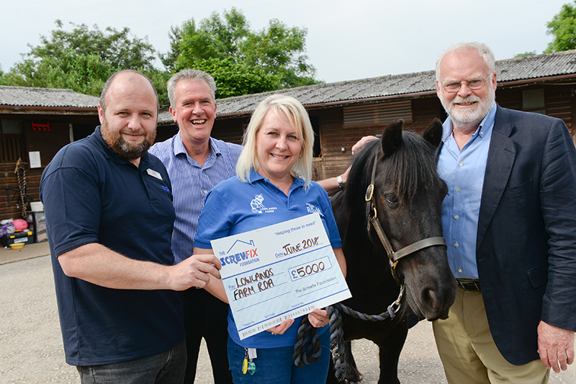
Increasing independence at Lowlands Farm RDA
Lowlands Farm RDA in Shrewley, Warwick, provides a riding group for disabled people in the local community; giving adults and children new opportunities with both physical and emotional benefits. Horse riding encourages people to engage in sports and education, build friendships and learn valuable life skills.
The charity owns a mechanical horse that helps riders gain confidence and vital core strength before moving on to real horses. Their Screwfix Foundation grant paid for a hoist to help riders who had previously found it impossible to mount the mechanical horse independently, allowing Lowlands to keep delivering their services to a wider range of clients, and provide the best possible experience.
Making pennies count
Hundreds of charities need funding and support for maintenance and building up-keep – and your Pennies donations play a huge role ensuring these causes get the help they deserve. On average just five days of Pennies donations is enough to fund one of these vital projects, helping charities making a huge difference to the communities they serve – and the Screwfix Foundation has supported over 900 such projects since 2013.
Thank you for every single donation – and remember the next time you’re grabbing supplies at Screwfix.com, you can round-up your purchase and help another charity in need of a revamp.

About Screwfix:
Screwfix is part of Kingfisher plc, the international home improvement company, with 1,302 stores in 10 countries in Europe, Russia and Turkey. For further information go to www.kingfisher.com.
Screwfix is convenient, straightforward and affordably-priced, helping its trade customers get the job done quickly, affordably and right first time. Tradespeople can shop 33,000 products over the phone, online, via their mobile or in-person from their local store.
- From power tools and work wear to cables and pipe fittings, Screwfix offers over 11,000 products available to pick up from over 620 UK stores nationwide.
- Over 33,000 products can be ordered over the phone, online or from a local store, with orders taken up until 8pm (weekdays) for next day delivery to home or site.
- Screwfix.com attracts over 5 million visits per week.
- Store network is visited by 7.1m customers a year
- The Screwfix Click & Collect service which enables customers to pick-up their goods in as little as one minute after ordering online or over the phone, has already received more than 27 million orders.
- UK-based Screwfix Contact Centre open 24 hours a day, 7 days a week (including bank holidays) on 03330 112 112.
- See www.screwfix.com/stores for store opening information.
- Next day delivery is available within store opening hours.
- World leading customer satisfaction levels.
- Screwfix was awarded Glassdoor’s Best Places to Work in 2017 and 2018.
- Screwfix was awarded Retail Week’s ‘Best Retailer over £250m’ and ‘Digital Pioneer’ awards in 2018
- For more information about Screwfix please visit our media centre: www.screwfixmedia.co.uk

PRESS information:
For more information, please contact:
Danielle Sweet, PR Manager, Tel: 01935 441706

Pennies, the digital charity box
April 2019

Pennies is a fintech charity (registered no. 1122489) launched in November 2010. It is the digital upgrade of the traditional charity box, designed to fit with our increasingly cashless lifestyles. Anyone can ‘feel-good’ give with participating Pennies retailers – by donating a few pence to charity when paying by card or mobile wallet. It’s as simple as a single press of a button or click of a mouse.

Pennies has enabled an incredible 70 million small change digital donations to date through its digital charity box, raising £17 million in extra income for more than 400 charities, and growing.

Pennies is live across a breadth of 60+ retail, hospitality and service sector leaders, including Domino’s, Boots Opticians, Screwfix, Hobbycraft, Topps Tiles, Virgin Holidays, Zizzi, The Entertainer, and Rontec and MRH roadside retail outlets. It is now also registered in the Republic of Ireland.

How Pennies works
- The option to give appears automatically in the card payment process: on the Chip & PIN machine in-store, at the checkout online or via a smart device.
- The retailer always nominates the charity that its customers can support. Pennies is entirely neutral.
- 100% of Pennies customer donations go to charity – 90% to the retailers’ nominated charity/ies and 10% to Pennies – also a charity – to grow micro-donating movement.
- At a time of consumer concern about how their data is being stored and used, Pennies is reassuringly anonymous. We neither see nor collect customer data, so customers can give in confidence – and it is always a choice to give. It really is about dropping a few pence in a charity box – but without physical cash.

For more information on Pennies please visit:
www.pennies.org.uk
https://www.facebook.com/Penniesorguk/
https://twitter.com/pennies_orguk

