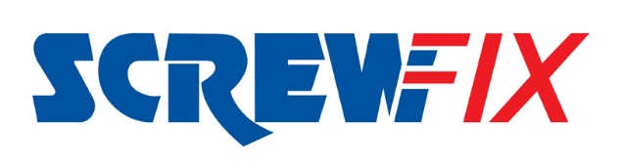

Yeovil Town FC ground to star in new Screwfix TV Ads
Yeovil Town Football Club is the setting of a new range of adverts from national retailer Screwfix, that begin airing today, Friday 4th August.

The television adverts, which feature many local extras are part of Screwfix’s sponsorship deal with Sky Sports and were filmed at the Yeovil club in July.

Sammy Ough, Advertising Manager at Screwfix comments, “We have an ongoing relationship with Yeovil Town Football Club and as such, they were our first choice of locations to film at. We are really pleased we could use local football players, alongside the actors. The crowd that feature in the ads are all locals. We are very thankful to Yeovil Town for all their help and support with these adverts.”

David Linney, from Yeovil Town said, “We really enjoy working with the team at Screwfix, they are a keen supporter of the club. This opportunity was great to be involved with. Everyone thoroughly enjoyed the day and are looking forward to seeing the adverts on the TV.”

For the 4th consecutive year, Screwfix will be sponsoring the Sky Sports coverage of the English football league. The 14 adverts will play before, during and after football matches on Sky Sports Football. The coverage begins this evening during the Sunderland vs Derby County match.

-ENDS-
Note to editors

About Screwfix:
Screwfix is part of Kingfisher plc, the international home improvement company, with nearly 1,200 stores in 10 countries in Europe, Russia and Turkey. For further information go to www.kingfisher.com.
Screwfix is convenient, straightforward and affordably-priced, helping its trade customers get the job done quickly, affordably and right first time. Tradespeople can shop 28,000 products over the phone, online, via their mobile or in-person from their local store.
- From power tools and work wear to cables and pipe fittings, Screwfix offers over 11,000 products available for pick up from over 520 stores nationwide. Our full range of over 28,000 products can be ordered over the phone, online or from a local store, with orders taken up until 7pm (weekdays) for next day delivery to home or site.
- Screwfix.com attracts 2.6 million unique visitors per week.
- The Screwfix Click & Collect service means customers can conveniently purchase supplies online or over the phone and then collect from the store in as little as one minute.
- Customers can call the UK-based Screwfix Contact Centre 24 hours a day, 7 days a week (including bank holidays) on 03330 112 112.
- UK stores are open 7 days a week, from 7am – 8pm Weekdays, 7am – 6pm Saturdays and 9am – 4pm Sundays. Excludes selected stores. See www.screwfix.com/stores for details.
- 9 out of 10 customers would recommend Screwfix to a friend.
- Screwfix was voted the 5th highest rated UK company for work-life balance by Glassdoor Employees' Choice Awards in 2016.
- Screwfix was awarded Glassdoor’s Best Places to Work in 2017.
- Screwfix was awarded Retail Week’s Multichannel Retailer of the Year in 2017.
- In 2016, Screwfix sales surpassed £1bn for the first time.
- Screwfix was awarded 2nd place in Retail Week’s Best Employer Rankings in 2017.
- Screwfix was awarded South West Contact Centre Forum’s Large Contact Centre of the Year Award in 2017.
- For more information about Screwfix please visit our media centre: www.screwfixmedia.co.uk

About Yeovil Town Football Club:

